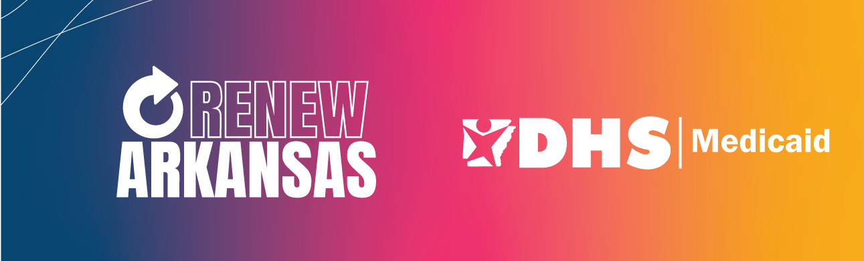

FAQ (Frequently Asked Questions)

What is the federal public health emergency and how does it affect Medicaid beneficiaries?
The federal government declared a public health emergency when the COVID-19 pandemic began in March 2020. Since then, state Medicaid programs have continued health care coverage for medical assistance programs, even for people who have not renewed their cases or who are no longer eligible.

Beneficiaries have been told they don’t have to renew Medicaid eligibility to keep coverage. Is this still true?
No. Beneficiaries have been allowed to keep their Medicaid during the pandemic without renewing, but that ends March 31, 2023. After that time, ineligible and unauthorized beneficiaries will begin to lose coverage. Eligible beneficiaries who get a renewal packet in the mail must return the renewal paperwork to keep their health care coverage.

When does Arkansas plan to begin the Medicaid renewal process?
The federal government has set March 31, 2023 as the last day states must keep ineligible beneficiaries enrolled in Medicaid. However, Arkansas is allowed to begin sending out renewal packets in February. DHS started mailing out renewals in February and will continue each month until renewals for all Medicaid programs have been sent. It is very important that Medicaid beneficiaries who get a renewal packet respond to them timely. Arkansas will work as quickly as possible to remove ineligible beneficiaries in order to protect taxpayers.

How long do beneficiaries have to send in their renewal paperwork?
Renewal packets should be returned by the due date listed on the packet, which is about 60 days from the date on the letter. If the packet is not returned by the due date, a reminder letter giving additional time will be sent. If the packet is not received by the date on the reminder, the case will close.

How soon could ineligible beneficiaries lose their Medicaid coverage?
Ineligible beneficiaries will begin losing coverage in April 2023. Those eligible for coverage through the marketplace will be connected for assistance with finding a health plan.

How will beneficiaries know if they need to renew their Medicaid eligibility?
Beneficiaries who need to renew their Medicaid eligibility will get a letter from DHS telling them that they need to renew. Everything beneficiaries need to know about how and when to send the packet back in will be included in that letter. DHS may have enough information to renew some beneficiaries without the need for the beneficiary to submit additional information.

If beneficiaries on Medicaid have not received a renewal letter yet, what should they do?
DHS will start mailing out renewals in February and continue each month until renewals for all Medicaid programs have been sent. That means that even if a beneficiary knows someone else who got a letter and they haven’t gotten one, they still may get one. Beneficiaries should be patient, but they can check to see if they will get a letter. Beneficiaries can go online at access.arkansas.gov, create an account if they don’t have one already, and see if they need to renew their eligibility. They can even complete the renewal information online when it is time. Beneficiaries also can submit a question via the Access Anywhere form at ar.gov/accessanywhere, or they can call 1-855-372-1084 or any local DHS county office and ask someone to check their Medicaid status to see if they need to renew coverage.

How is DHS ensuring that beneficiaries are aware of the need to send back renewal packets?
DHS wants those eligible for Medicaid to remain covered, so there will be lots of reminders to complete the renewal paperwork. This effort is called Renew Arkansas. The Renew Arkansas campaign includes:
- A “one-stop shop” website at ar.gov/renew for everything beneficiaries need to know about the process, including phone numbers and toolkits with handouts and graphics.
- Information shared on television (KARK, FOX16, KATV, and THV) and radio.
- Ads on digital platforms that will be seen on smartphones, tablets, and smart TVs).
- Messaging on DHS social media accounts (Facebook, Twitter, Instagram, and YouTube).
- All Renew Arkansas materials available in English, Spanish, and Marshallese.
- Medicaid providers such as doctors, dental managed care, and non-emergency transportation connecting with beneficiaries and encouraging them to renew if they get a renewal packet in the mail. Providers and community partners also are being provided renewal materials to share with beneficiaries.

What happens If beneficiaries don’t send in their paperwork on time?
If beneficiaries do not respond to their renewal with the requested information on time, they will be sent a letter explaining that their coverage will end. The letter will give a specific end date based on the date when the information was due.
What if others in my household receive a renewal packet and I do not?
Everyone may not be due for renewal at the same time. If others in your household receive a packet and you don’t, your renewal is not due yet.
What happens if beneficiaries are not eligible for Medicaid?
Ineligible beneficiaries will get a letter explaining when their Medicaid coverage will end. It will include information on how to file an appeal if the beneficiary thinks the decision was incorrect. Additionally, if beneficiaries are ineligible due to income, DHS will automatically send their information to the federal marketplace. Information about the marketplace also is listed in the letter.

Can beneficiaries still update their current contact information?
Yes. Beneficiaries should update their mailing address, phone, and email by calling the Update Arkansas hotline at 1-844-872-2660. Beneficiaries also can go online at access.arkansas.gov, create an account, and update their information or visit a county office. As a reminder, beneficiaries are expected to update their address or phone number with DHS within 10 days of either of those changing.

I still haven’t gotten my renewal. Should I be worried?

No. DHS will check to see if we can renew your case without asking you for any information. If we can, then you’ll get a letter in the mail letting you know that you have been renewed. If not, you’ll get a renewal packet in the mail. Renewals are being sent over several months, so yours may not be up yet. If you ever got a letter from us saying that you were ineligible but keeping your coverage due to the Public Health Emergency, then you should receive your renewal letter/packet by August. Otherwise, your renewal should be due annually in the same month you originally were approved for health care coverage through Medicaid. If you’re worried, go to access.arkansas.gov and log into or create your account. There you can check your status. You also can call our call center at 855-372-1084 or visit/call your local county office.

I lost coverage. What do I do?

There are a number of reasons people were determined to be no longer eligible for Medicaid. Visit our website for options if you lost coverage https://humanservices.arkansas.gov/divisions-shared-services/medical-services/update-arkansas-2/if-you-have-lost-health-care-coverage/

I’m having trouble reaching someone who can help.

There are a number of different ways you can reach out to DHS. Our Medicaid assistance line is 855-372-1084. You also can call your local county office – we’ve recently made some upgrades to the phone system to help calls get answered more timely, or you can go to ar.gov/accessanywhere and send us a secure message about your issue. We have a team ready to respond.

Are there extended call center hours?

Yes. Starting May 1, the 855-372-1084 number will have a live person answering calls from 7 a.m. to 7 p.m. Monday through Friday. DHS will be monitoring call volume and wait times and may adjust the days and times based on that information.

My Access Arkansas account shows that my case is “pending.” What does that mean?

That means that a determination has not been made in your case either because it is pending work on the part of DHS OR because you, the beneficiary, still needs to send in requested information. To determine if it is pending because you need to turn something in, go to your message center at access.arkansas.gov and read the latest notices that you were sent.

