Request for Information

Provider Enrollment

This is a Request for Information (“RFI”) only and as such will NOT result in any award of contract.
The Department of Human Services, Division of Medical Services (DMS) is in the information gathering stage and no decisions have been made concerning the agency’s intent to issue a formal Request for Proposal. Responding to this RFI is appreciated and will NOT prohibit the respondents from responding to any future procurements.

ISSUE DATE: February 3, 2020

RESPONSES DUE: March 2, 2020, 4:00 p.m. CST

Table of Contents
OVERVIEW 3
Instructions to Respondents 3
Disposition of Responses 3
Intent of the RFI 4
Overview 4
Purpose 4
Requirements 5
System Requirements 5
Business Process Operations (BPO) 6
Financial/Total Cost of Ownership 6
Current Environment 6
Response to RFI 6
Contents of Response 7
Reimbursement 8
No Award of Contract 8
Attachment A: Respondents Contact Information 8
Appendix A 8

OVERVIEW

Instructions to Respondents
- The respondent to this RFI shall submit two (2) hard copies and two (2) electronic copies of their response. The electronic format shall be submitted on CD-ROM or flash drive. The software used to produce the electronic files must be Microsoft Word 97 and/or Excel 97 or newer. These electronic files must be logically named and easily mapped to the hard copy submittal. The electronic media must be clearly labeled in the same manner as the hard copy.
- The respondent shall also submit an electronic redacted copy of the response suitable for release to the public. Any confidential or trade secret information covered under the Arkansas Freedom of Information Act (FOIA) statutes should be either redacted or completely removed. The redacted response shall be marked as “redacted” copy and contain a transmittal letter authorizing release of the redacted version of the response in the event DHS receives a public records request. The vendor should keep in mind the following:
- One (1) complete copy of the submission documents from which any proprietary information has been redacted should be submitted on a flash drive in the Response Packet. A CD is also acceptable. Do not submit documents via email or fax.
- Except for the redacted information, the redacted copy must be identical to the original hard copy, reflecting the same pagination as the original and showing the space from which information was redacted.
- The vendor is responsible for identifying all proprietary information and for ensuring the electronic copy is protected against restoration of redacted data.
- If the State deems redacted information to be subject to FOIA, the vendor will be contacted prior to release of the documents.
- The State has no liability to a vendor with respect to the disclosure of the vendor’s confidential information ordered by a court of competent jurisdiction pursuant to FOIA or other applicable law.

- Responses to this RFI shall be provided no later than 4:00 PM, Central Standard Time, Monday, March 2, 2020. Responses shall be submitted to:
Department of Human Services
Procurement Office
Attn: Nawania Williams
700 Main Street, Slot W345
Little Rock, AR 72201
- Administrative and/or procurement related questions concerning this RFI should be submitted in writing via email to Nawania.Williams@dhs.arkansas.gov.

Disposition of Responses
- All responses become the property of the State and will be subject to the provisions of the Arkansas Freedom of Information Act, Ark. Code Ann. § 25-19-101 et seq.

- Responses should not contain material considered by the respondent to be confidential under state or federal law for any reason, including being proprietary, copyrighted, or capable of giving an unfair advantage to competitors.
- The State shall have the right to use all ideas, or adaptations of those ideas, contained in any response received to this RFI. While responses to this RFI are optional, all knowledgeable parties are strongly encouraged to provide complete responses.

- DMS may exercise the option to further discuss the details of the response with one or more respondents if it is determined to be in the best interest of the State.

- Responding or not responding to this RFI shall not determine any future partnerships.

Intent of the RFI
- DMS is issuing this RFI for planning purposes with the intent to gather information on potential future strategic opportunities related to the program area(s) covered. This RFI shall not be construed as a commitment by DMS to solicit contractual offers or award contracts.

- Review of the responses to this RFI by DMS will be undertaken primarily to gauge the aggregate level of qualified interest from potential contractors, assess the overall magnitude of the opportunity identified by potential contractors, and inform the design of any solicitation(s) and/or eventual program(s). Responses will not be reviewed on a competitive basis.

Overview
DMS is the single state Medicaid agency for the State of Arkansas. In that capacity, it is responsible for operating the Title XIX and Title XXI programs through the State’s 1115 Research and Demonstration Waiver, which was granted by the Centers for Medicare and Medicaid Services (CMS), U.S. Department of Health and Human Services.
DMS has over 46,000 actively enrolled providers, such as medical and behavioral health practitioners, providers of the various therapy disciplines, institutions, durable medical equipment companies, and transportation entities, in Arkansas. Additional information may be found on the DMS website: https://medicaid.mmis.arkansas.gov/default.aspx

Purpose
DMS is issuing this RFI to reduce the burden on providers during enrollment and to gather best practices, ideas, and thoughts on how to streamline the enrollment and revalidation process, while maintaining federal and state rule compliance. The purpose of this RFI is to solicit input from qualified interested parties, which may be used as input in the development of an RFP for one overarching provider enrollment management system to bring Arkansas providers into state and federal compliance.
This RFI is seeking ideas and feedback for the procurement of a provider management system (herein sometimes called the “System”) and corresponding Business Process Operation (BPO) services. The System should streamline the enrollment process across all Medicaid provider types and create a single enrollment process that electronically collects and processes information needed to support provider screening, enrollment, verification, registration, and credentialing.
The intent of consolidating and streamlining the provider enrollment process is to reduce the processing time and duplication of work by DMS and providers by allowing providers to submit data once, whether the provider is enrolling or revalidating, in one program or in multiple state-supported programs.
The respondent must address provider screening based on risk level, including elevating risk of providers in accordance with CMS’s regulations. Screening process must include the following:
- Medicare Provider, Enrollment, Chain and Ownership System (PECOS) validation
- Background checks (state and federal)
- Fingerprinting
- Site visits
- Checks against required exclusion lists, including the list published by the Office of Inspector General (OIG), System for Award Management (SAM), and DHS.

The System must meet all Arkansas and federal provider enrollment requirements, including but not limited to:
- Centers for Medicare and Medicaid Services (CMS) provider enrollment regulations found at 42 CFR part 455
- Section 6401(b) of the Affordable Care Act
- Section I of the Arkansas Medicaid Provider Manual
- Medicaid Provider Enrollment Compendium (MPEC) – Latest Version
Additionally, the System must provide a platform to supply and receive required information to the various components of the Medicaid Management Information System (MMIS), including but not limited to the users of the MMIS. There are currently ninety-one (91) identified provider types.

Requirements
DMS is requesting information from interested parties regarding the procurement of a provider management system and business process outsourcing (BPO). The System must meet the following minimum requirements. Based in part on the information received in response to this RFI, further refinement and detail requirements for the System and BPO are expected.

System Requirements
The Respondent must provide detailed information describing how the proposed system will meet the overarching goal of this RFI, including, at a minimum, the following:
- Submission and processing of provider enrollment information in electronic and paper format.
- Interface with existing MMIS and how the system will allow for modifications and upgrades to the MMIS platform
- Compliance with CMS Medicaid Information Technology Architecture (MITA) requirements (found at https://www.medicaid.gov/medicaid/data-and-systems/mita/index.html), Health Insurance Portability and Accountability Act (HIPAA), Health Information Technology for Economic and Clinical Health (HITECH), Personal Information Protection Act (PIPA), and any other applicable federal or state privacy law
- Streamlined enrollment for multiple program and provider types
- Collecting, updating, and share provider data while allowing electronic access to the state, state healthcare programs, providers, and Managed Care Organizations.
- Provision of a robust reporting functionality and allowance for ad-hoc reporting.
- Provision of a portal that allows a provider to complete an application and prompts the provider to submit all necessary supporting documentation based on programs in which the provider will participate, checks status, and updates existing enrolled provider information.
- Ability to communicate to providers electronically as well as by mail.
- Ability to support provider payment of Provider Enrollment fees.

Business Process Operations (BPO)
Provide personnel and services to perform the following:
- Outreach and Education
- Re-Validation Activities
- Enrollment Activities
- Provider Information Updates
- Documentation and Work-Flow Management
- Call-Center Support for All Provider Management Activities
- Required Site Visits for revalidation and enrollment (for moderate to high risk providers only)

Financial/Total Cost of Ownership
Provide estimated financial expenditures and total cost of ownership.
- This RFI does not constitute a solicitation for proposals, a commitment to conduct procurement, or an offer of a contract or prospective contract; DMS will not award a contract because of this RFI. DMS will not be liable for any costs incurred by respondents in the preparation and submission of information in response to this RFI.
- Information received by DMS becomes the property of DMS and will not be returned to the sender. There will be no acknowledgement by DMS of receipt of the information. Acceptance of responses to this RFI imposes no obligations of any kind upon DMS.

Current Environment
The current technical environment consists of a solution containing a Data Warehouse/Decision Support System (DW/DSS), Pharmacy Processing Solution, and Core Services (Claims Processing MMIS). Each system is hosted by a separate contractor utilizing database architectures, services, and web-based presentation layers.
The current BPO environment services are provided by the current contractor providing the Core Services module.

Response to RFI
If a contractor is interested in responding to any or all the areas identified, DMS is requesting the following detailed written response:
- How would the respondent provide a solution for this System and BPO, including on-going maintenance and software updates?
- What issues related to the management of provider information or an overall enrollment concept have not been addressed in this RFI?
- What should DMS consider and address while planning for this System and BPO replacement, as identified in the RFI?
- Describe the transition process from the current environment to the new system.
- Provide detailed information about the type of electronic interfaces that can be built to validate information with a variety of potential data partners.
- How would a respondent update the System to reflect federal requirements for providers and new mandates that arise? Describe any barriers to complying with any state and federal laws.
- Provide examples of similar systems and BPO that have been implemented in other state Medicaid programs and descriptions of the experience in those states along with relevant data, including processing timeframes, customer satisfaction, and data verification.
- Provide a cost and timeline estimate for fulfilling the requirements of implementing a System and BPO as outlined in this RFI. Provide separate cost and timeline estimates for additional features such as credentialing and functions provided in the response.
- What issues and challenges has the respondent experienced when interfacing their solution with existing state systems?
- Provide detailed information on how provider education, training, and outreach will be addressed. Include process flows, approach, and communication solutions, as well as details on the following aspects of provider education, training, and outreach:
  - Provider enrollment representative;
  - Application support process for providers; and
  - Training materials (links to reference materials), communication plan, and implementation.
- Provide detailed information on how internal staff’s continued education and training will be addressed. Include process flows, approach, and communication solutions, and details on the following:
- Provider enrollment representative internal staff training; and
- Training process for new enhancement rollouts.
- Provide detailed information on how new and ongoing federal requirements, i.e., revalidation and background checks, will be addressed. Include process flows, approach, and communication solutions for the following:
  - Training process for new enhancement rollouts for internal staff; and
  - Communication/training for providers.

Contents of Response
If you are interested in responding to this RFI, DMS is requesting the following:
- Detailed Written Response: to any or all the areas listed above. Response should be clearly legible and sequentially page-numbered and include the respondent’s name and RFI number at the top of each page.
- Presentations/Demonstrations: DMS may request that the respondents schedule a 90-minute presentation with select DMS management. Please indicate your willingness to schedule an in-person presentation. Should this opportunity become available, DMS will contact you with dates and times that are convenient for both parties. DMS reserves the right to decide if presentations will be scheduled for some or any of the respondents.
- A completed Attachment A: Respondent’s Information, which includes contact information (i.e., name, title, mailing address, email address, authorized signature, and phone number of the contact person for questions relating to the RFI).

Reimbursement
DMS will not reimburse any respondent for the cost of preparing and submitting a response to the RFI or for travel costs associated with presenting the demonstration, if requested.

No Award of Contract
This is a Request for Information (“RFI”) only and as such will NOT result in any award of contract. DMS is in the information-gathering stage and no decisions have been made concerning the agency’s intent to issue a formal Request for Proposal. Responding to this RFI is appreciated and will NOT prohibit the respondents from responding to any future procurement.

Attachment A: Respondents Contact Information
Company Name
Address
Federal Employer ID Number
For Clarification of this Response Contact:
Name
Title
Phone
Email
Signature of Authorized Person
Name
Title
Date

Appendix A

Go to https://medicaid.mmis.arkansas.gov/default.aspx
Select Provider Information
Enrollment > Provider Enrollment Information
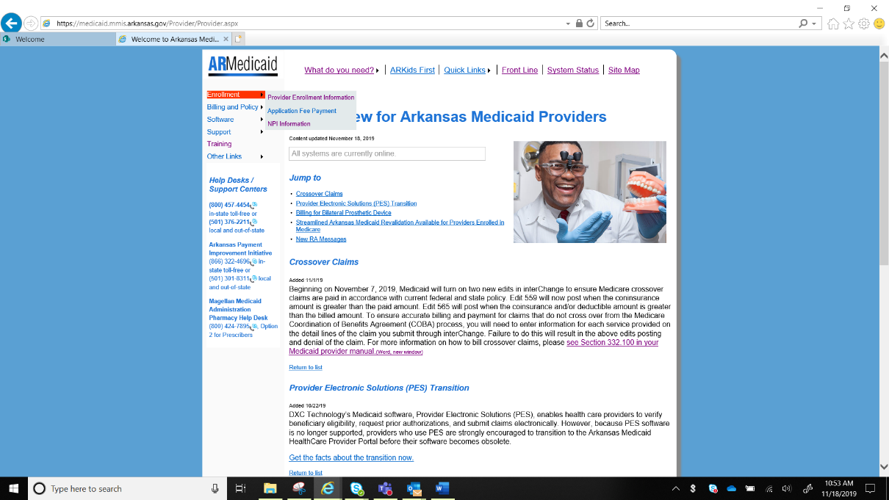

Under Application Information, select Required Documents Finder
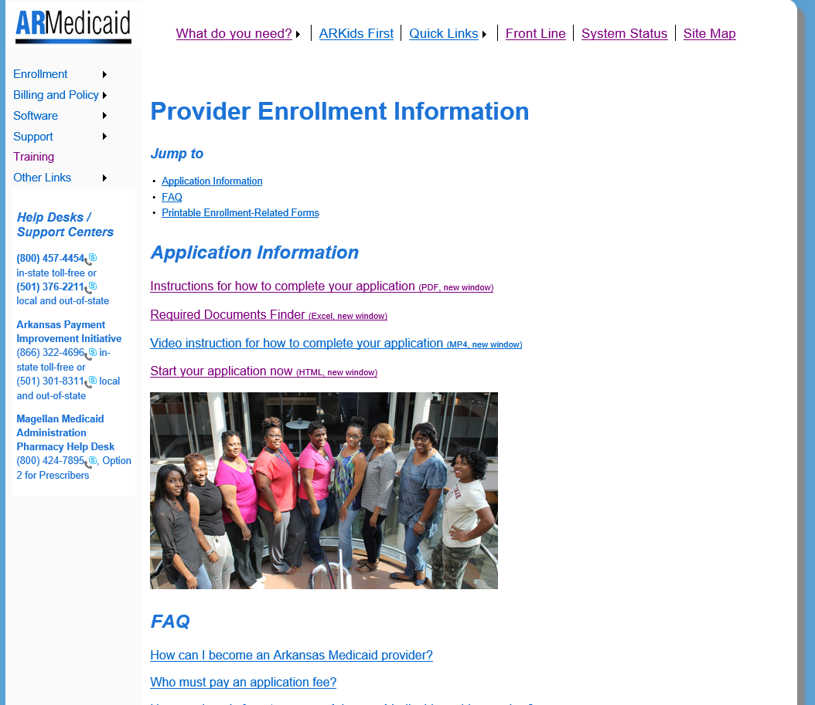
Excel spreadsheet will open.
