252.438 National Drug Codes (NDCs) | 1-1-23
Effective for claims with dates of service on or after January 1, 2008, Arkansas Medicaid implemented billing protocol per the Federal Deficit Reduction Act of 2005. This explains policy and billing protocol for providers that submit claims for drug HCPCS/CPT codes with dates of service on and after January 1, 2008.
The Federal Deficit Reduction Act of 2005 mandates that Arkansas Medicaid require the submission of National Drug Codes (NDCs) on claims submitted with Healthcare Common Procedure Coding System, Level II/Current Procedural Terminology, 4th edition (HCPCS/CPT) codes for drugs administered. The purpose of this requirement is to assure that the State Medicaid Agencies obtain a rebate from those manufacturers who have signed a rebate agreement with the Centers for Medicare and Medicaid Services (CMS).
A. Covered Labelers
Arkansas Medicaid, by statute, will only pay for a drug procedure billed with an NDC when the pharmaceutical labeler of that drug is a covered labeler with Centers for Medicare and Medicaid Services (CMS). A “covered labeler” is a pharmaceutical manufacturer that has entered into a federal rebate agreement with CMS to provide each state a rebate for products reimbursed by Medicaid Programs. A covered labeler is identified by the first five (5) digits of the NDC. To assure a product is payable for administration to a Medicaid beneficiary, compare the labeler code (the first five (5) digits of the NDC) to the list of covered labelers which is maintained on the DHS contracted Pharmacy vendor website.
A complete listing of “Covered Labelers” is located on the website. See Diagram 1 for an example of this screen. The effective date is when a manufacturer entered into a rebate agreement with CMS. The Labeler termination date indicates that the manufacturer no longer participates in the federal rebate program and therefore the products cannot be reimbursed by Arkansas Medicaid on or after the termination date.
Diagram 1
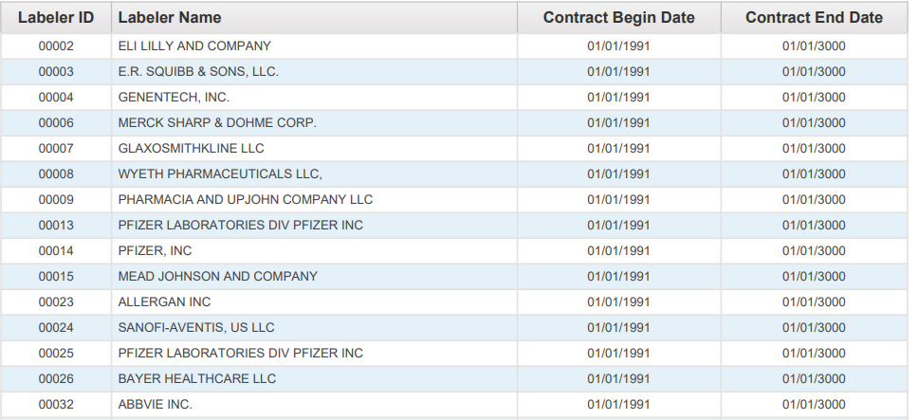

For a claim with drug HCPCS/CPT codes to be eligible for payment, the detail date of service must be prior to the NDC termination date. The NDC termination date represents the shelf-life expiration date of the last batch produced, as supplied on the Centers for Medicare and Medicaid Services (CMS) quarterly update. The date is supplied to CMS by the drug manufacturer/distributor.
Arkansas Medicaid will deny claim details with drug HCPCS/CPT codes with a detail date of service equal to or greater than the NDC termination date.
When completing a Medicaid claim for administering a drug, indicate the HIPAA standard 11-digit NDC with no dashes or spaces. The 11-digit NDC is comprised of three (3) segments or codes: a 5-digit labeler code, a 4-digit product code, and a 2-digit package code. The 10-digit NDC assigned by the FDA printed on the drug package must be changed to the 11-digit format by inserting a leading zero (0) in one (1) of the three (3) segments. Below are examples of the FDA assigned NDC on a package changed to the appropriate 11-digit HIPAA standard format. Diagram 2 displays the labeler code as five (5) digits with leading zeros; the product code as four (4) digits with leading zeros; the package code as two (2) digits without leading zeros, using the “5-4-2” format.
Diagram 2
00123 | 0456 | 78
LABELER CODE  (5 digits) | PRODUCT CODE  (4 digits) | PACKAGE CODE  (2 digits)

NDCs submitted in any configuration other than the 11-digit format will be rejected/denied. NDCs billed to Medicaid for payment must use the 11-digit format without dashes or spaces between the numbers.
See Diagram 3 for sample NDCs as they might appear on drug packaging and the corresponding format which should be used for billing Arkansas Medicaid:
Diagram 3
10-digit FDA NDC on PACKAGE | Required 11-digit NDC  (5-4-2) Billing Format
12345 6789 1 | 12345678901
1111-2222-33 | 01111222233
01111 456 71 | 01111045671

B. Drug Procedure Code (HCPCS/CPT) to NDC Relationship and Billing Principles
HCPCS/CPT codes and any modifiers will continue to be billed per the policy for each procedure code. However, the NDC and NDC quantity of the administered drug is now also required for correct billing of drug HCPCS/CPT codes. To maintain the integrity of the drug rebate program, it is important that the specific NDC from the package used at the time of the procedure be recorded for billing. HCPCS/CPT codes submitted using invalid NDCs or NDCs that were unavailable on the date of service will be rejected/denied. We encourage you to enlist the cooperation of all staff members involved in drug administration to assure collection or notation of the NDC from the actual package used. It is not recommended that billing of NDCs be based on a reference list, as NDCs vary from one (1) labeler to another, from one (1) package size to another, and from one (1) time period to another.
Exception: There is no requirement for an NDC when billing for vaccines, radiopharmaceuticals, and allergen immunotherapy.
I. Claims Filing
The HCPCS/CPT codes billing units and the NDC quantity do not always have a one-to-one relationship.
Example 1: The HCPCS/CPT code may specify up to 75 mg of the drug whereas the NDC quantity is typically billed in units, milliliters or grams. If the patient is provided 2 oral tablets, one at 25 mg and one at 50 mg, the HCPCS/CPT code unit would be 1 (1 total of 75 mg) in the example whereas the NDC quantity would be 1 each (1 unit of the 25 mg tablet and 1 unit of the 50 mg tablet). See Diagram 4.
Diagram 4
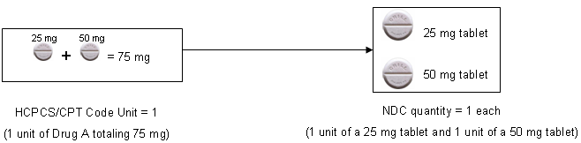

Example 2: If the drug in the example is an injection of 5 ml (or cc) of a product that was 50 mg per 10 ml of a 10 ml single-use vial, the HCPCS/CPT code unit would be 1 (1 unit of 25 mg) whereas the NDC quantity would be 5 (5 ml). In this example, 5 ml or 25 mg would be documented as wasted. See Diagram 5. For billing wastage, see bullets A (Electronic Claims Filing) and B (Paper Claims Filing) below.

Diagram 5
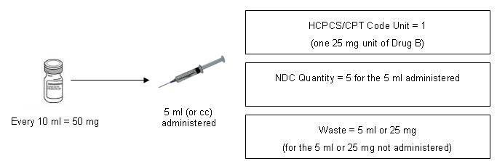

A. Electronic Claims Filing – 837P (Professional) and 837I (Outpatient)
Providers are instructed to bill as follows:
- 1 NDC for a procedure – 1st/only detail shall be billed with no modifier
- 2 NDCs for same procedure – 1st detail shall be billed with a KP and 2nd gets billed with a KQ modifier
- 3 NDCs for same procedure – 1st detail shall be billed with a KP and 2nd & 3rd detail get billed with a KQ modifier
- 4 or more NDCs for same procedure – submit via paper claim
- Wastage of each NDC shall be billed on a separate line with a JW modifier.
NOTE: The NDCs listed above are not the same (unless with a JW modifier). Same NDCs shall be billed on a single line with appropriate units.
NOTE: CMS definitions of modifiers:
- KP = First drug of a multiple drug unit dose formulation
- KQ = Second or subsequent drug of a multiple drug unit dose formulation
- JW = Drug wastage
B. Paper Claims Filing – CMS-1500
Providers are instructed to bill as follows:
- 1 NDC for a procedure – 1st/only detail shall be billed with no modifier
- 2 NDCs for same procedure – 1st detail shall be billed with a KP and 2nd gets billed with a KQ modifier
- 3 NDCs for same procedure – 1st detail shall be billed with a KP and 2nd & 3rd detail get billed with a KQ modifier
- 4 or more NDCs for same procedure – 1st detail shall be billed with a KP and 2nd and subsequent details shall be billed with a KQ modifier
- Wastage of each NDC shall be billed on a separate line with a JW modifier.
NOTE: CMS definitions of modifiers:
- KP = First drug of a multiple drug unit dose formulation
- KQ = Second or subsequent drug of a multiple drug unit dose formulation
- JW = Drug wastage
Diagram 6
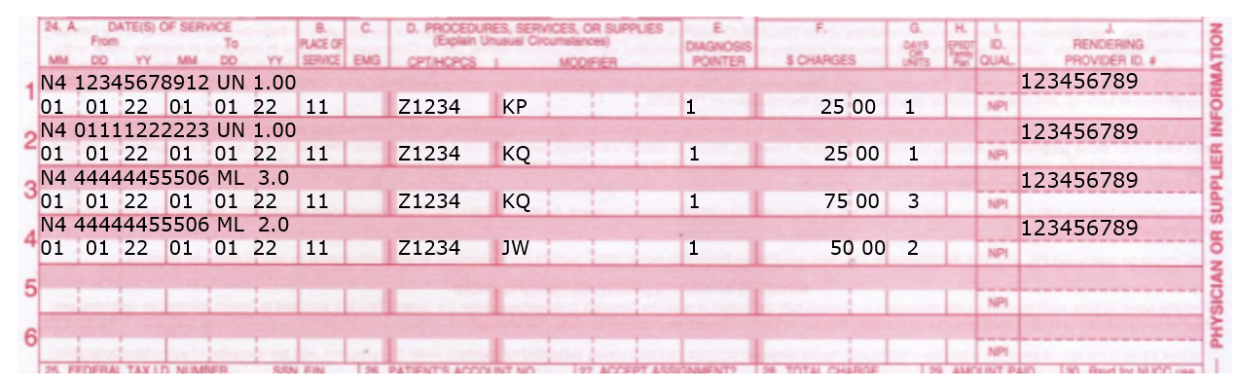

II. Adjustments
Paper adjustments for paid claims filed with NDC numbers will not be accepted. Any original claim will have to be voided and a replacement claim will need to be filed. Providers have the option of adjusting a paper or electronic claim electronically.
III. Record Retention
Each provider must retain all records for five (5) years from the date of service or until all audit questions, dispute or review issues, appeal hearings, investigations or administrative/judicial litigation to which the records may relate are concluded, whichever period is longer.
At times, a manufacturer may question the invoiced amount, which results in a drug rebate dispute. If this occurs, you may be contacted requesting a copy of your office records to include documentation pertaining to the billed HCPCS/CPT code. Requested records may include NDC invoices showing purchase of drugs and documentation showing what drug (name, strength and amount) was administered and on what date, to the beneficiary in question.
252.439 Billing of Multi-Use and Single-Use Vials | 1-1-23
Arkansas Medicaid follows the billing protocol per the Federal Deficit Reduction Act of 2005 for drugs.
A. Multiple units may be billed when applicable. Take-home drugs are not covered. Drugs loaded into an infusion pump are not classified as “take-home drugs.” Refer to payable CPT code ranges.
View or print the procedure codes for Nurse Practitioner services.
B. When submitting Arkansas Medicaid drug claims, drug units should be reported in multiples of the dosage included in the HCPCS procedure code description. If the dosage given is not a multiple of the number provided in the HCPCS code description the provider shall round up to the nearest whole number in order to express the HCPCS description number as a multiple.
1. Single-Use Vials: If the provider must discard the remainder of a single-use vial or other package after administering the prescribed dosage of any given drug, Arkansas Medicaid will cover the amount of the drug discarded along with the amount administered. Discarded drugs shall be billed on a separate detail line with a JW (Drug wastage) modifier.
2. Multi-Use Vials: Multi-use vials are not subject to payment for any discarded amounts of the drug. The units billed must correspond with the units administered to the beneficiary.
3. Documentation: The provider must clearly document in the patient’s medical record the actual dose administered in addition to the exact amount wasted and the total amount the vial is labeled to contain.
Remember to verify the milligrams given to the patient and then convert to the proper units for billing.
Follow the Centers for Disease Control (CDC) requirements for safe practices regarding expiration and sterility of multi-use vials.

