NOTIFICATION OF NURSING FACILITY ADMISSION WEBSITE
Resetting Your Password
Forget Your Password?
Password Expired?

- If you forget your password or the password has expired, you may use the following procedure to reset the password and access the website.

- NOTE: If your facility does not have an email address on file with the Division of Provider Certification and Quality Assurance, you cannot use this process to reset your password.

- Please contact:

Evelyn Thrower, 870-939-4035 Evelyn.Thrower@dhs.arkansas.gov
or
Ramie Allen, 870-242-6173 Ramie.Allen@dhs.arkansas.gov

to register your email address. When there is a change in e-mail contact information, please provide the updated information as soon as possible so that you will have access to the password reset function.

GETTING STARTED
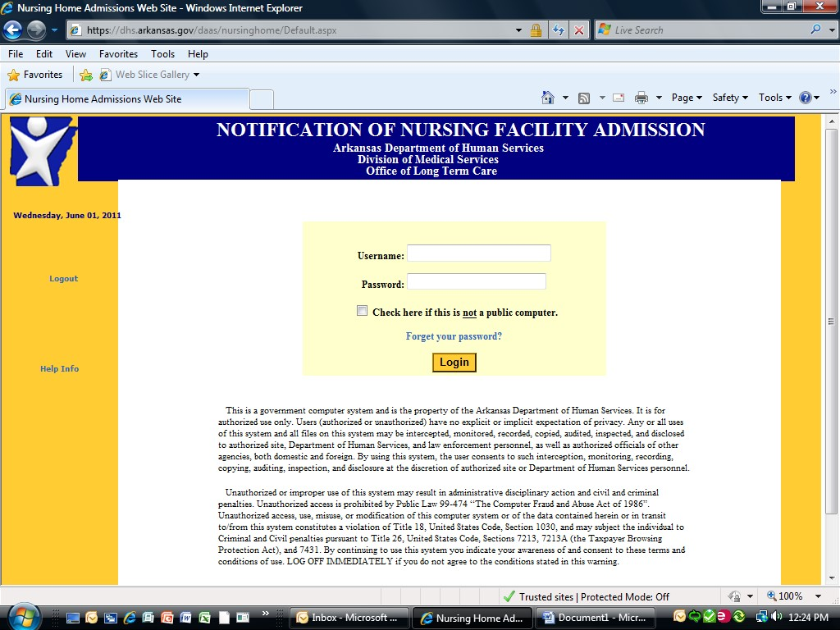
Go to the Notification of Nursing Facility Admission website:
https://dhs.arkansas.gov/daas/Nursing Home/

Click on Forget your password?

Resetting your password
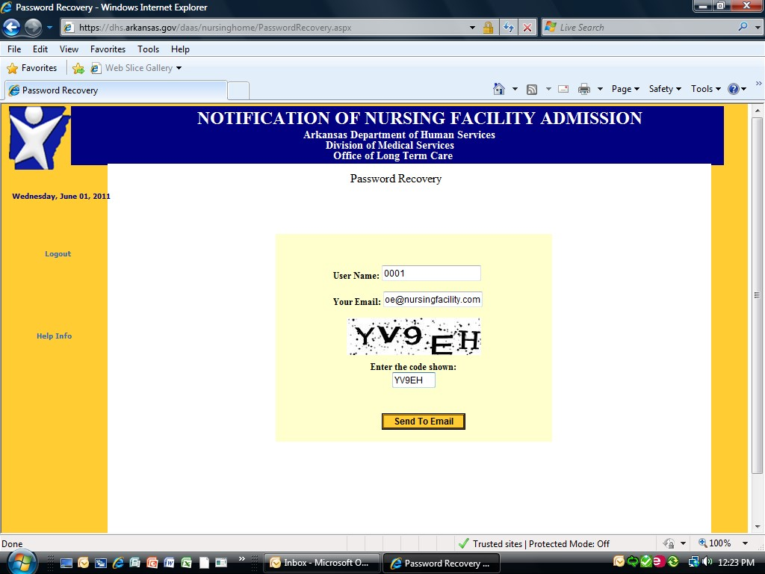
You will be taken to a second screen to enter the information needed to reset your password.

Enter your user name. This is the four- digit state vendor code assigned to your facility.

Enter the email address which is on file with the Department of Human Services, Division of Aging and Adult Services.

Enter the code as shown on the screen

Entering information

Once you have entered information in all three fields, click Send to Email.
Now what?
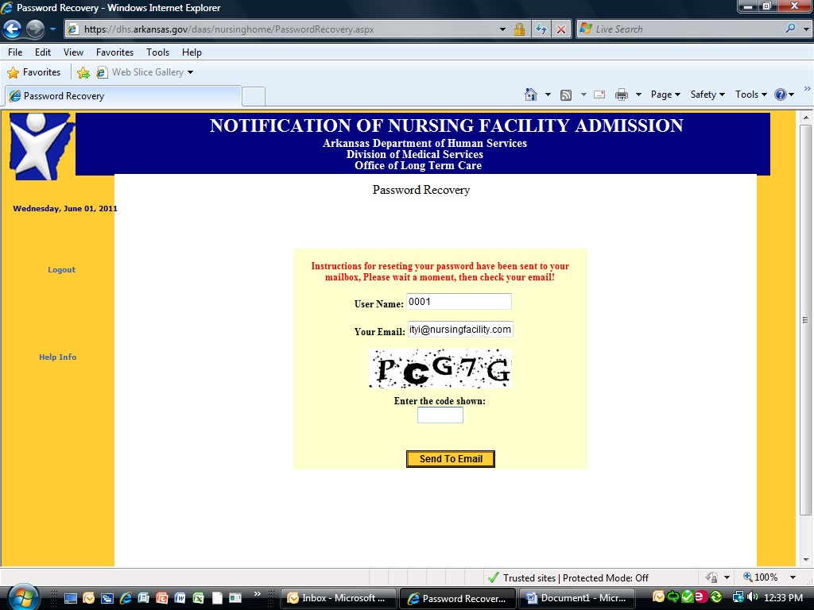

You will see the following message:

Instructions for resetting your password have been sent to your mailbox. Please wait a moment, then check your email!

Go to your email account
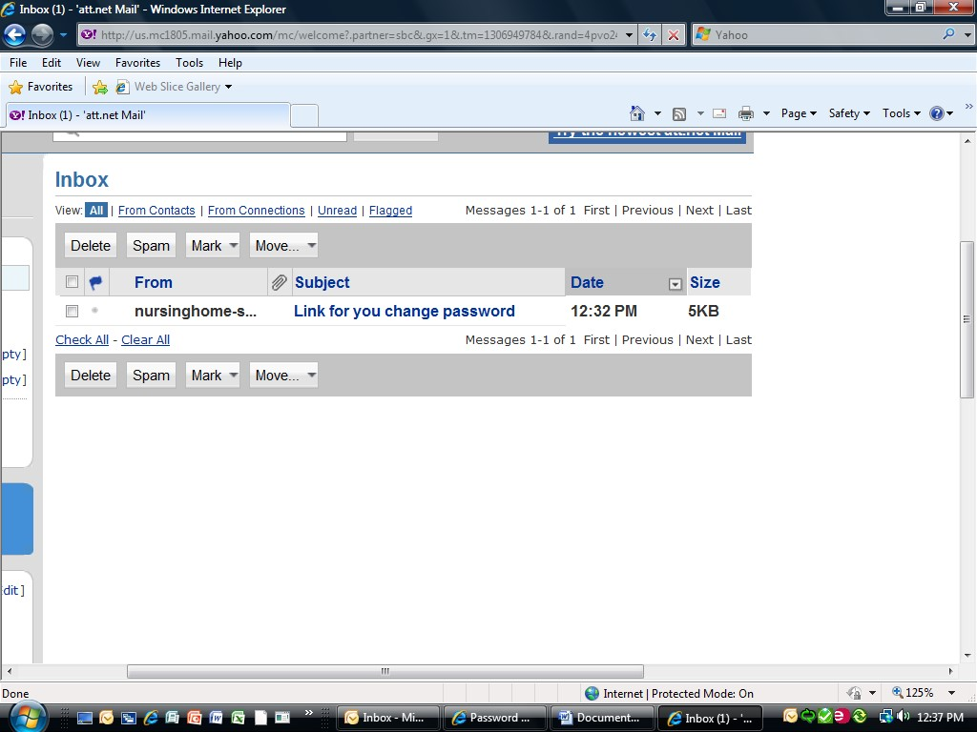

Open the email account to which the information was sent.

You will see the following: Link for you change password

Finding the link

Open the email to find the link for resetting your password.
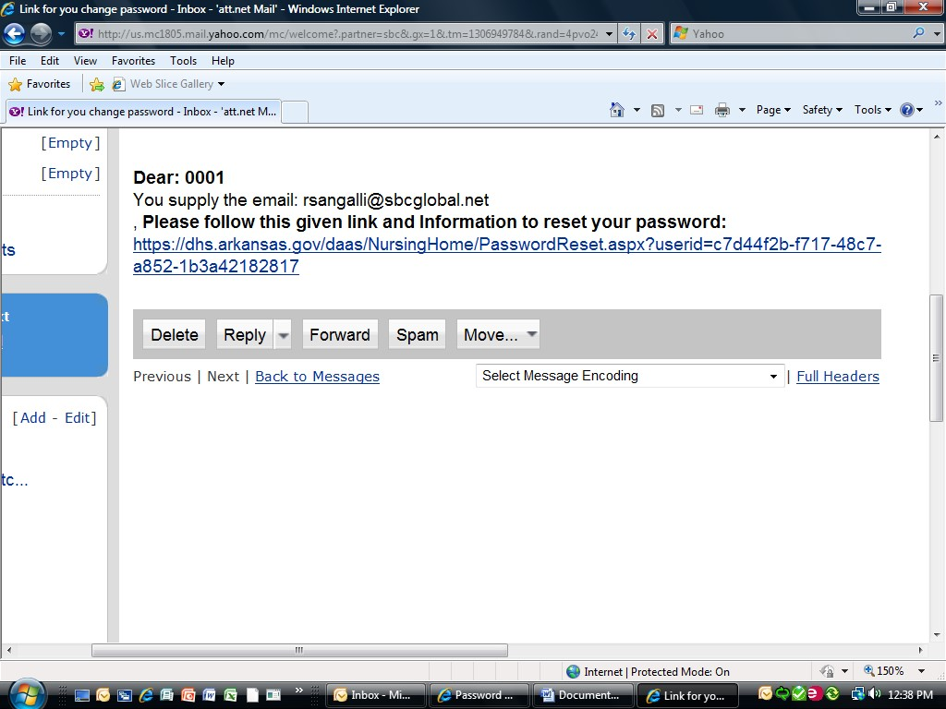
jdoe@samplefacility.com
Click on the link and you will be taken to the screen where you can change your password.

Create the new password
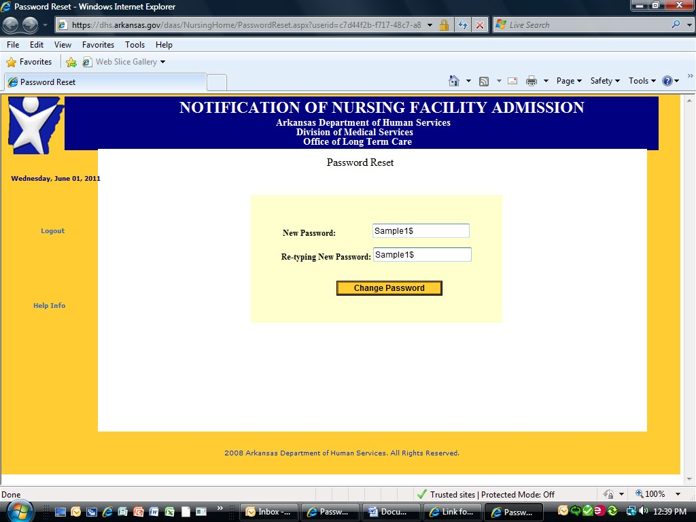

Enter your new password and confirm by entering it a second time.

Remember that your password must
be at least eight characters in length. It must contain at least one upper case letter, one lower case letter, one number, and one symbol or punctuation sign.

Click Change Password.

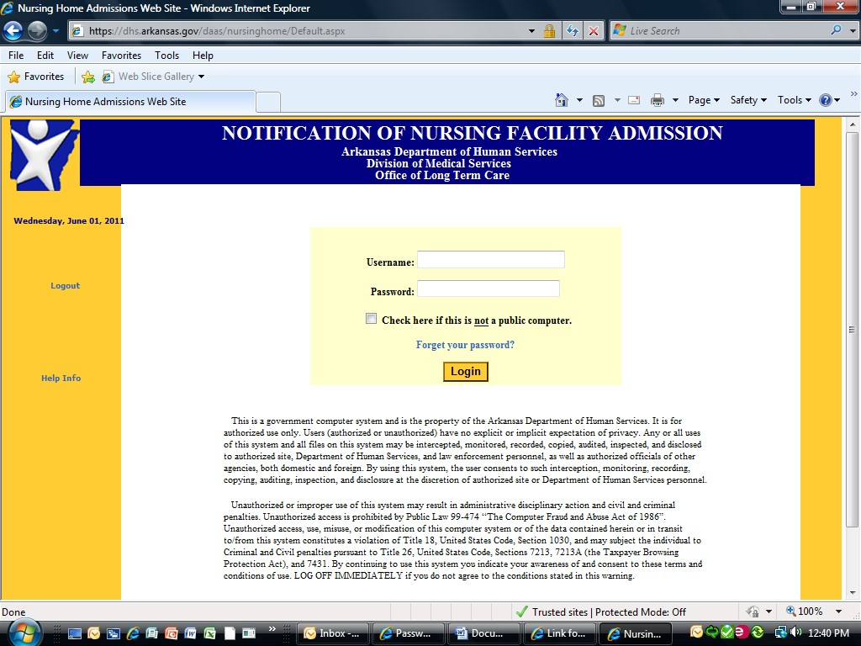
Ready to enter new admissions information

You will be taken back to the original website sign-in screen.

You will now be able to access the website by entering your user name and the newly created password.

If you need assistance, contact:

Evelyn Thrower, (870) 939-4035 Evelyn.Thrower@dhs.arkansas.gov
Or
Ramie Allen, 870-242-6173 Ramie.Allen@dhs.arkansas.gov

