Thank you all for your questions as we begin work in our new Quick Base application for 703 submissions. As we proceed in this new system, we will continue to evaluate as this is a new process for everyone and notify you of any updates to the system as applicable. If you have any questions or concerns, please email us at [MedNeeds.Quickbase@dhs.arkansas.gov](mailto:MedNeeds.Quickbase@dhs.arkansas.gov). The FAQ page will be updated on a regular basis based on received questions.

Again, thank you for all you do to care for the residents.

**Q: How do we register to use the Quick Base application and how many people can we register to use it?**

**A:** Each facility will be allowed one (1) user account that can be used to submit Med Needs 703 data. Please email [MedNeeds.Quickbase@dhs.arkansas.gov](mailto:MedNeeds.Quickbase@dhs.arkansas.gov) and provide the name and email address for the registered user identified for your facility. This information must include at least the user’s first name, last name, and email address to register.

The registered user will receive an invitation email from QuickBase, which must be used to complete the initial registration.

After the initial registration process, the user can access the portal by going directly to [http://ARDHS.QuickBase.com](https://gcc02.safelinks.protection.outlook.com/?url=http%3A%2F%2Fardhs.quickbase.com%2F&data=02%7C01%7CSarah.Schmidt%40dhs.arkansas.gov%7Cf15b1c88c76a43e8b3e908d85b1b2888%7C5ec1d8f0cb624000b3278e63b0547048%7C1%7C0%7C637359519481410167&sdata=E6%2FHoZl2cC%2BPacxwlJHTUQVePS6bpMIMI5tONTUKCe4%3D&reserved=0) and selecting the “703 Med Needs” icon.

**Q: What is the web address to sign into the Med Needs Quick Base application?**

**A:** You can log in and access Quick Base at <http://ARDHS.QuickBase.com>

**Q: What program types are currently being used in the Quick Base application?**

**A:** At this time, the Quick Base application is set up to receive 703 applications for Nursing Homes, ICF/ID, PACE, and Assisted Living.. This also includes PASRR related admissions.

**Q: Is there any training available on how to use the Quick Base application?**

**A:** A training guide and demonstration videos can be found at <https://humanservices.arkansas.gov/about-dhs/dpsqa/office-of-long-term-care/med-needs>.

DHS will also be providing additional trainings and Q&A sessions during the first few months after the Quick Base application Go-Live date (9/15/2020). Notifications for these trainings and sessions will be posted to the DHS website.

In order to receive the meeting link for these events and other pertinent information regarding the Quick Base system, please register for the DPSQA Provider Email Sign Up (<https://humanservices.arkansas.gov/about-dhs/dpsqa/dpsqa-provider-email-sign-up>).

**Q: Is it still required for the nurse to sign the 703 and where do they sign?**

**A:** There is a place on the application for the MD to sign; however, it does not specify a signature place for the RN/Nurse. The Additional Signature slot may be used in this scenario. Several facilities have also uploaded the paper 703 form which contains the signature of the RN and Physician and placed it under the documents section to meet the signature requirement.

**Q: Some of the more recent 703s that we have submitted to OLTC and received 704 Approvals for via email are now showing up in the Quick Base application. Do we need to resent these through Quick Base?**

**A:** No, do not resend any application which you have already submitted to OLTC via email or fax through the Quick Base system. DHS is still working to upload all recent 703/704 information into Quick Base for you to retrieve and archive. You will be able to view past applications once they are fully uploaded. If you are needing a copy of the 704 you originally received via email, and do not see the file in the Quick Base application at this time- please email [MedNeeds@arkansas.gov](mailto:MedNeeds@arkansas.gov) to request.

**Q: How can we correct a typo or misspelled resident/client name, etc. once a Client Record has been created?**

**A:** Provider Users do not have the ability to correct the Client Record demographic seen at the top of the page; however, you can request any corrections to that information through the [MedNeeds.Quickbase@dhs.arkansas.gov](mailto:MedNeeds.Quickbase@dhs.arkansas.gov) email. DPSQA and OLTC staff can make the appropriate changes as needed.

**Q: Does the information from the 703 paper form have to be typed into the QuickBase system or can the paper form be uploaded on its own?**

**A:** In order to use the QuickBase application system to submit your 703, the information must be entered electronically into the 703 Intake tab fields on the online portal. You can, however, include a copy of the paper 703 as an attachment to that application. Details on how to upload a document to an electronic application can be found on page 13 of the Med Needs QuickBase Provider User Training Guide.

**Q: After the 703 is submitted online, will a paper 704 be mailed/emailed or will all documents be uploaded to the QuickBase system?**

**A:** After a 703 application has been processed through the online portal, you will receive notification of the 703 approval or denial within the QuickBase system itself. How to view and print the application and the 704-Determination can be found on page 17 of the Med needs QuickBase Provider User Training Guide.

**Q: How do I reset my password to QuickBase?**

**A:** When you click on the link below, you should get this page, where you can click “**I forgot my password**”.

[https://ardhs.quickbase.com/db/main?a=signin](https://gcc02.safelinks.protection.outlook.com/?url=https%3A%2F%2Fardhs.quickbase.com%2Fdb%2Fmain%3Fa%3Dsignin&data=02%7C01%7CSarah.Schmidt%40dhs.arkansas.gov%7C36cd785d56894c2ffeb408d85ffbdf4d%7C5ec1d8f0cb624000b3278e63b0547048%7C1%7C0%7C637364882668538413&sdata=NuydtQnhYcbybsXGcySrGScKSPYH%2Fy7rwytYq9qBjtQ%3D&reserved=0)

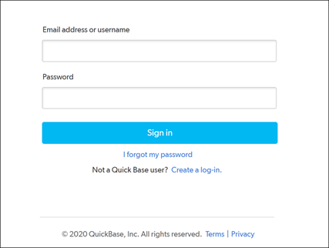

Put in your registered facility email address and then click the **Reset my Password** button to generate an email that will be good for resetting your password for 30 minutes. 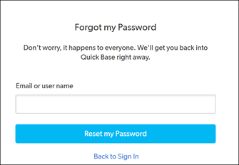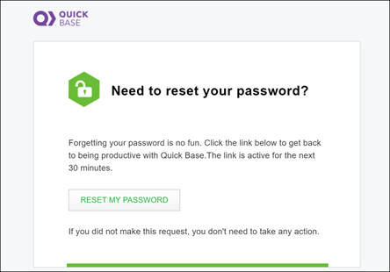

Once you reset your password, you’ll sign in with your registered facility’s email address and the new password. It will ask you to enter the verification code that was just generated in your work email. Once you enter the code, it should sign you into the account successfully.

**Q: How do I go back and fix a SS# that was entered with dashes as an error without having to resubmit the 703s with no dashes on the SS#?**

**A:** At this time, the Provider User features do not include editing rights for the Social Security Number field. If you find that you have entered a SSN in error, please email [MedNeeds.Quickbase@dhs.arkansas.gov](mailto:MedNeeds.Quickbase@dhs.arkansas.gov) with the individual’s name, correct SSN. Edits to the SSN can only be completed by DHS staff.

**Q: I have an app that is missing a form. How do I fix this problem?**

**A:** If you have not already submitted the application, you can upload and attach documents through the Document tab. If the application has already been submitted, additional documents cannot be added by the facility unless the application is returned back from DHS. If you would like for an additional document/form to be included with an already submitted application, please contact us at [MedNeeds.Quickbase@dhs.arkansas.gov](mailto:MedNeeds.Quickbase@dhs.arkansas.gov) for assistance.

**Q: We have added missing information to an application and the resubmit button is grayed out. What can I do?**

**A:** First, make sure that you have opened the application with the edit function, indicated with the pencil (  ) icon. Once you have completed your edits and/or added any additional information or documents, select the “Return Application-Missing Information Provided” option from the Provider Application Options drop down menu. The final step is to save the application in order to resubmit to DHS.

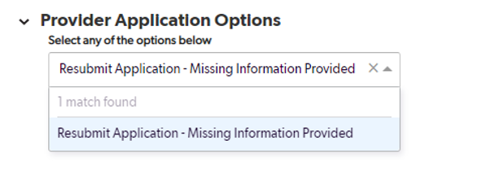

**Q: There are several 703s on my dashboard that say unsubmitted from years ago. How do I get these cleared up?**

**A:** If you have unsubmitted applications that are no longer applicable and need to be removed, submit the individual’s name, SSN, and the Application # associated with the application you need removed to [MedNeeds.Quickbase@dhs.arkansas.gov](mailto:MedNeeds.Quickbase@dhs.arkansas.gov). DHS will verify this removal request with you and remove the application internally.

**Q: Where do I get a copy of the manual?**

**A:** The Med Needs QuickBase Provider User Training Guide and Demo/Training Video are available on the DHS-DPSQA Med Needs webpage located at   
<https://humanservices.arkansas.gov/about-dhs/dpsqa/office-of-long-term-care/med-needs>

**Q:** **Having an issue signing in. It sends a verification code but expires by the time I get in.**

**A:** The verification code should send quickly and is good for 30 minutes; however, it may appear in a variety of email folders, including spam or junk folders. We encourage you to check those folders if you do not receive the verification code within your main inbox within the first several minutes after requesting it. You should also be able to send the verification code to a cell phone number as well.

**Q: What if the 703 does not give you the option to ass a nurse signature?**

**A:** Nurse’s signature can be uploaded under the additional signatures slot, or the 703-paper copy with the nurse’s signature can be uploaded under the Documents tab.

**Q: I submitted a 703 that was returned because of missing signature. How can I go back to see if the information I submitted was completed?**

**A:** If an application is returned for additional or missing information, edit capabilities will be available for you to add any information or documentation that was requested by the DHS RN. Once you have confirmed that all information/documentation has been added, you will resubmit the application for review again. Once the application is resubmitted, the application will return to the “Submitted” status on your dashboard. You will then be able to follow the status as it processes through DHS. If you have additional questions regarding the information DHS is requesting, you can reach out to DHS for clarification.

**Q: Can we email to check on a 703 was received prior to QuickBase?**

**A:** For inquiries on 703 Forms that were submitted via mail, fax, or email prior to QuickBase, please email [medneeds@arkansas.gov](mailto:medneeds@arkansas.gov). Ensure that you provide the individual’s name, SSN, facility name, and date of submission.

**Q: LPN has been added to the licensed box but when you click on the down arrow the only option is RN or DAAS nurse?**

**A**: Our software developers are currently working to provide this option in the drop down menu.

**Q: We have a hospice reassessment 704 with the wrong approval date. Who do we contact to get this corrected for billing purposes?**

**A:** If you find an error or question on the 704 Determination specifics, please email [MedNeeds.Quickbase@dhs.arkansas.gov](mailto:MedNeeds.Quickbase@dhs.arkansas.gov) with the individual’s name, SSN, and Application # and the correction needed.

**Q: I have resubmitted a 703 due to missing information. It shows that it was resubmitted but still under the incomplete section. The box is not clicked saying that the missing information has been received. What do I do?**

**A:** In this status, the application is still pending review. The DHS RN will update that information while reviewing.

**Q: When we print the 704 LOC to send to the DCO caseworker, the DCO caseworker is not accepting the form because there is no nurse signature showing on the 704 LOC?**

**A:** The Division of Provider Services and Quality Assurance are in ongoing communication with the County Offices regarding the new look to the 704 Determinations. For specific issues you have with DCO caseworkers accepting the 704, please forward any communication with the DCO caseworker to us at [MedNeeds.Quickbase@dhs.arkansas.gov](mailto:MedNeeds.Quickbase@dhs.arkansas.gov).

**Q: If you have a resident that has been in a facility for some time and has a change of condition, do you submit a new 703?**

**A:** Yes, you have the option under Application type to choose “Change of Condition.” Also, a change of condition requires the nurse’s signature who is filling out the 703, and either the Physician or Administrator’s signature. The resident/responsible party’s signature is not required on a change of condition, if you have the original signature on file.

**Q: Will financial 704s ever be on the portal?**

**A:** There is no plan to incorporate financial 704s at this time to the MedNeeds QuickBase portal.

**Q: Can we send the documentation in prior to admission for approval?**

**A:** No, we must have an admission date to process the application.

**Q: If a signature is on file, do we have to submit a signature on the portal?**

**A:** You can submit on the portal a statement with “Signature on File” and use this on change of conditions or reassessments only.

**Q: Do you have to submit a new 787 when a resident is admitted to Hospice or will the 703 work?**

**A:** You will submit the 703 application and mark assessment type of “Change of Condition.”

**Q: I submitted a new 703 and it is showing under the left side as submitted. Week later it is gone and when I enter the SS# to find the 703 nothing shows up?**

**A:** Please provide specifics on this type of case to [MedNeeds.Quickbase@dhs.arkansas.gov](mailto:MedNeeds.Quickbase@dhs.arkansas.gov) as these will need to be addressed on an individual basis. Ensure to provide the individual’s name, SSN, and other helpful information in order for DHS staff to quickly assist.

**Q: If a 703 was submitted prior to QuickBase but have not received a 704 yet, do we submit the 703s through the portal?**

**A:** No, do not resend any application which you have already submitted to OLTC via email for fax through the QuickBase system. DHS is still working to upload all recent 703/704 information into QuickBase for you to retrieve and archive. You will be able to view past applications once they are fully uploaded. If you are needing a copy of the 704 you originally received via email, and do not see the file in QuickBase at this time- please email [MedNeeds.Quickbase@dhs.arkansas.gov](mailto:MedNeeds.Quickbase@dhs.arkansas.gov) to request a copy.

**Q: I show there is a 703 that was submitted prior to QuickBase and shows unsubmitted in the portal. I have already received a 704. Do I need to do anything?**

**A:** You do not need to do anything at this time. DHS is continuously working to update the QuickBase application system with all prior submitted applications that were fully processed. You will see that these type of applications will soon be moved to the completed status in QuickBase with the same 704-Determination as you have on your paper-based 704 you received prior to QuickBase.