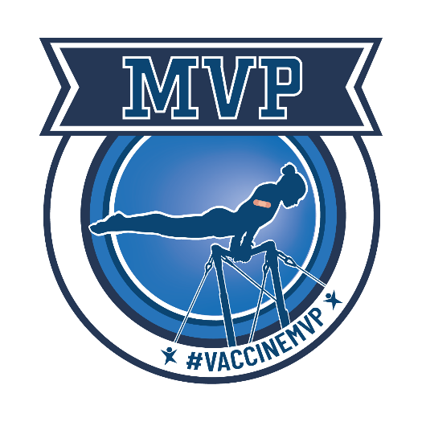
COVID-19 is a dangerous virus, and it can cause serious health problems, hospitalization, and even death. The best way to protect yourself is by getting vaccinated against this deadly virus today.

You can schedule your free vaccine by visiting vaccines.gov and searching for a provider near you.

I’m vaccinated and have encouraged my friends, family, and co-workers to do the same. The good news is that because you are in a program paid for by Arkansas Medicaid:

- The vaccine is free to you
- Medicaid will provide you a free ride to get vaccinated if you don’t have one
- A quick vaccine shot will not count against the 12 office visits Medicaid covers each year.
All of the vaccines available right now are safe and will give you strong protection against the virus, even the more contagious Delta variant. Right now, anyone who is 5 or older can get a COVID-19 vaccine at no cost.

It’s not just people who are elderly or who have complex medical issues that are at risk of getting seriously ill. The Delta variant is putting younger and healthy people in the hospital. Almost all the people hospitalized in Arkansas right now with COVID-19 are unvaccinated. If you haven’t done so already, now is the time to get the shot and get protected.
It’s normal to have questions about the vaccines, and the Department of Health has answers to many common questions here. If you have other questions, your primary care physician can help you learn more about the benefits of getting the vaccine.

Don’t wait. Make an appointment today to get vaccinated. It is quick, easy, and could save your life. If you need a ride from Medicaid, call 1-888-987-1200.

