GovCONNECT Case Management System - ADMIS User Guide

Version 0.1

Publishing Date: 12/4/2020

Document Control Information
Deliverable Information
Deliverable Name | User Guide Document: GovCONNECT Case Management System - ADMIS
Project Name | State of Arkansas DHS – GovCONNECT Case Management System - ADMIS
Deliverable Document Type | Microsoft Word
Deliverable Author | Deloitte Consulting

Revision History
Version | Date | Additions/modifications | Prepared/revised by
0.1 | 12/04/2020 | Initial Document | Deloitte Consulting

As used in this document, “Deloitte” means Deloitte Consulting LLP, a subsidiary of Deloitte LLP. Please see www.deloitte.com/us/about for a detailed description of the legal structure of Deloitte USA LLP, Deloitte LLP and their respective subsidiaries. Certain services may not be available to attest clients under the rules and regulations of public accounting.

Contents
1. Introduction 2
1.1 Overview 2
1.2 Global Features 2
2 About This Guide 3
2.1 Who Should Use This Document 3
2.2 Prerequisite Knowledge 3
2.3 Common User Interface Elements 3
3 User Creation/Maintenance 5
4 Program Creation/Maintenance 6
5 Service Creation/Maintenance 8
6 Provider Creation/Maintenance 9
7 License Creation/Maintenance 11
8 Contract Creation/Maintenance 12
9 Client Creation/Maintenance 14
10 Client Treatment Episode Creation/Maintenance 16
11 Billing 18
11.1 Approve Billing Button 18
11.2 Posting (DHS ADMIN Task) 18
11.3 New Button (DHS ADMIN Task) 18
12 Invoice (Master Providers and DHS Users) 20
12.1 Details 20
12.2 Printable Invoice Generation 20
13 Reports 22
13.2 Master Provider and DHS Users 26

Introduction

Overview

The GovCONNECT Case Management System - ADMIS application is a rewrite of the existing application which is enhanced to track GPRA client’s data that will be uploaded to the federal server.

Global Features

The GovCONNECT Case Management System - ADMIS application has many global features that give the user a seamless, intuitive experience.

Global Menu

The Global Menu is on the top of the GovCONNECT Case Management System - ADMIS application within the top banner. This allows the user to navigate to Screens from anywhere within the application. Below is a screenshot of the Global Menu:

Accessibility

The GovCONNECT Case Management System - ADMIS application shall ensure quality services and comply with the Americans with Disabilities Act of 1990.

Social Security Numbers

For security purposes, all data stored within our databases, including Social Security Numbers, Individual Taxpayer Identification Numbers and Dates of Birth are encrypted with 128-bit encryption to ensure that in the event a data breach is attempted, the data will be protected.

About This Guide

Who Should Use This Document

This guide is intended for the following groups:

- DHS Users and Providers

Prerequisite Knowledge

Using the GovCONNECT Case Management System - ADMIS application and guide assumes that the user has the following prerequisite knowledge:

- Using a Tablet PC, Laptop, or standard desktop computer
- Internet connectivity with one of the following browsers:
  - Google Chrome
  - Edge

Common User Interface Elements

Multi-select Box

A multi-select box allows the user to make one or multiple selections from a predetermined list of choices. To select an item, click the appropriate record to highlight it and click the appropriate arrow to move the record to the corresponding box. Items displayed in the right box have been chosen and the items in the left box are available.

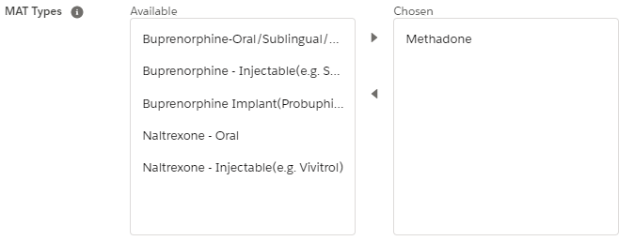

Dropdown Lists

A dropdown list allows the user to choose information from a predetermined list that “drops down” when activated. To select an item, move the mouse pointer to the appropriate item in the list and click it.

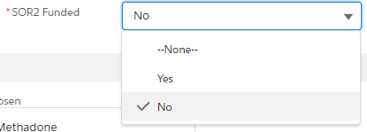

Text Boxes

Text boxes are used to record variable information, and may be either numeric or alpha-numeric, depending on the information being requested. To enter information, tab to or click into the text box and type in the data.

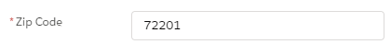

User Creation/Maintenance
Clicking the icon at the top right of the page to navigate to the Setup option will display the SETUP Home screen for users in the DHS Admin role (Fig 3.1). Once the SETUP Home screen displays, click the ‘Users’ link under the Administration header to expand and display additional options. Click the ‘Users’ link in the expanded menu option(Fig 3.2).

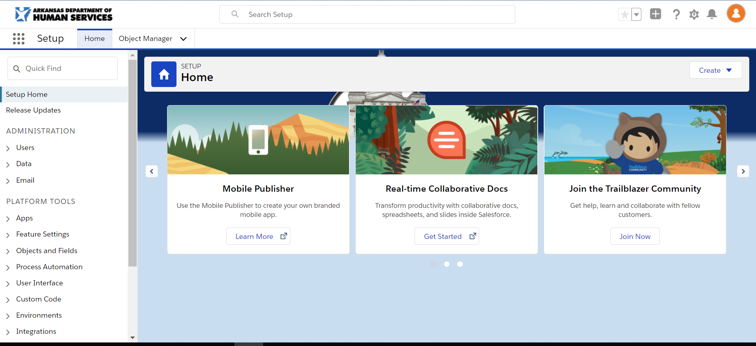 (Fig 3.1) 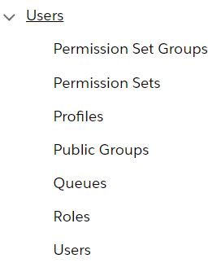(Fig 3.2)

After clicking the Users link, the Active Users screen will display the list of users that have been given access to the GovCONNECT Case Management System - ADMIS system (Fig 3.3). Select the button to create a new user and set the user’s role for the system. The New User screen will display (Fig 3.4).

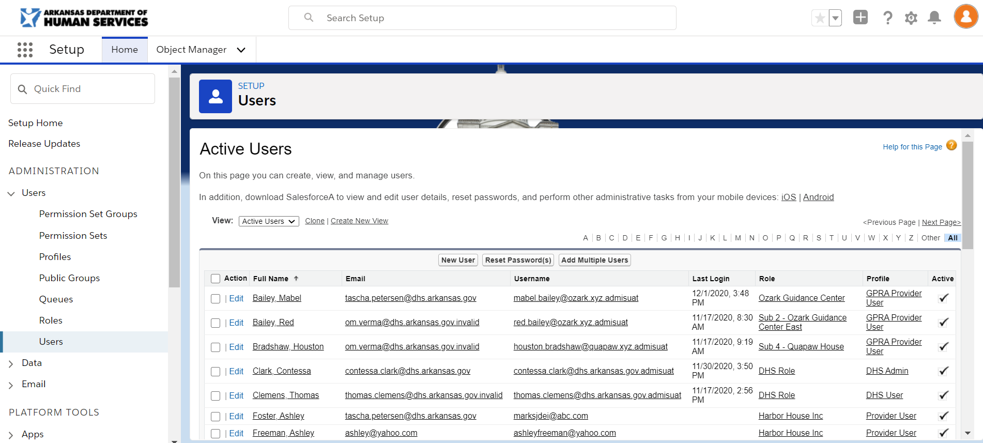(Fig 3.3) 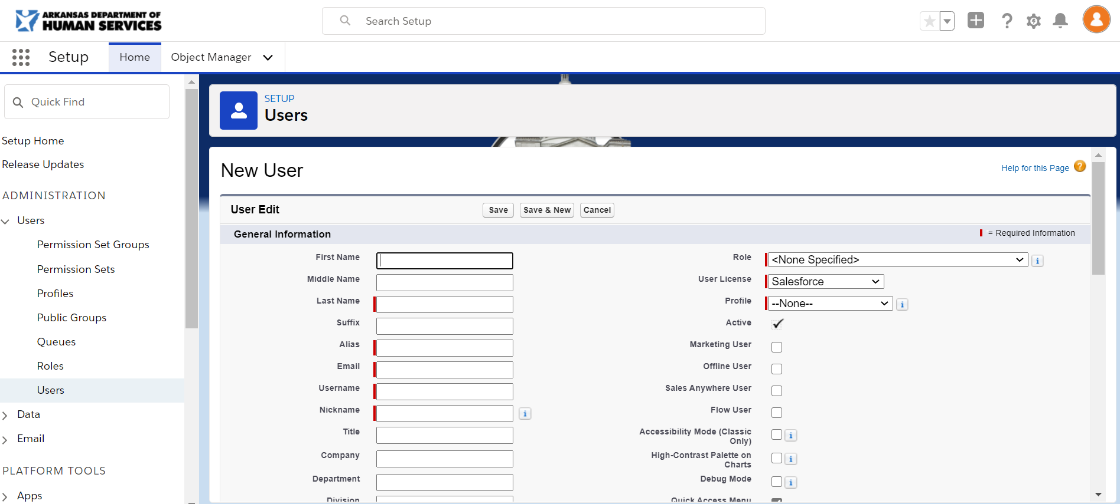(Fig 3.4)

The screens will require users to enter values in fields that are identified with a red bar . After completing required entries, clicking the 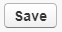 button will complete the user setup. You will be navigated back to the Active Users screen. The new user will display in the list.

Clicking the action on the Active Users screen will display the User Edit screen allowing you to update a user’s information or reset a user’s password (Fig 3.5). Clicking a field will all you to change previous entered information and checking the checkbox will reset a user’s password.

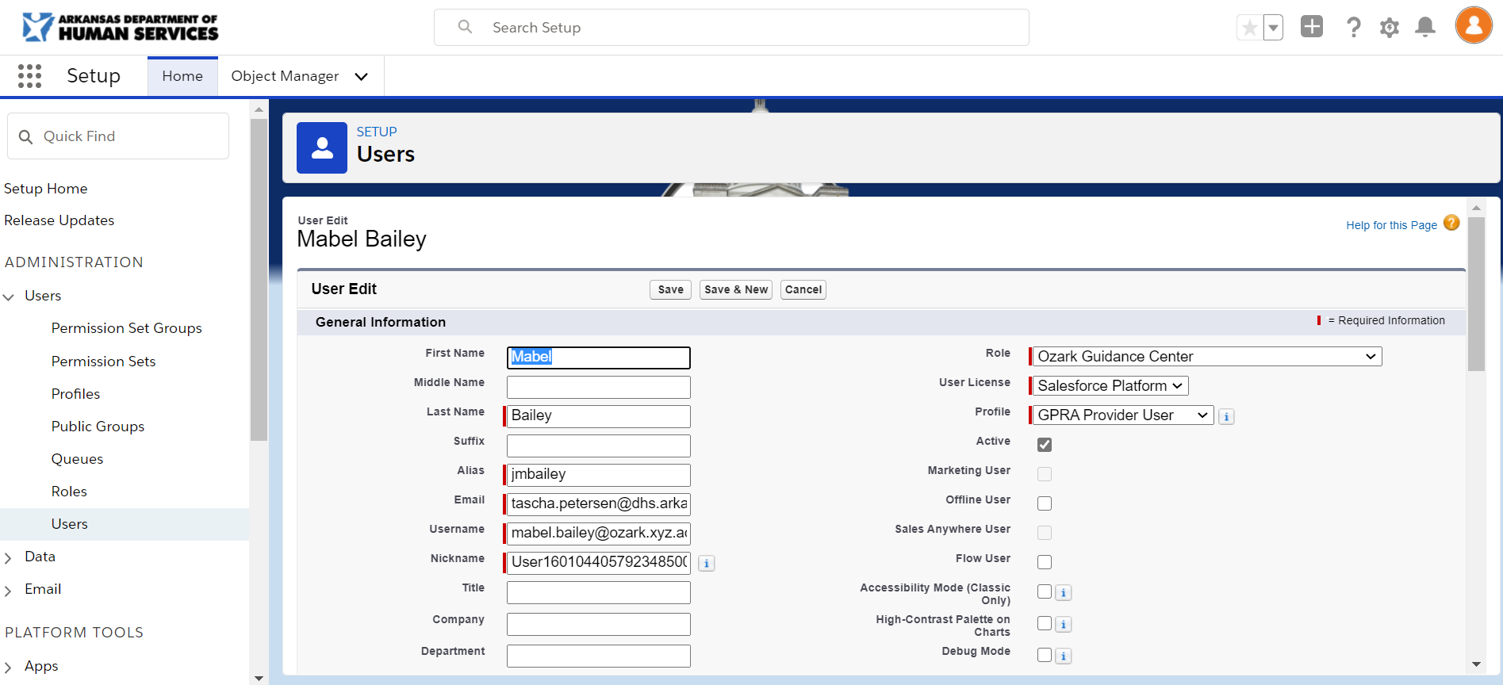 (Fig 3.5)

You have the ability to discard changes and quite editing or creating a user by clicking the 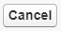 button. All data entered will not be saved and will navigate you back to the Active Users screen.

Program Creation/Maintenance
Clicking the Program Masters menu option(Fig 4.1) on the menu at the top of the screen will display a list of program masters that have been created (Fig 4.2).

Fig 4.1 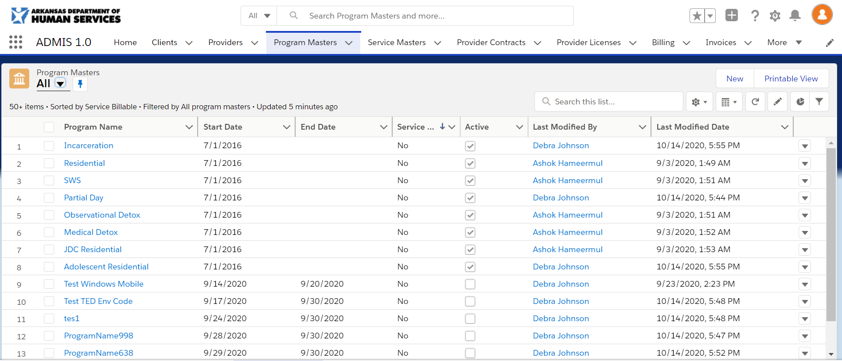 Fig 4.2

Clicking the 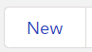 button will display the New Program Master screen (Fig 4.3). You will be required to enter values for required fields identified with to the left of the field name. Clicking the button will save the screen changes. If you fail to complete entering in required data, the screen will display a list of fields that need reviewing and the fields will be outlined in red with a message to complete this field (Fig 4.4). After completing entries for required fields and clicking the save button again, you will return to the Program Masters screen and the new record will display in the list.

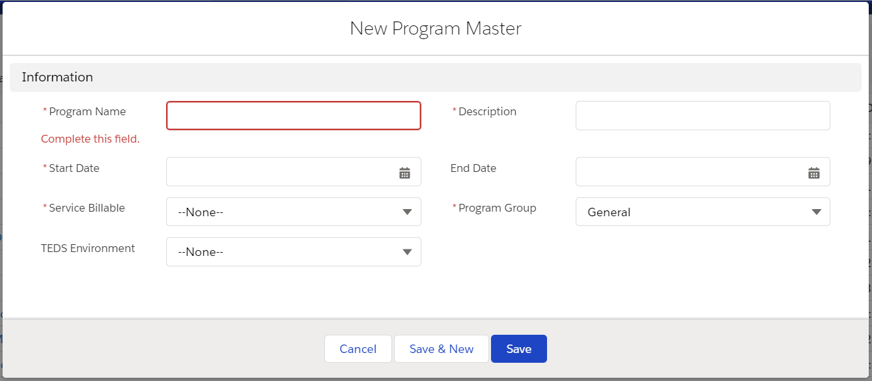 Fig 4.3 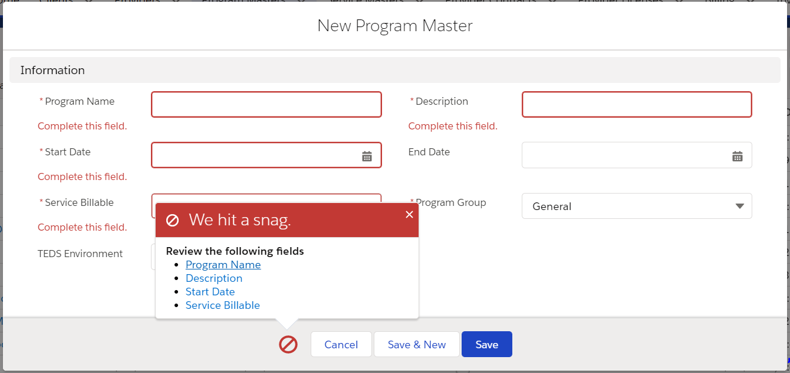 Fig 4.4

To view additional details for rows in the Program Masters screen, click the program name on the row you wish to view. The Program Details screen (Fig 4.5) will display. You can Edit the details by clicking the 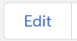 button located at the top right of the screen. The Edit [Program Master Name] screen (Fig 4.6) will display and require the same fields denoted in Fig 4.4.

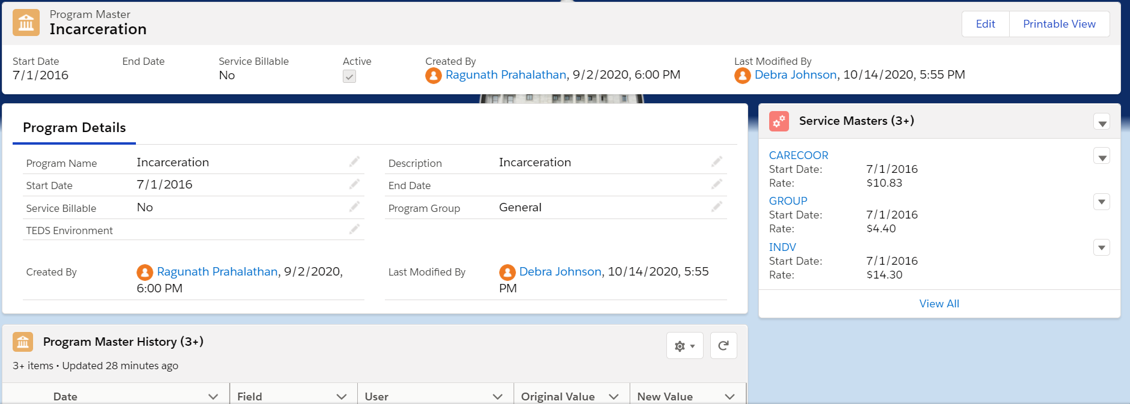Fig 4.5 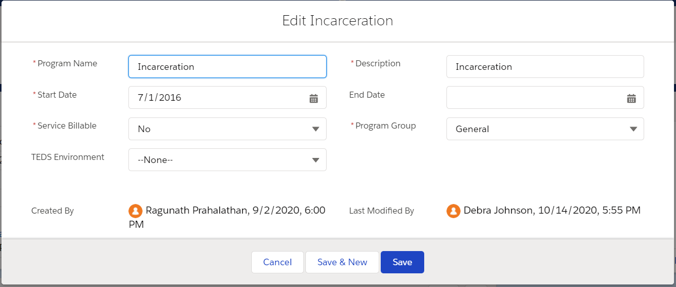Fig 4.6

The Program Details screen displays a list of last 3 service masters added (Fig 4.7) that are associated to the program master. You can add or edit the service masters by clicking the at the top of the table for New or to the right of service master name to edit. The New Service Master(Fig 4.8) or Edit [Service Masters] (Fig 4.9) screens will display to allow you to add or edit existing services masters. Clicking the 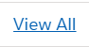 link or the 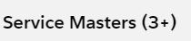 table header will display the Service Masters screen(Fig 4.10) with all associated service masters for the program master.

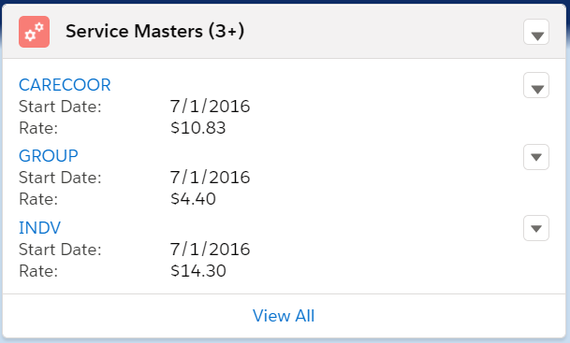Fig 4.7 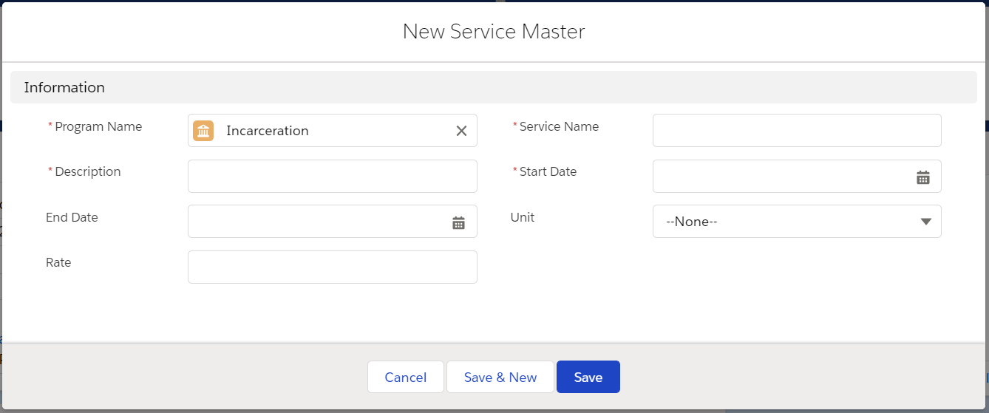Fig 4.8
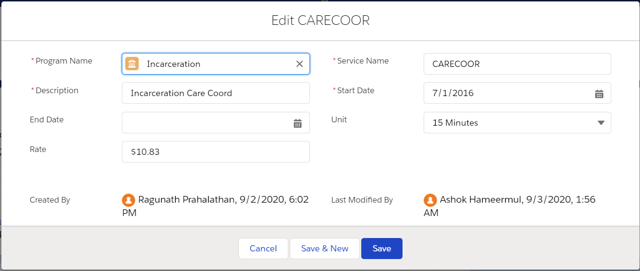Fig 4.9 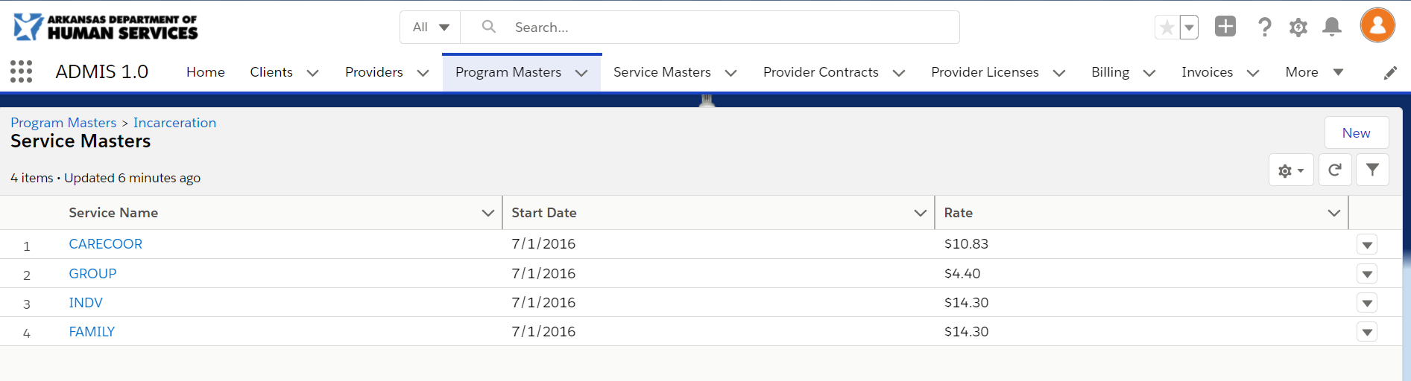Fig 4.10

A history of changes to the program master (Fig 4.11) can be viewed at the bottom of the Program Detail screen. You can click the 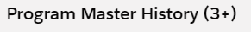 header to view a full list of history changes(Fig 4.12).

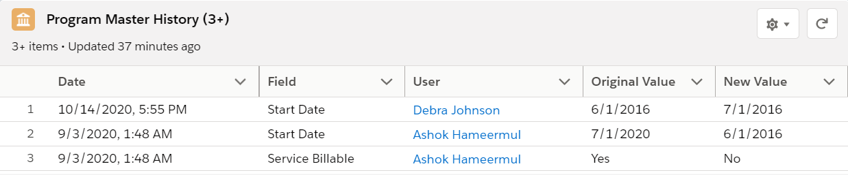Fig 4.11 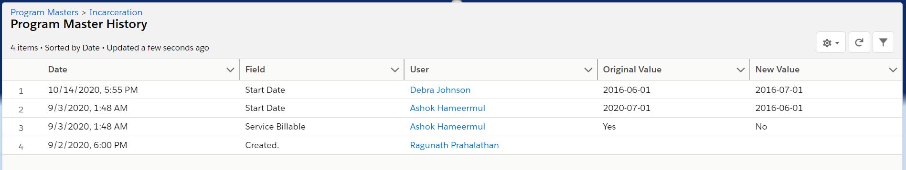Fig 4.12

Service Creation/Maintenance
Clicking the Service Masters menu option(Fig 5.1) on the menu at the top of the screen will display a list of program masters that have been created (Fig 5.2).

Fig 5.1 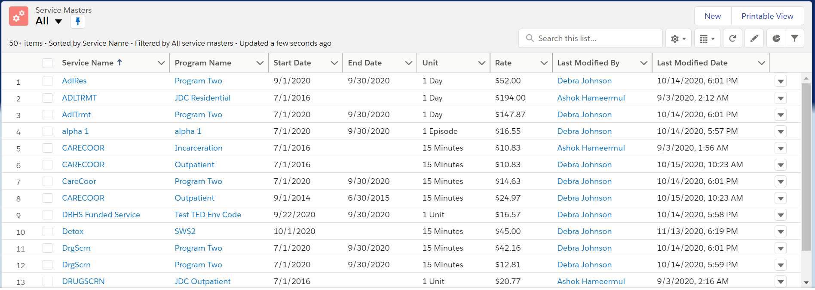 Fig 5.2

Clicking the button will display the New Service Master screen (Fig 5.3). You will be required to enter values for required fields identified with to the left of the field name. Clicking the button will save the screen changes. If you fail to complete entering in required data, the screen will display a list of fields that need reviewing and the fields will be outlined in red with a message to complete this field (Fig 5.4). After completing entries for required fields and clicking the save button again, you will return to the Service Masters screen and the new record will display in the list.

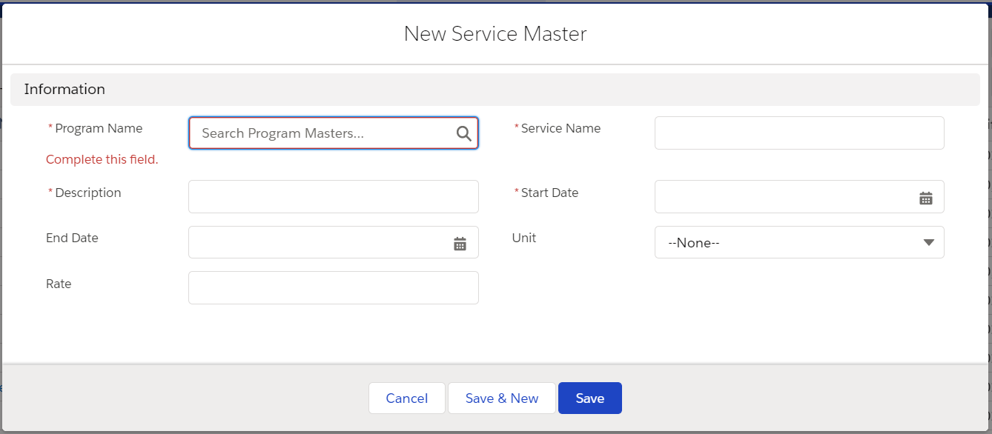 Fig 5.3 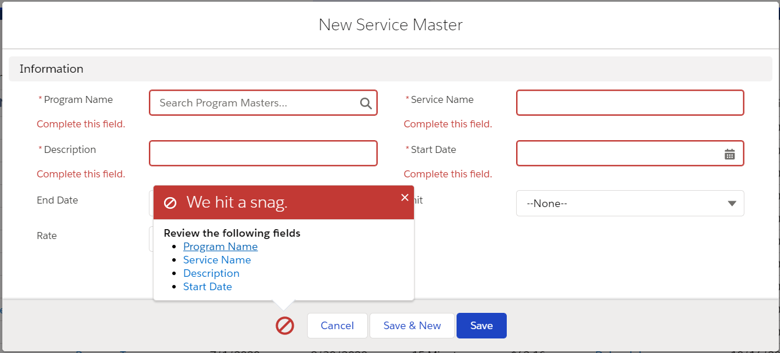 Fig 5.4

To view additional details for rows in the Service Masters screen, click the service name on the row you wish to view. The Service Details screen (Fig 5.5) will display. You can Edit the details by clicking the button located at the top right of the screen. The Edit [Service Master Name] screen (Fig 5.6) will display and require the same fields denoted in Fig 5.4.

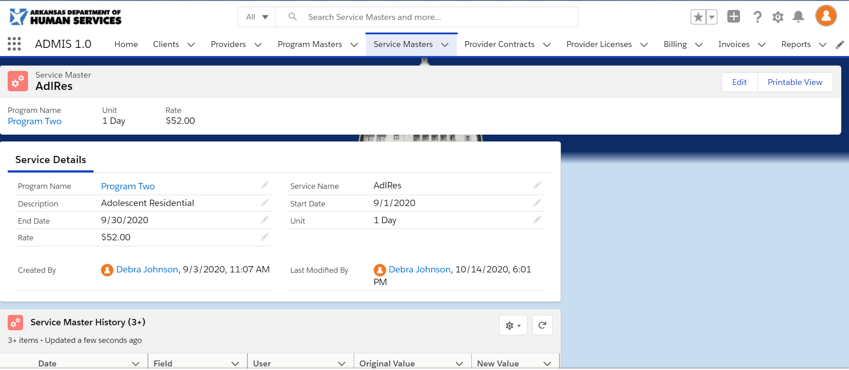 Fig 5.5 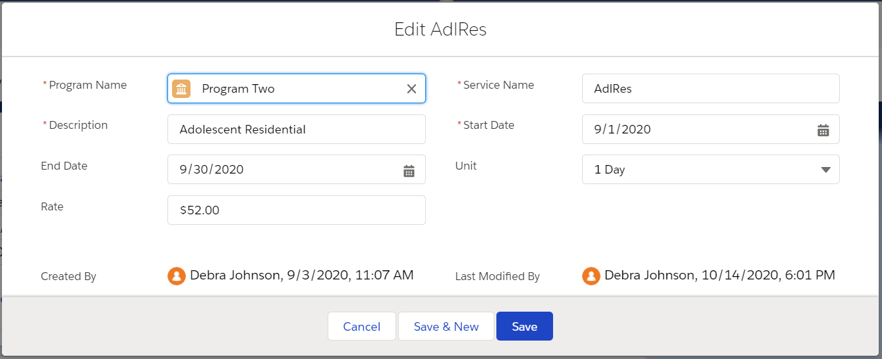 Fig 5.6

A history of changes to the service master (Fig 5.7) can be viewed at the bottom of the Service Detail screen. You can click the 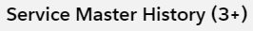 header to view a full list of history changes(Fig 5.8).

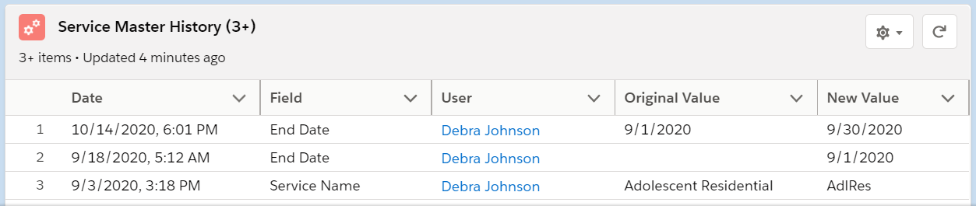Fig 5.7 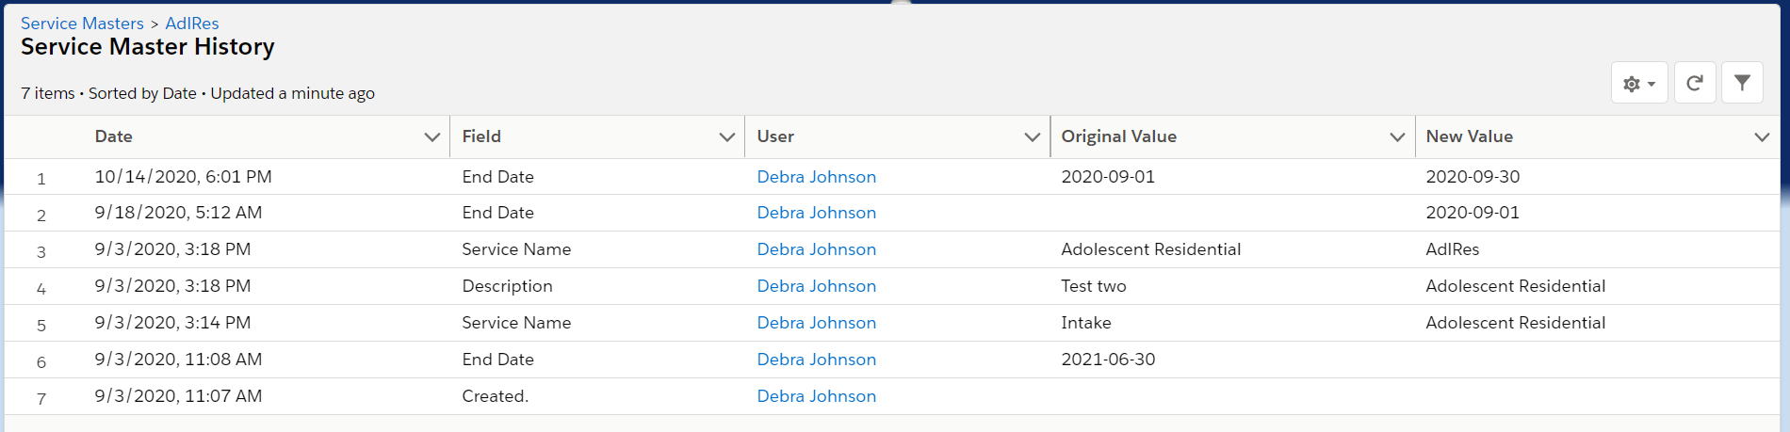Fig 5.8

Provider Creation/Maintenance
Clicking the Providers menu option(Fig 6.1) on the menu at the top of the screen will display a list of providers that have been created (Fig 6.2).

Fig 6.1 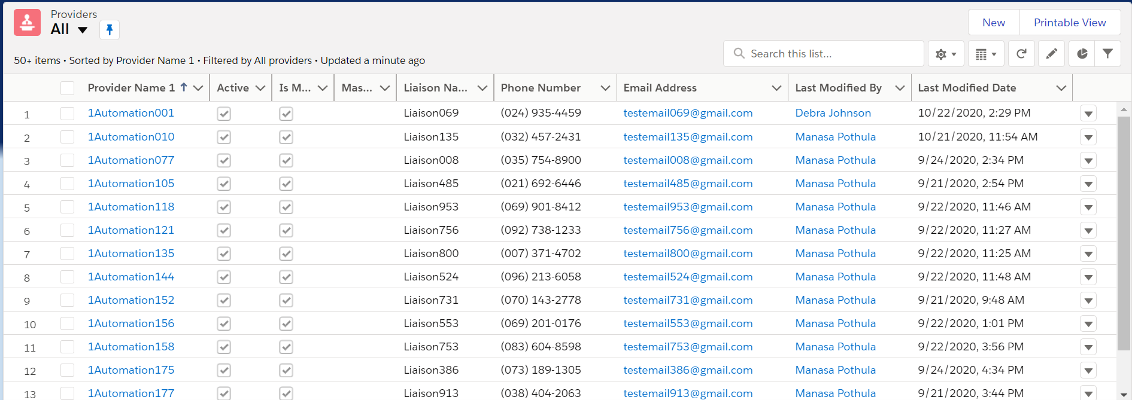 Fig 6.2

Clicking the button will display the New Provider screen (Fig 6.3). You will be required to enter values for required fields identified with to the left of the field name. Clicking the button will save the screen changes. If you fail to complete entering in required data, the screen will display a list of fields that need reviewing and the fields will be outlined in red with a message to complete this field (Fig 6.4). After completing entries for required fields and clicking the save button again, you will return to the Providers screen and the new record will display in the list.

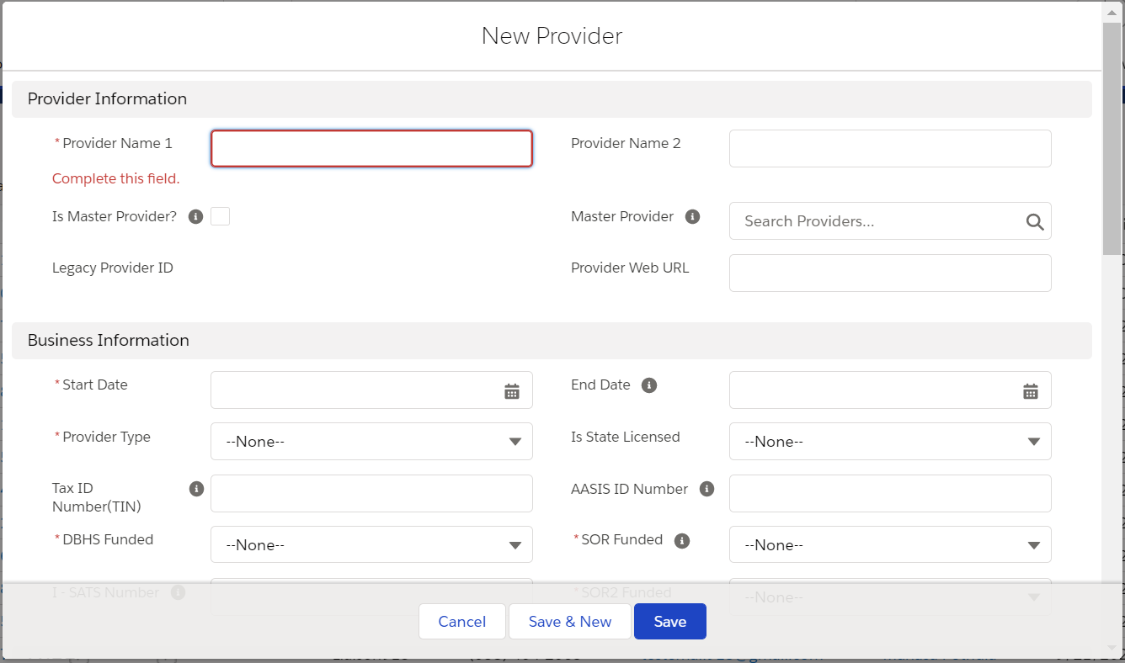 Fig 6.3 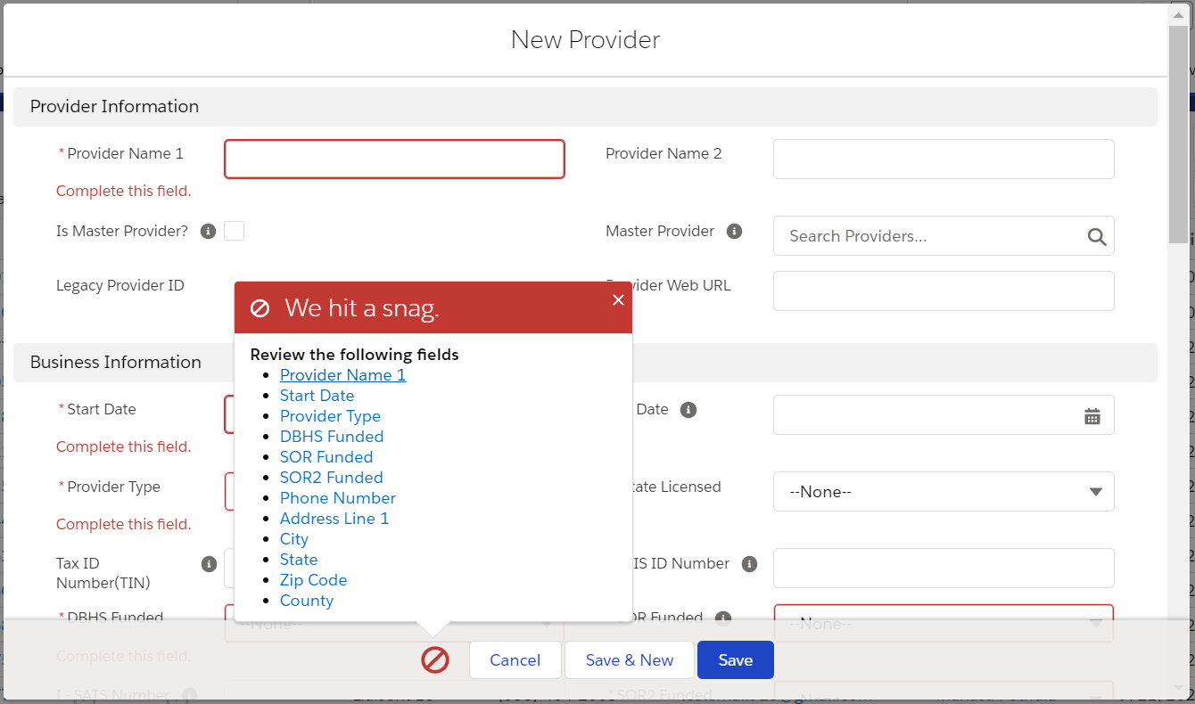 Fig 6.4

To view additional details for rows in the Providers screen, click the provider name on the row you wish to view. The Provider Details screen (Fig 6.5) will display. You can Edit the details by clicking the button located at the top right of the screen. The Edit [Provider Name] screen (Fig 6.6) will display and require the same fields denoted in Fig 6.4.

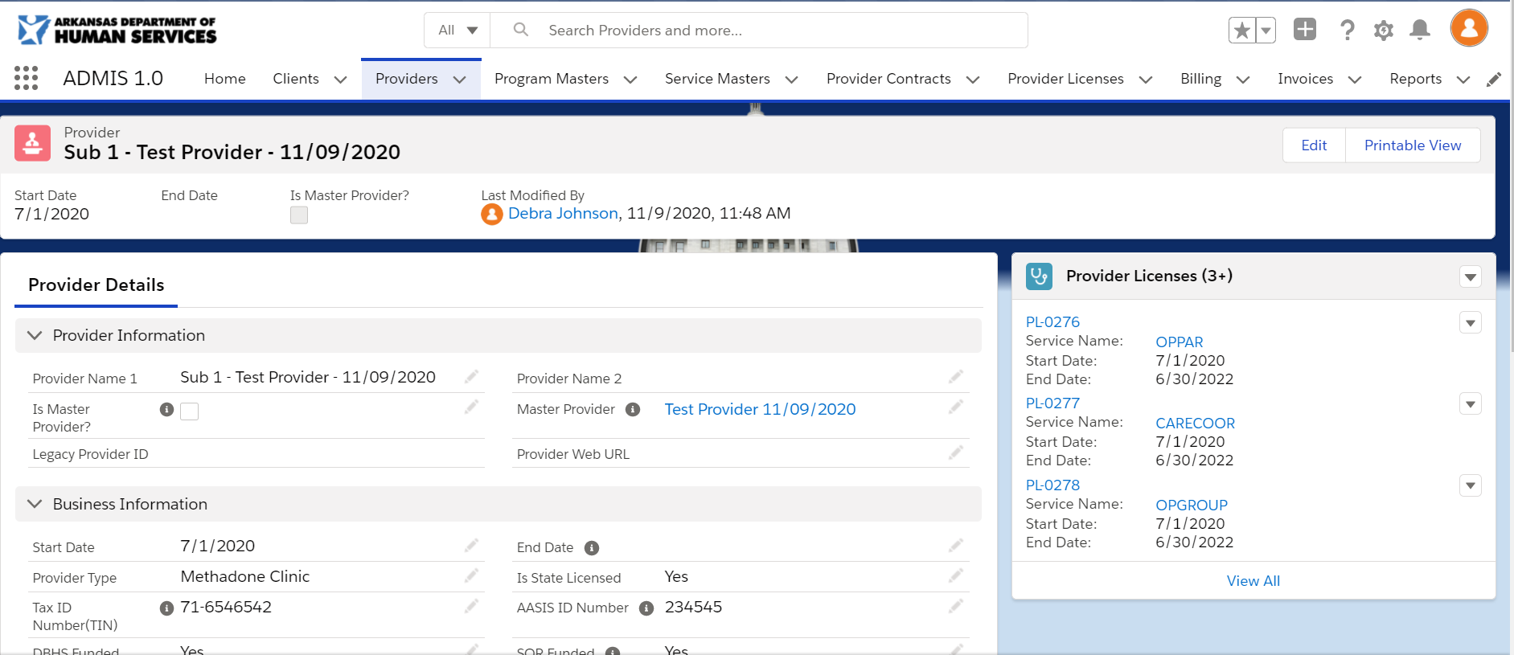Fig 6.5 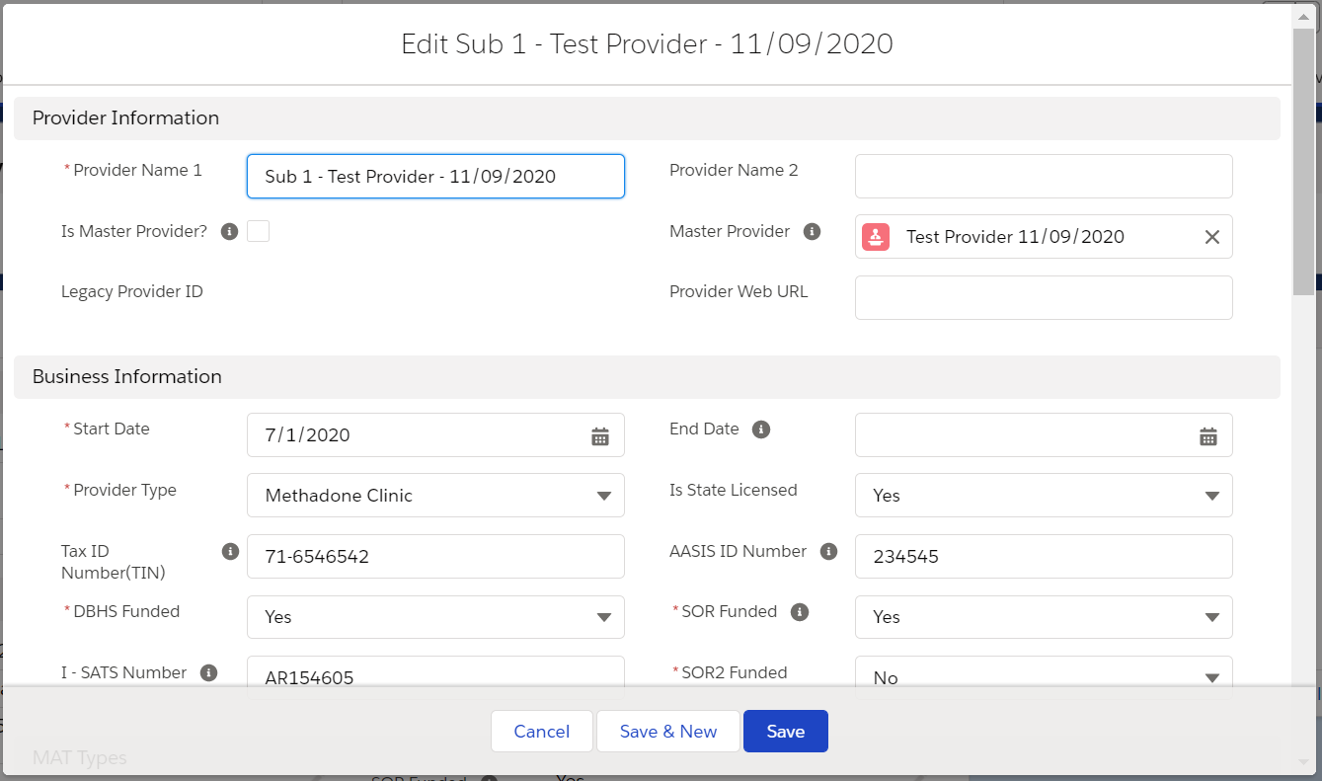 Fig 6.6

The Provider Details screen displays a list of last 3 service masters added (Fig 6.7) that are associated to the program master. You can add or edit the Licenses by clicking the at the top of the table for New or to the right of license name to edit. The New License (Fig 6.8) or Edit [License ID] (Fig 6.9) screens will display to allow you to add or edit existing licenses. Clicking the link or the table header will display the Service Masters screen(Fig 6.10) with all associated service masters for the program master.

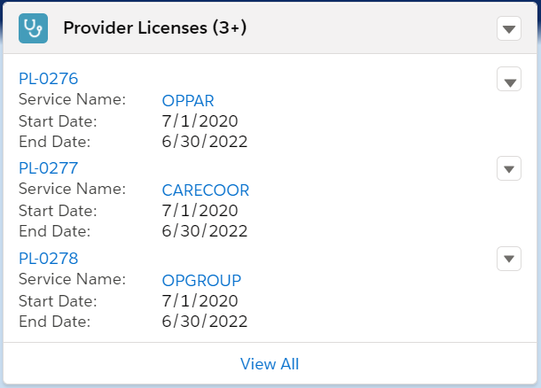 Fig 6.7 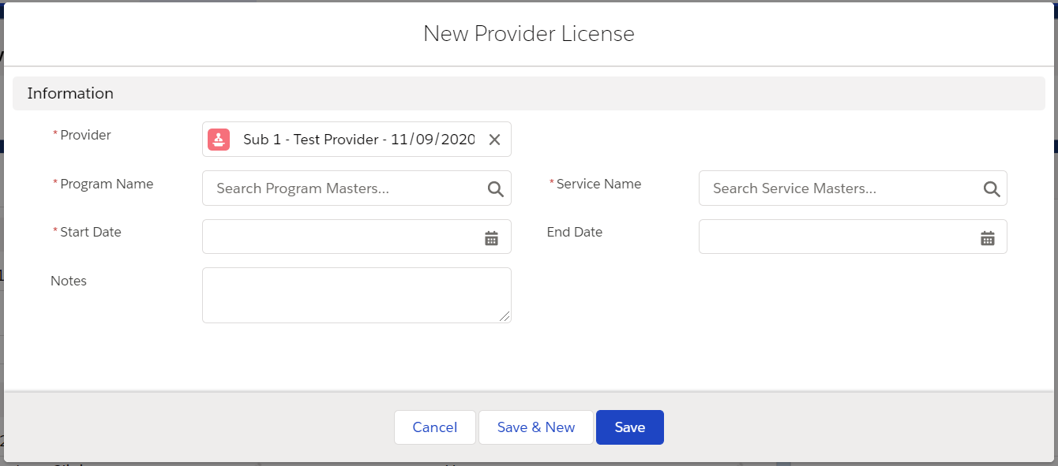 Fig 6.8
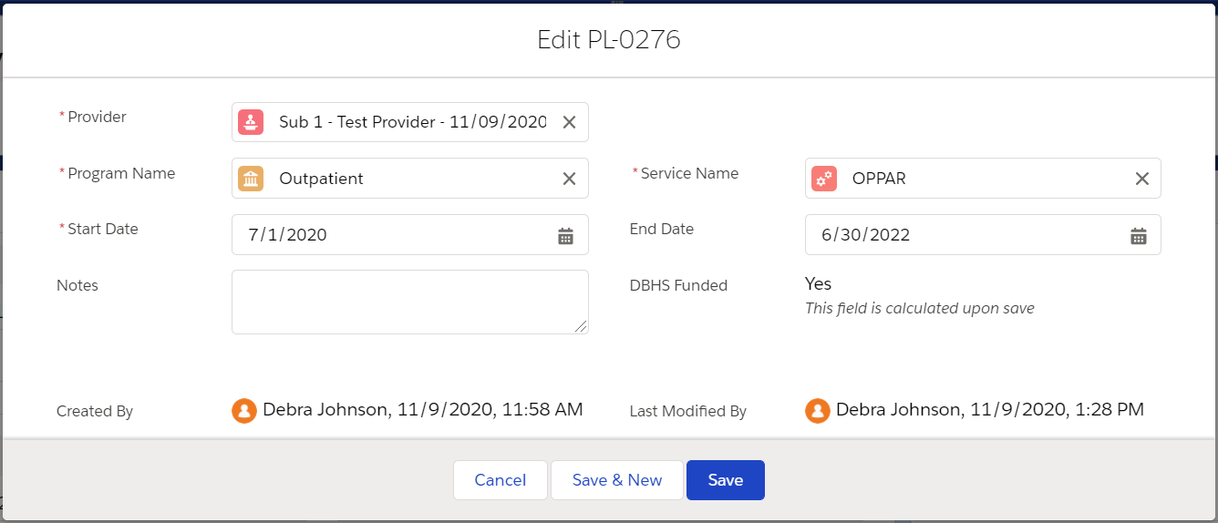 Fig 6.9 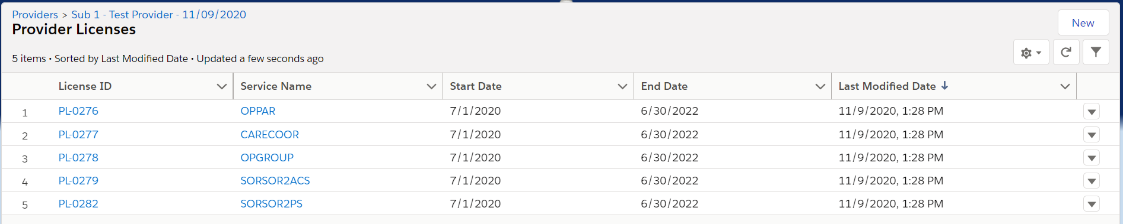 Fig 6.10

License Creation/Maintenance

Clicking the Provider Licenses menu option(Fig 7.1) on the menu at the top of the screen will display a list of provider licenses that have been created (Fig 7.2).

Fig 7.1 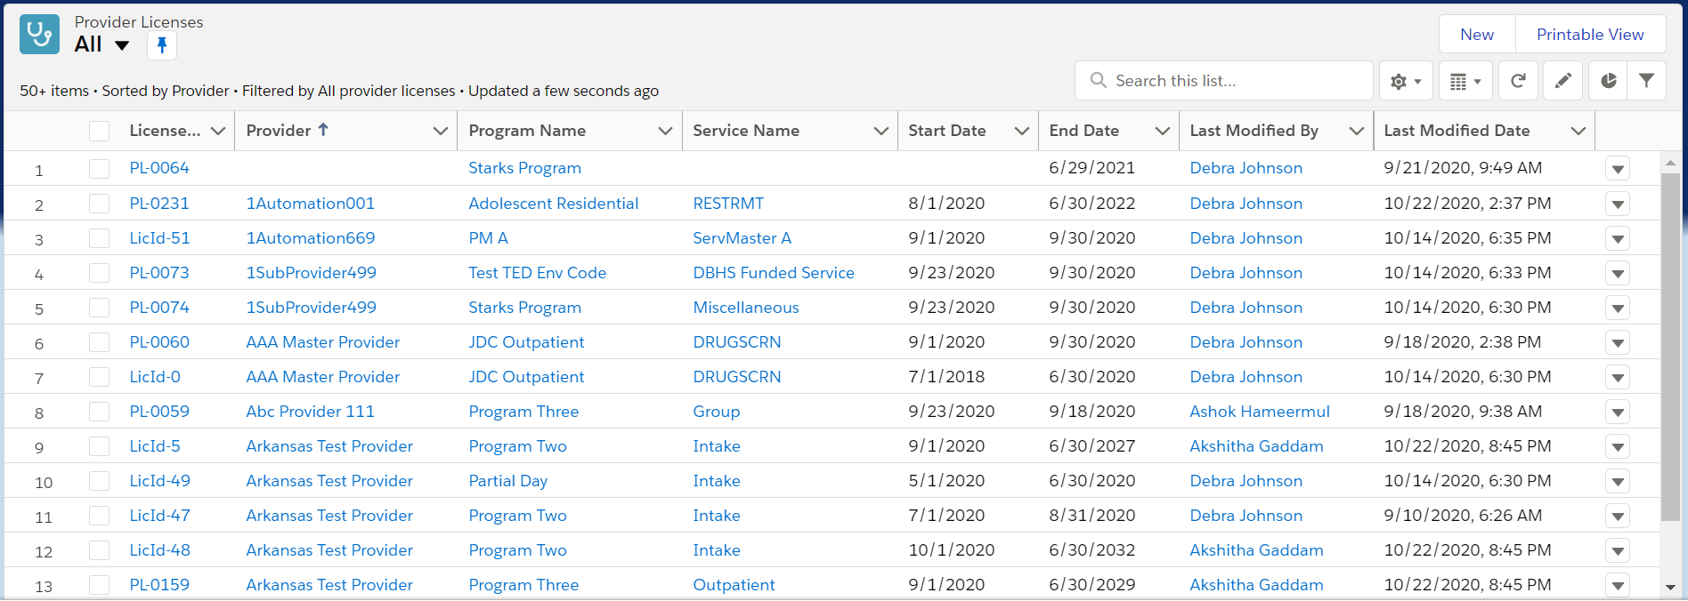 Fig 7.2

Clicking the button will display the New Provider License screen (Fig 7.3). You will be required to enter values for required fields identified with to the left of the field name. Clicking the button will save the screen changes. If you fail to complete entering in required data, the screen will display a list of fields that need reviewing and the fields will be outlined in red with a message to complete this field (Fig 7.4). After completing entries for required fields and clicking the save button again, you will return to the Provider Licenses screen and the new record will display in the list.

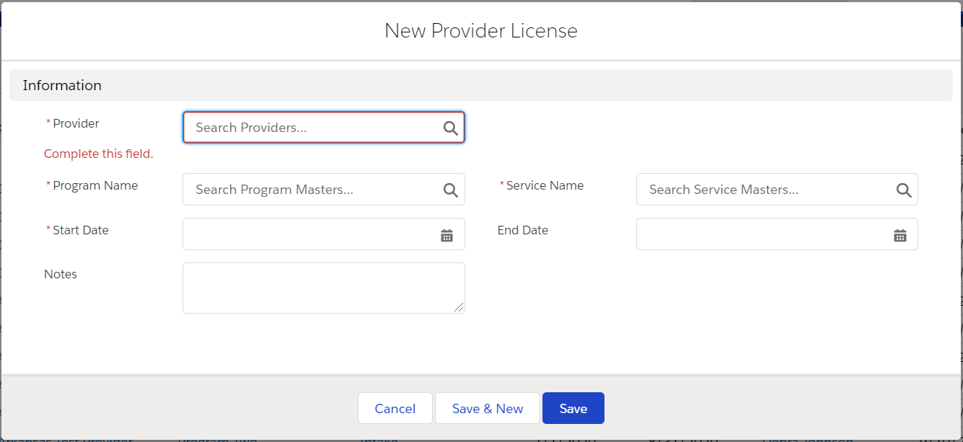 Fig 7.3 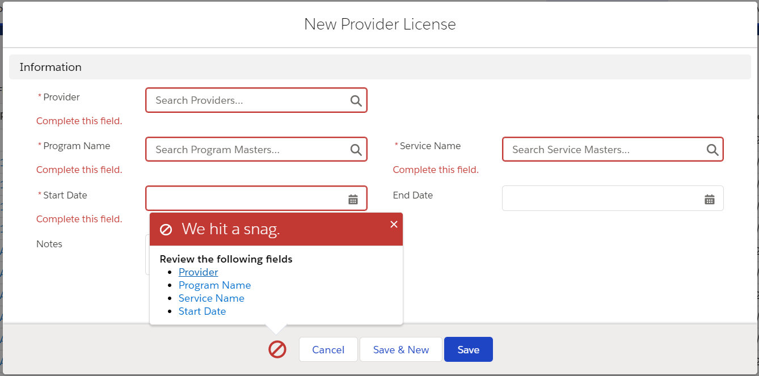 Fig 7.4

To view additional details for rows in the Provider Licenses screen, click the program name on the row you wish to view. The Program Details screen (Fig 7.5) will display. You can Edit the details by clicking the button located at the top right of the screen. The Edit [License ID] screen (Fig 7.6) will display and require the same fields denoted in Fig 7.4.

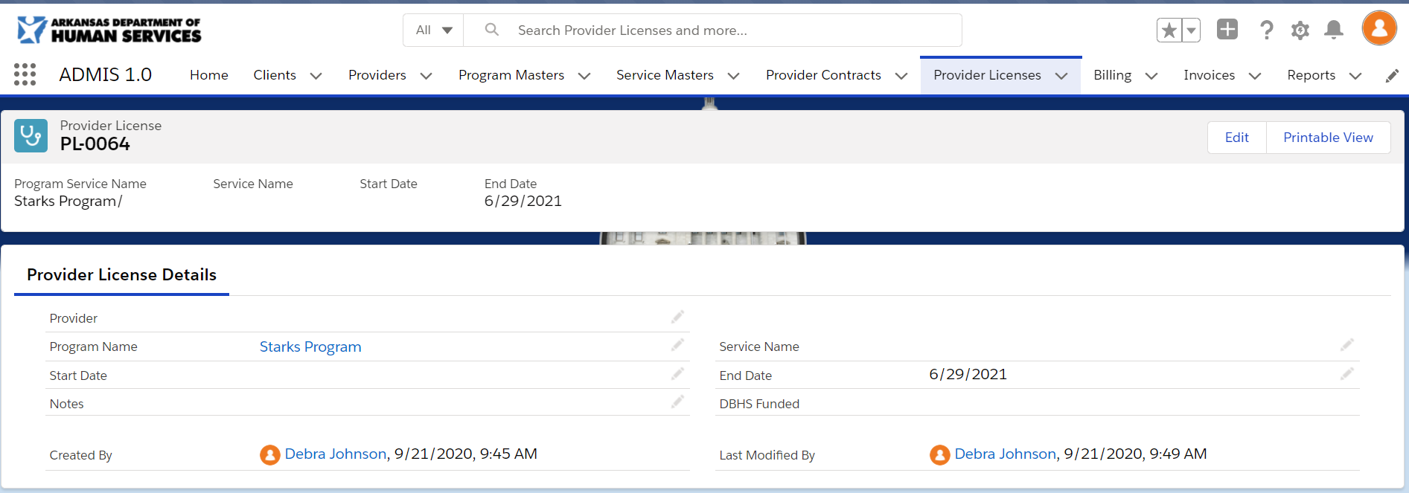 Fig 7.5 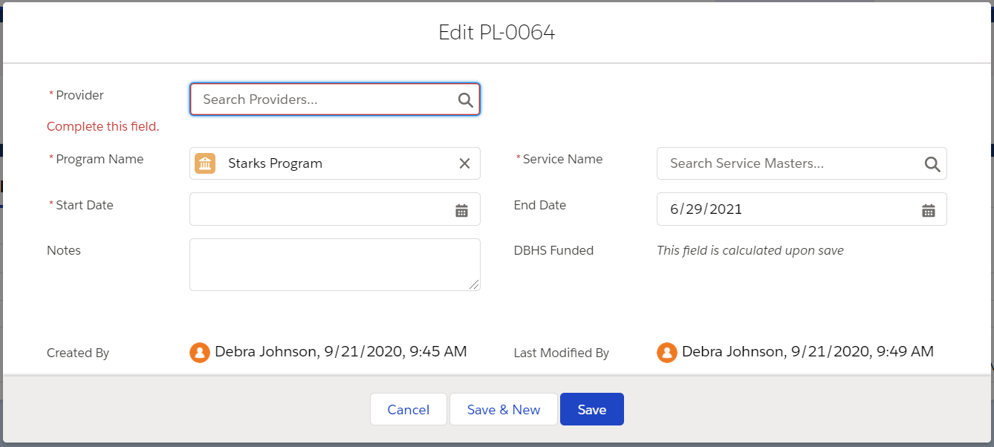 Fig 7.6

Contract Creation/Maintenance
Clicking the Provider Contracts menu option(Fig 8.1) on the menu at the top of the screen will display a list of Provider Contracts that have been created (Fig 8.2).

Fig 8.1 Fig 8.2

Clicking the button will display the New Provider Contract screen (Fig 8.3). You will be required to enter values for required fields identified with to the left of the field name. Clicking the button will save the screen changes. If you fail to complete entering in required data, the screen will display a list of fields that need reviewing and the fields will be outlined in red with a message to complete this field (Fig 8.4). After completing entries for required fields and clicking the save button again, you will return to the Provider Contracts screen and the new record will display in the list.

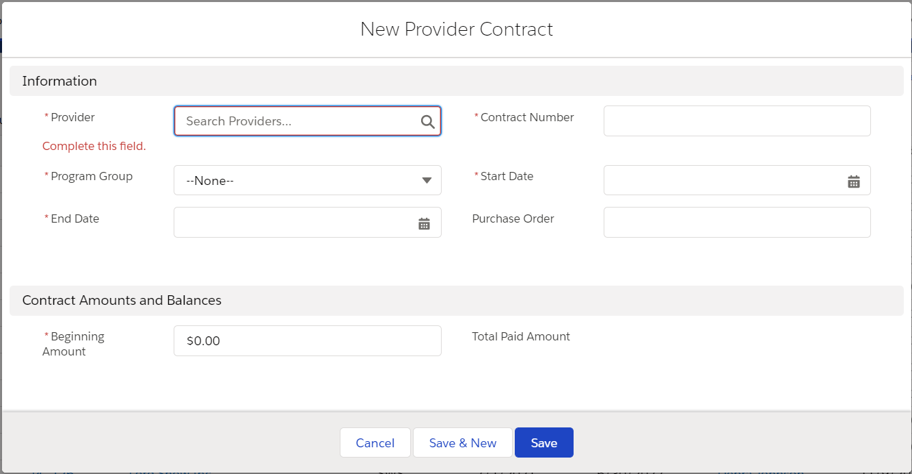 Fig 8.3 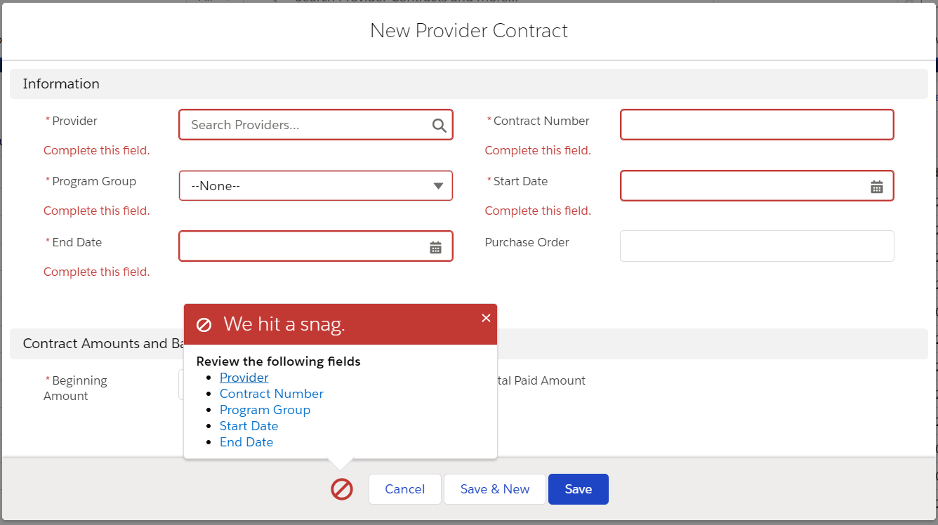Fig 8.4

To view additional details for rows in the Provider Contracts screen, click the program name on the row you wish to view. The Program Details screen (Fig 8.5) will display. You can Edit the details by clicking the button located at the top right of the screen. The Edit [Provider Contract Number] screen (Fig 8.6) will display and require the same fields denoted in Fig 8.4.

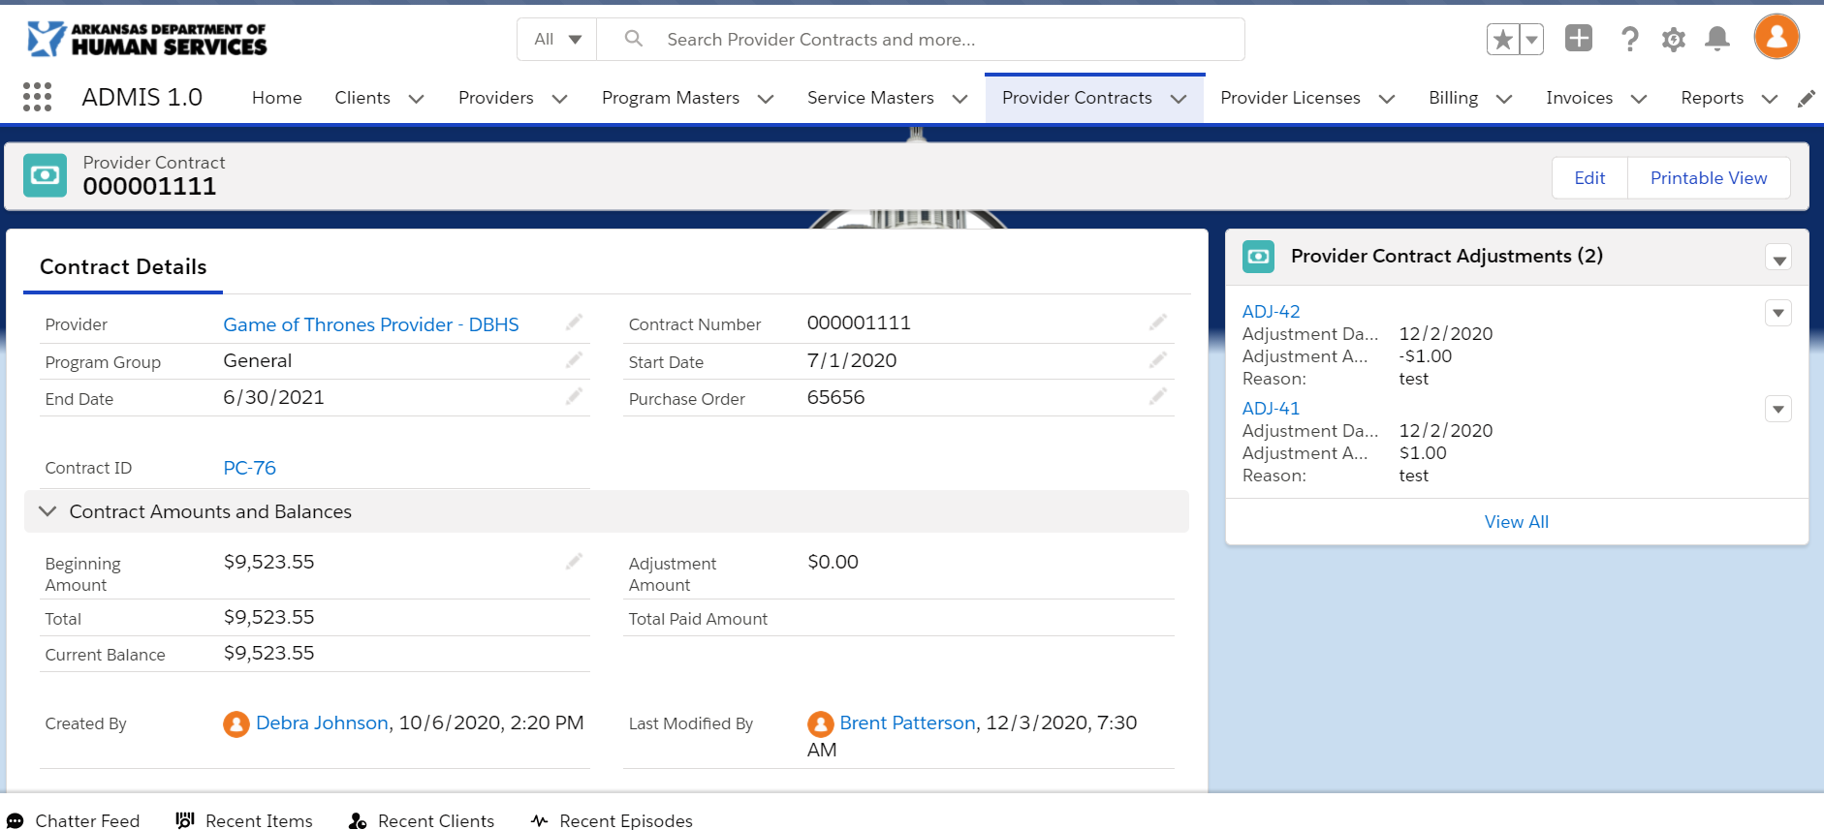Fig 8.5 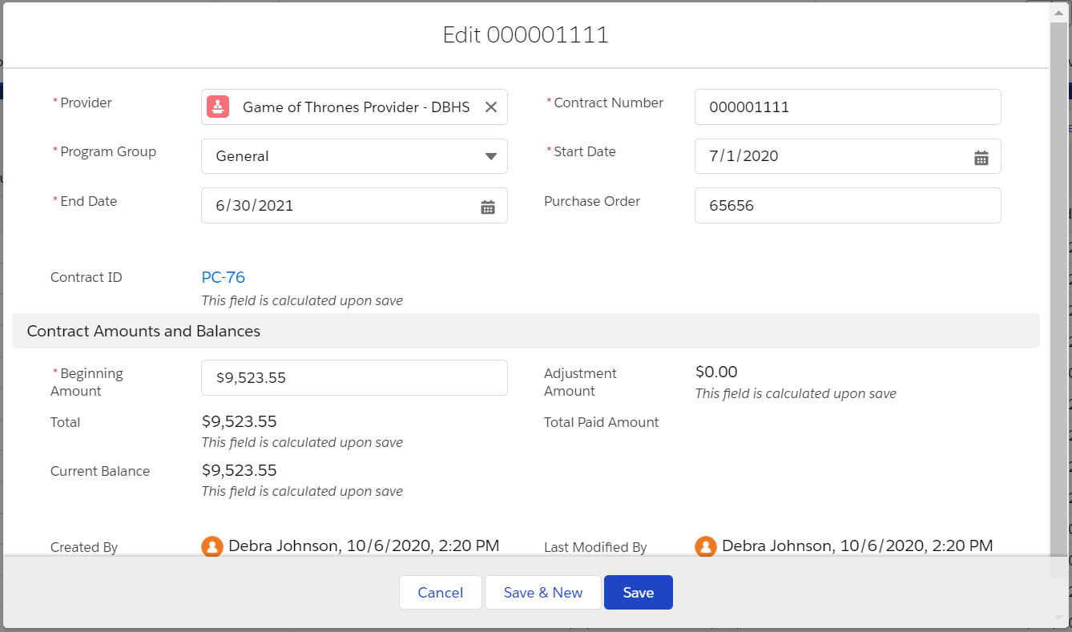Fig 8.6

The Provider Contract details screen displays a list of last 3 provider contract adjustments added (Fig 8.7) that are associated to the Provider Contract. You can add or edit the provider contract adjustments by clicking the at the top of the table for New or to the right of provider contract adjustment ID to edit. The New Provider Contract Adjustment (Fig 8.8) or Edit [provider contract adjustment] (Fig 8.9) screens will display to allow you to add or edit existing contract adjustment. Clicking the link or the table header will display the Provider Contract Adjustments screen(Fig 8.10) with all associated provider contract adjustments for the provider contract.
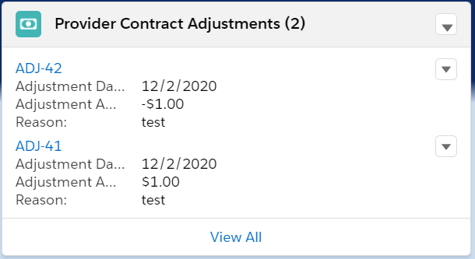 Fig 8.7 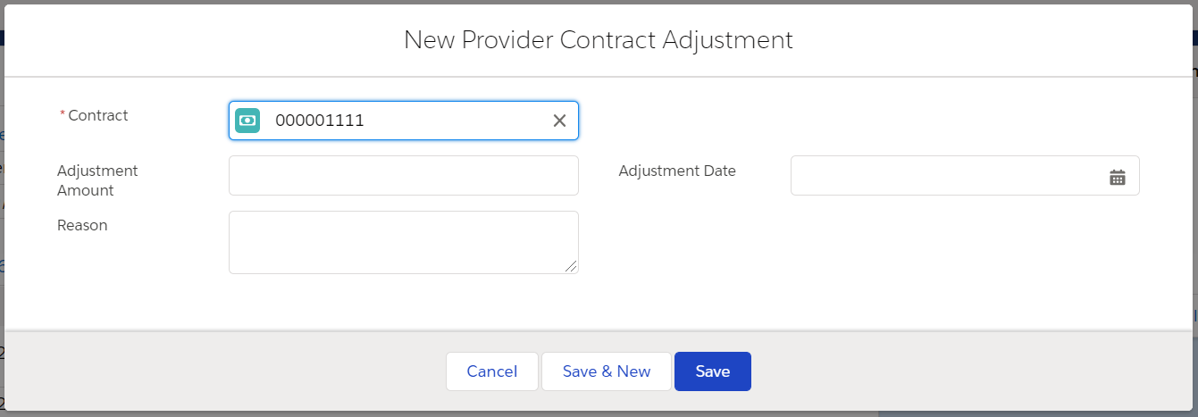 Fig 8.8 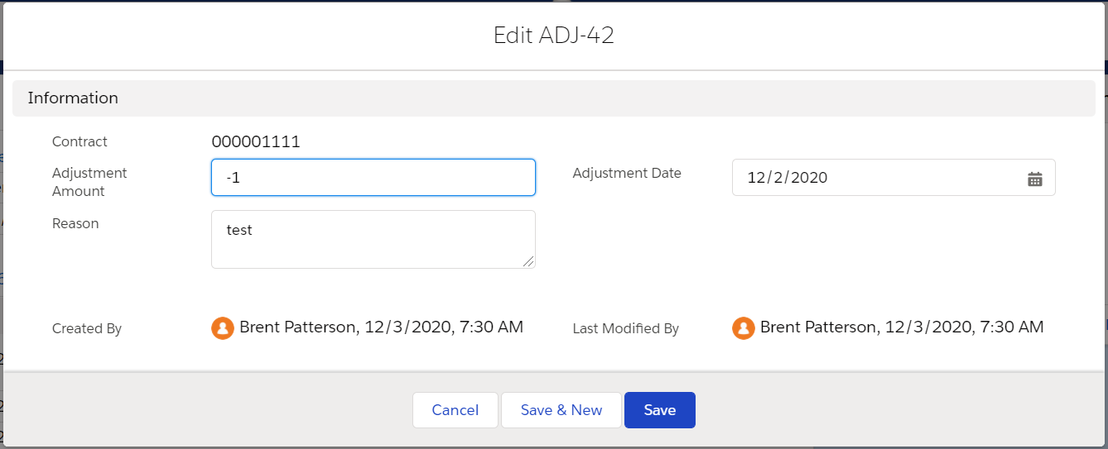 Fig 8.9 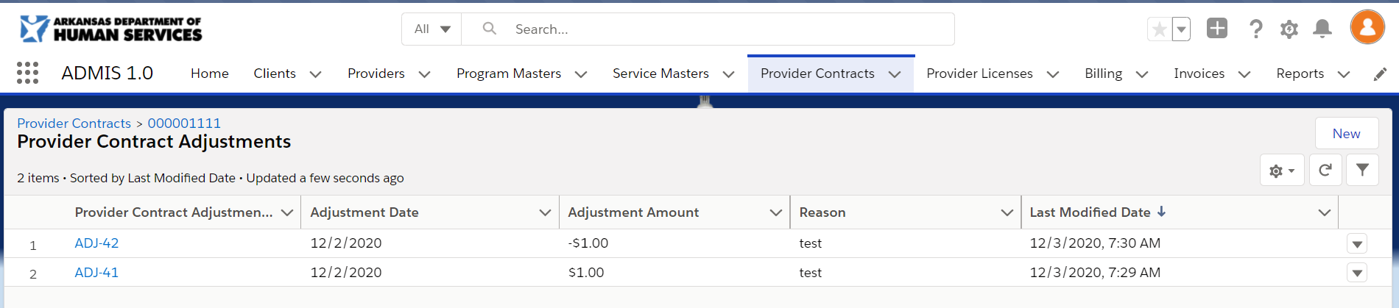 Fig 8.10

A history of changes to the Provider Contract (Fig 8.11) can be viewed at the bottom of the Provider Contract Detail screen. You can click the header to view a full list of history changes(Fig 8.12).

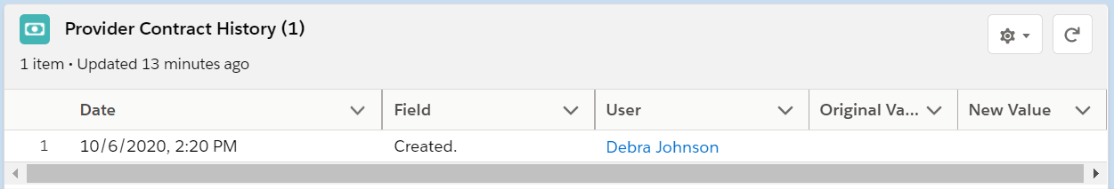 Fig 8.11 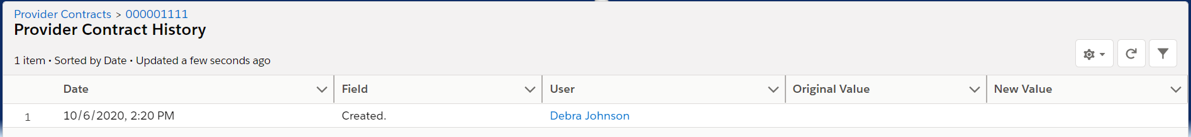 Fig 8.12

To extend a contract at the end of the state fiscal year, you will need to select the provider(s) on the Program Masters screen by clicking the on the rows for the providers or clicking the in the column headers to select all Providers. Once you have selected the providers , you will click the 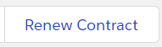 button at the top right of the screen. Clicking the button will create a new shell contract for the next state fiscal year with a 0 balance and will extend current provider license end dates to the end of the next state fiscal year.

Client Creation/Maintenance
Clicking the Clients menu option(Fig 9.1) on the menu at the top of the screen will display a list of clients that have been created (Fig 9.2).

Fig 9.1 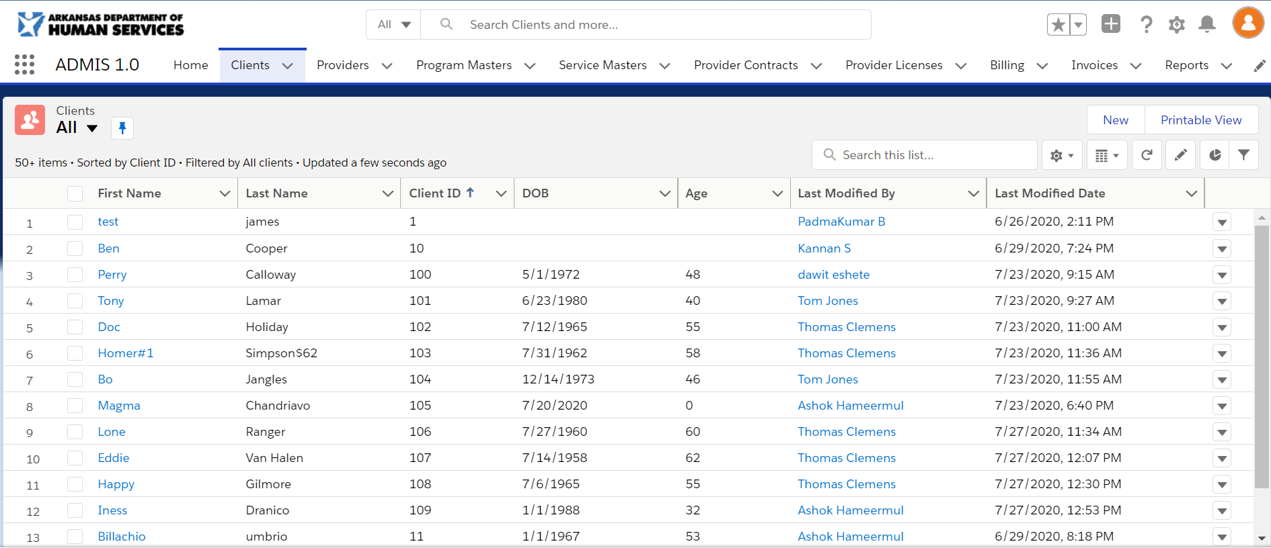 Fig 9.2

Clicking the button will display the New Client screen (Fig 9.3). You will be required to enter values for required fields identified with to the left of the field name. Clicking the button will save the screen changes. If you fail to complete entering in required data, the screen will display a list of fields that need reviewing and the fields will be outlined in red with a message to complete this field (Fig 9.4). After completing entries for required fields and clicking the save button again, you will return to the Clients screen and the new record will display in the list.

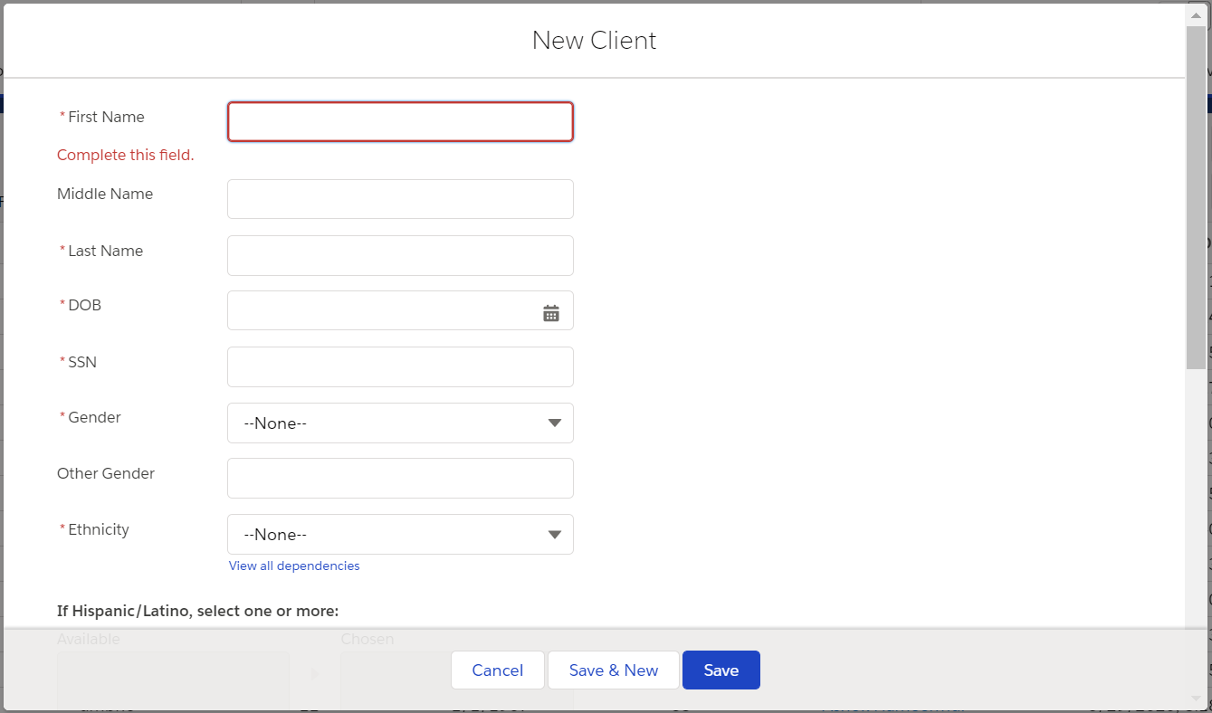 Fig 9.3 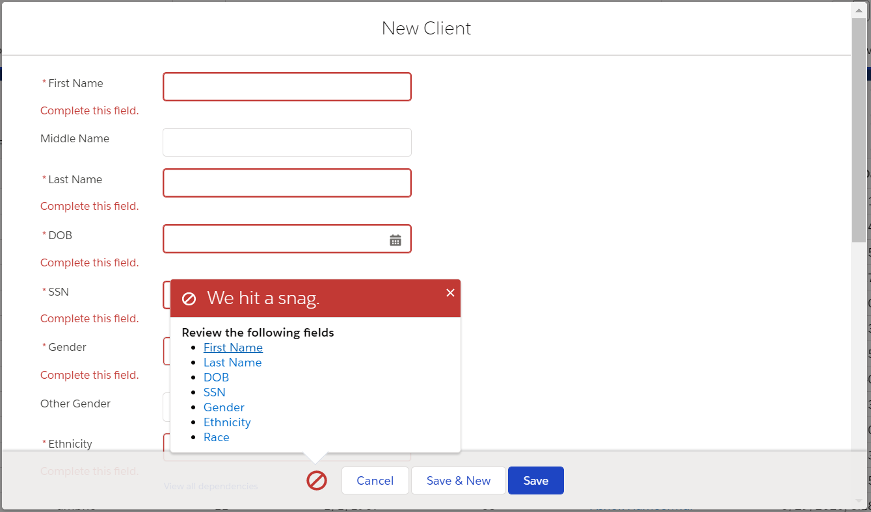 Fig 9.4

To view additional details for rows in the Clients screen, click the program name on the row you wish to view. The Program Details screen (Fig 9.5) will display. You can Edit the details by clicking the button located at the top right of the screen. The Edit [Client Name] screen (Fig 9.6) will display and require the same fields denoted in Fig 9.4.

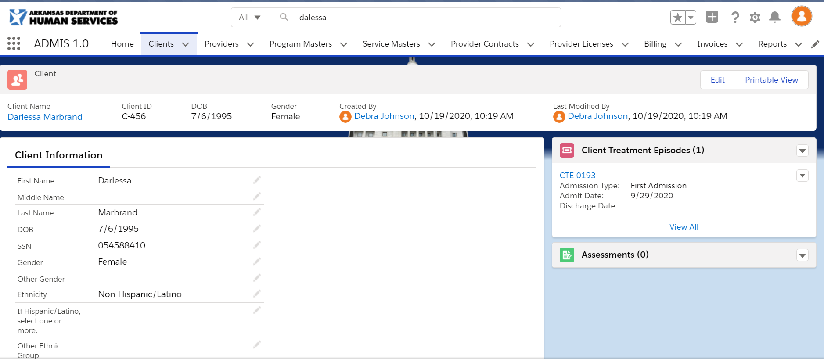 Fig 9.5 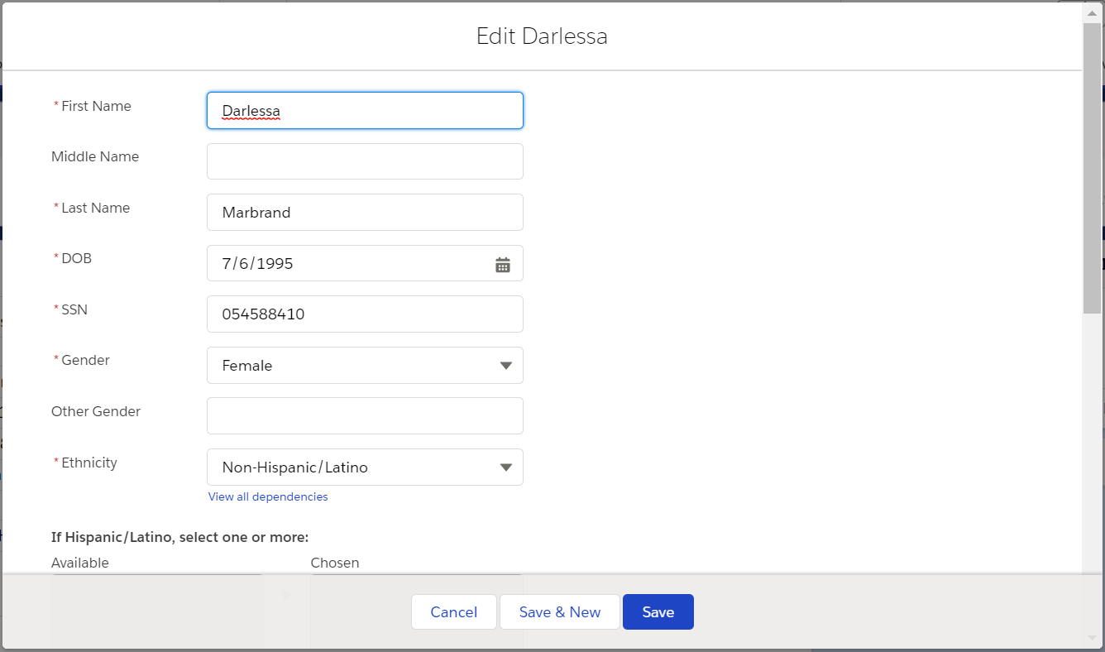 Fig 9.6

The Client details screen displays a list of last 3 client treatment episodes added (Fig 9.7) that are associated to the Client. You can add or edit the client treatment episodes by clicking the at the top of the table for New or to the right of Client Treatment Episode ID to edit. The New Client Treatment Episode (Fig 9.8) or Edit [Client Treatment Episode ID] (Fig 9.9) screens will display to allow you to add or edit existing services masters. Clicking the link or the 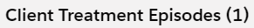 table header will display the client treatment episodes screen(Fig 9.10) with all associated client treatment episodes for the client.

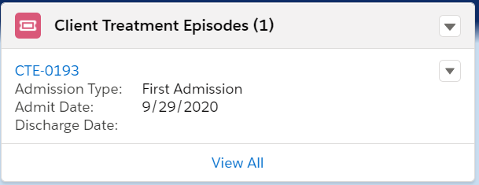 Fig 9.7 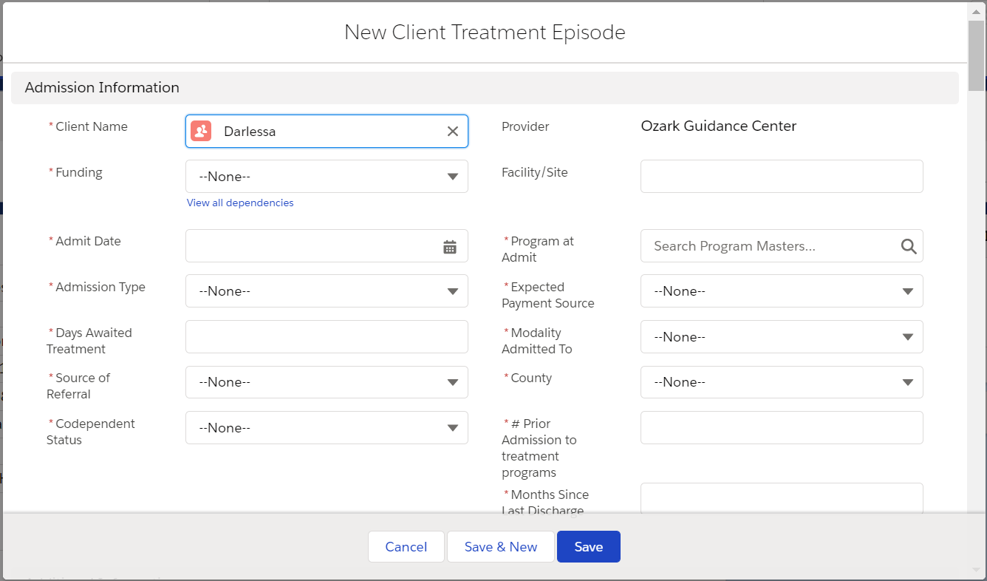 Fig 9.8
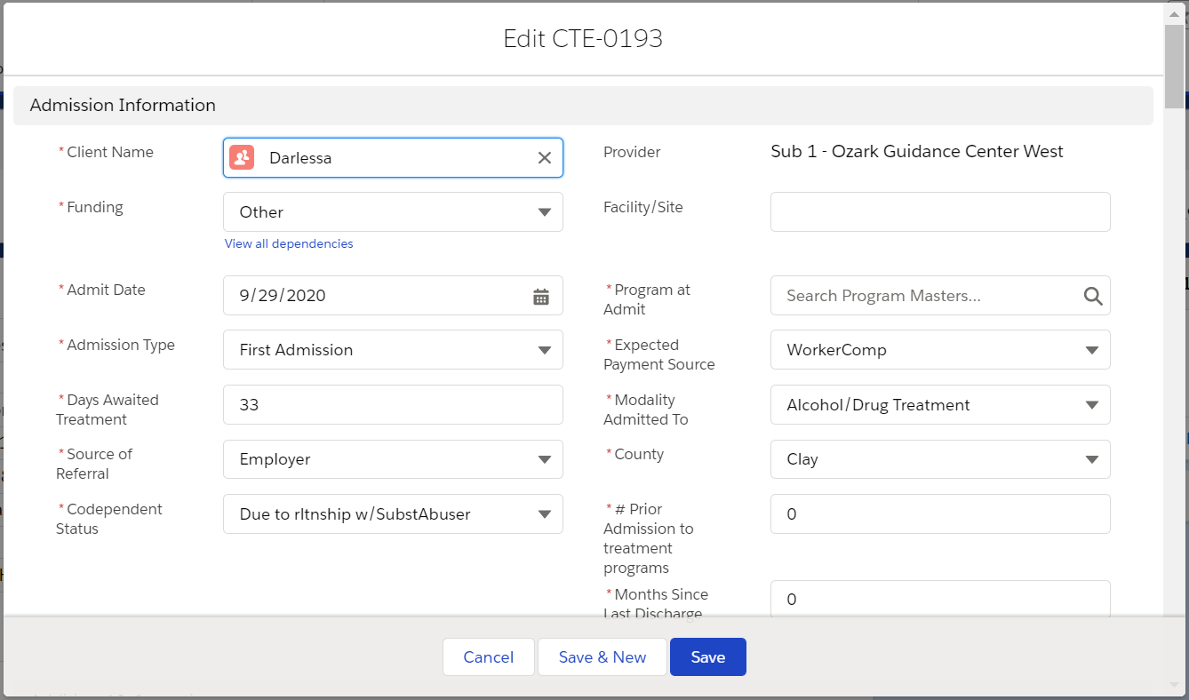 Fig 9.9 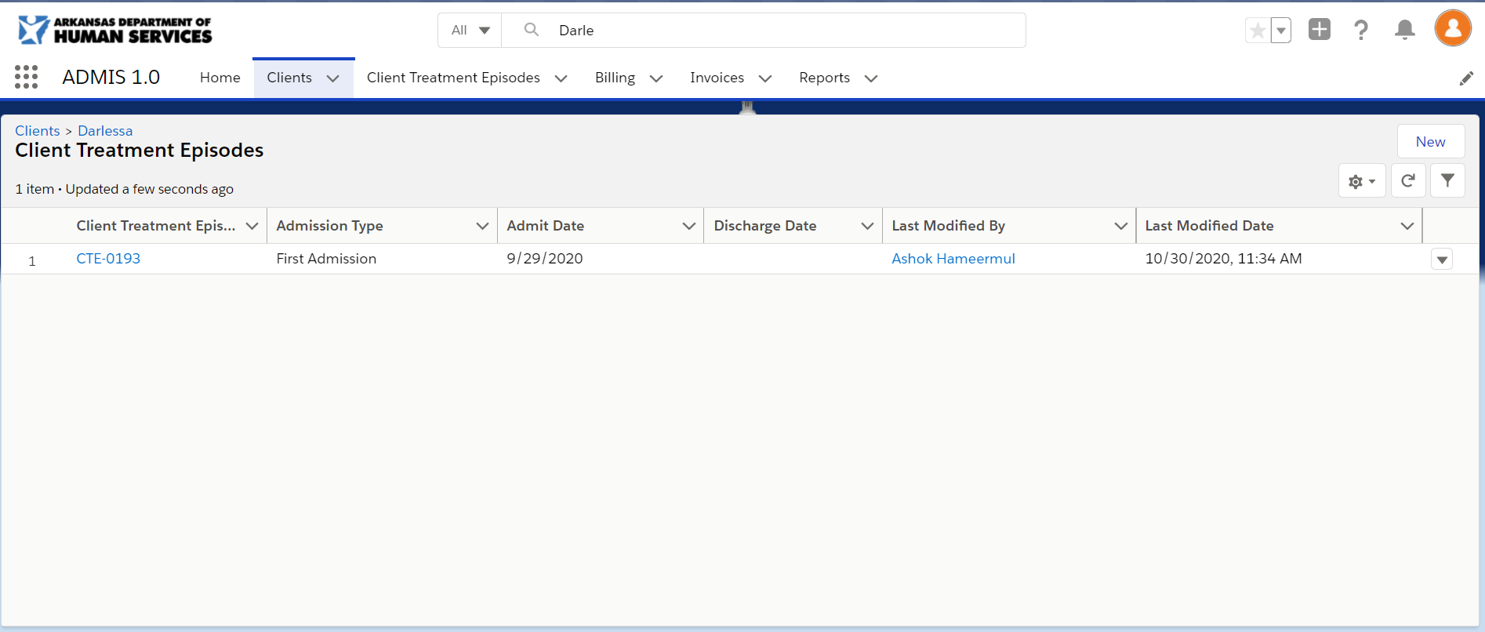 Fig 9.10

The Client details screen displays a list of last 3 assessments added (Fig 9.11) that are associated to the client. You can add or edit the assessments by clicking the at the top of the table for New or to the right of Assessment ID to edit. The New Service Master(Fig 9.12) or Edit [Assessment ID] (Fig 9.13) screens will display to allow you to add or edit existing assessment. Clicking the link or the table header will display the Assessments screen(Fig 9.14) with all associated assessments for the client.

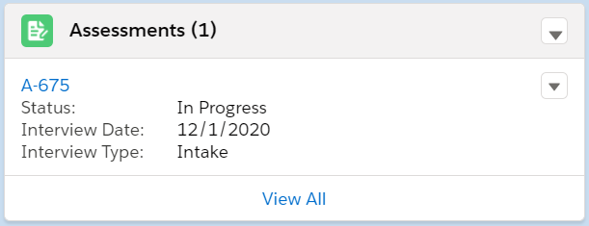 Fig 9.11 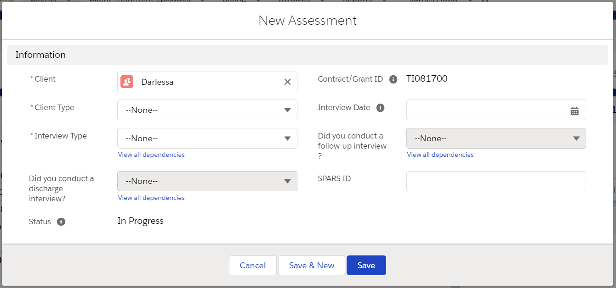 Fig 9.12 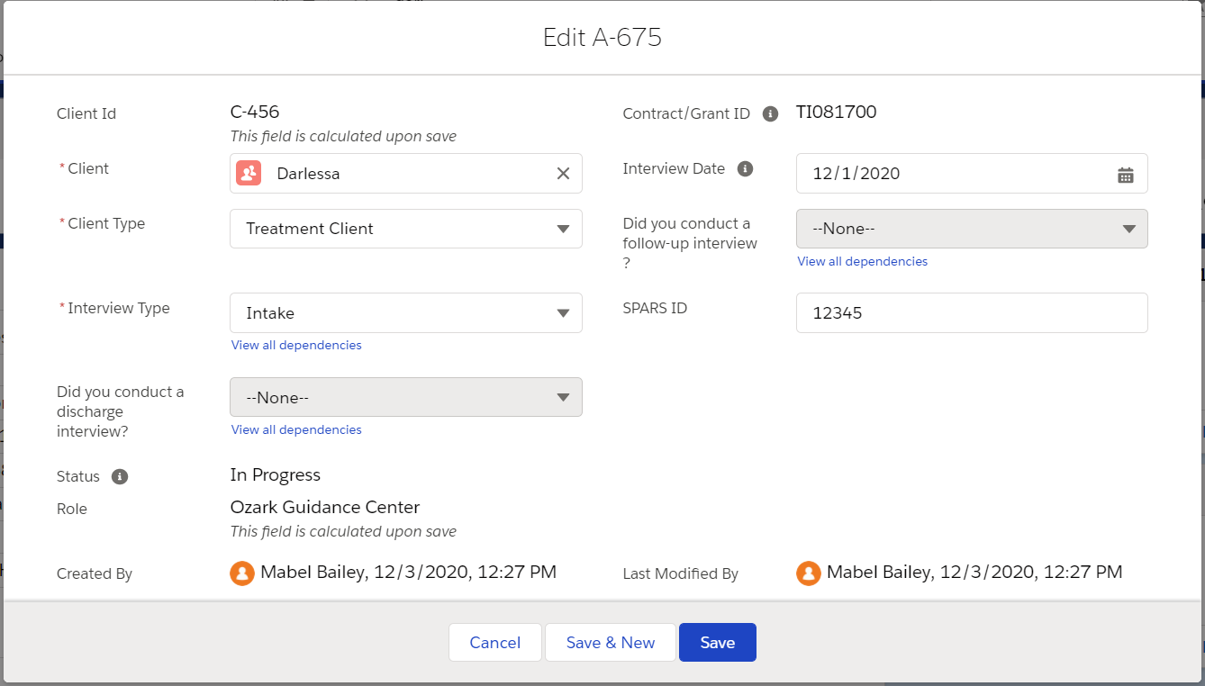 Fig 9.13 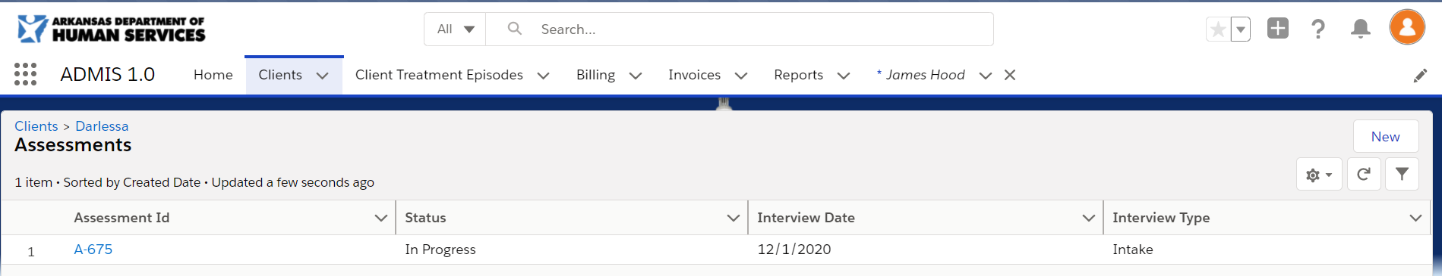 Fig 9.14

Client Treatment Episode Creation/Maintenance
Clicking the Client Treatment Episodes menu option(Fig 8.1) on the menu at the top of the screen will display a list of client treatment episodes that have been created (Fig 8.2).
Fig 10.1 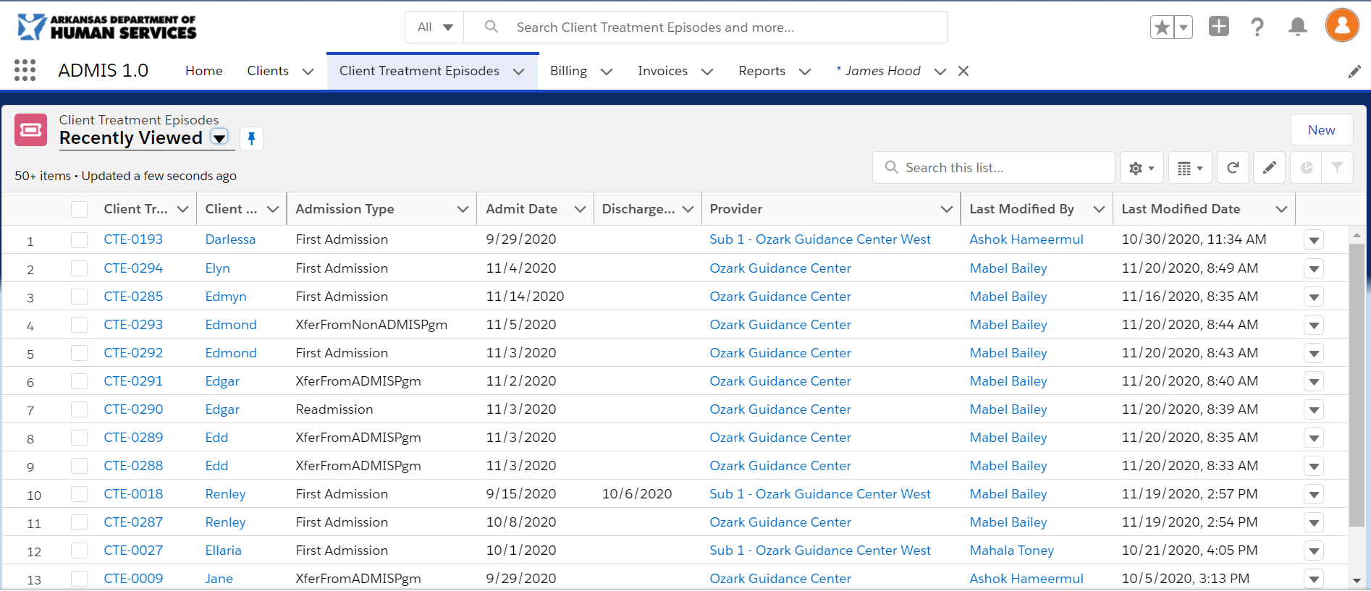 Fig 10.2
Clicking the button will display the New Client Treatment Episode screen (Fig 10.3). You will be required to enter values for required fields identified with to the left of the field name. Clicking the button will save the screen changes. If you fail to complete entering in required data, the screen will display a list of fields that need reviewing and the fields will be outlined in red with a message to complete this field (Fig 10.4). After completing entries for required fields and clicking the save button again, you will return to the Client Treatment Episodes screen and the new record will display in the list.
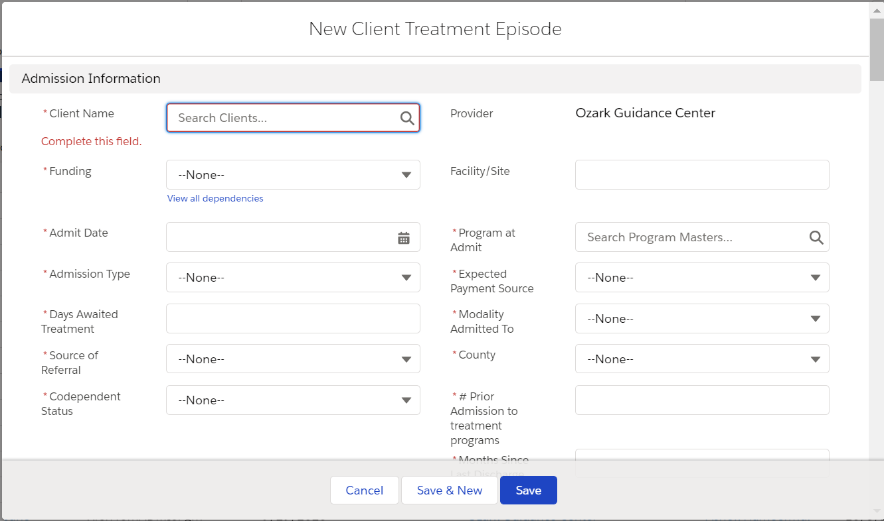 Fig 10.3 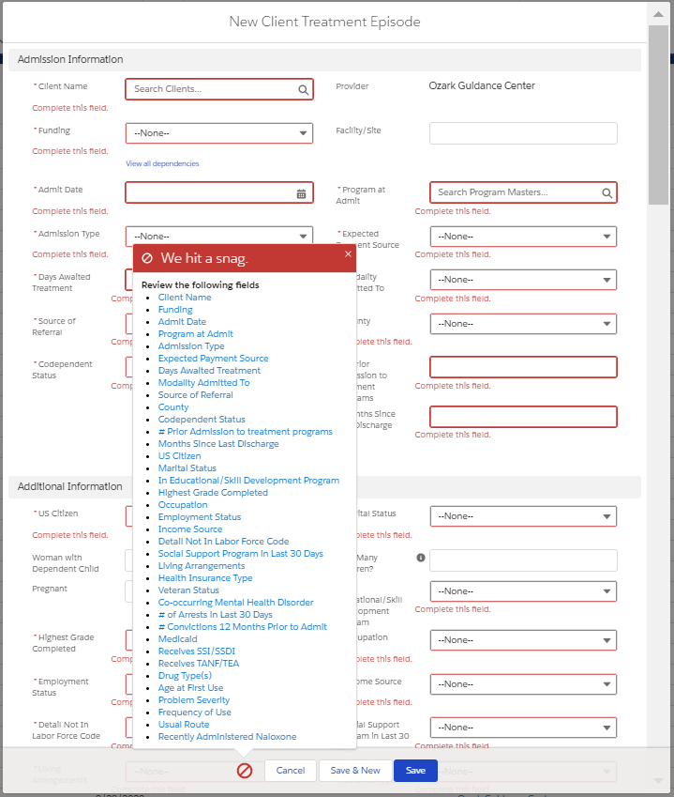 Fig 10.4

To view additional details for rows in the Client Treatment Episodes screen, click the Client Treatment Episode ID on the row you wish to view. The Client Treatment Episode Details screen (Fig 10.5) will display. You can Edit the details by clicking the button located at the top right of the screen. The Edit [Client Treatment Episode ID] screen (Fig 10.6) will display and require the same fields denoted in Fig 10.4.

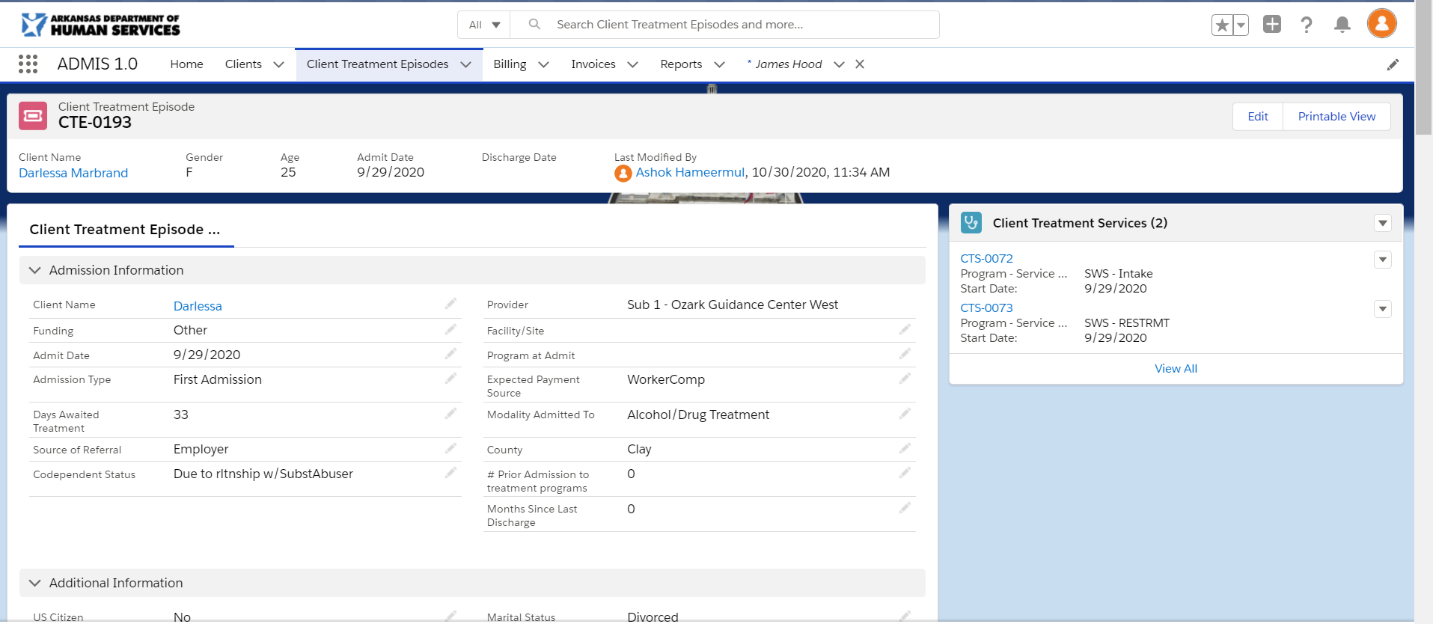 Fig 10.5 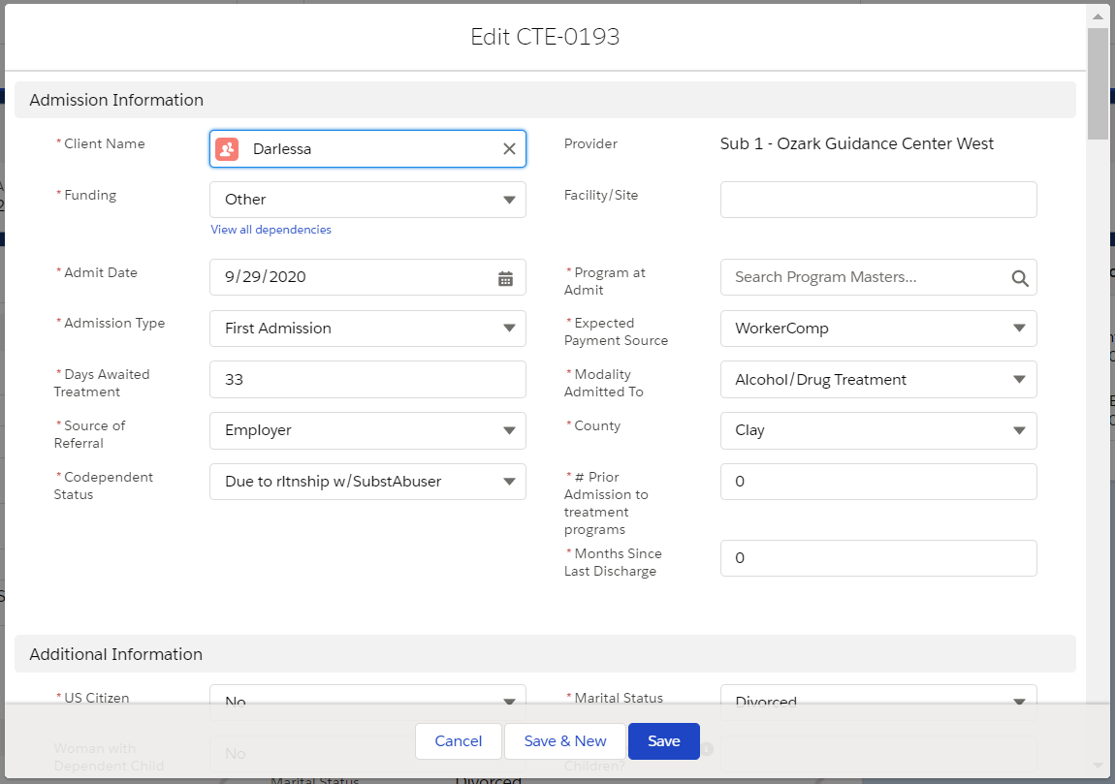 Fig 10.6

  - Treatment Service Creation/Maintenance
The Client Treatment Episode details screen displays a list of last 3 client treatment services added (Fig 10.7) that are associated to the client treatment episode. You can add or edit the client treatment service by clicking the at the top of the table for New or to the right of Client Treatment Service ID to edit. The New Client Treatment Service (Fig 10.8) or Edit [Client Treatment Service ID] (Fig 10.9) screens will display to allow you to add or edit existing client treatment services. Clicking the link or the table header will display the Client Treatment Services screen(Fig 10.10) with all associated client treatment services for the client treatment episode.
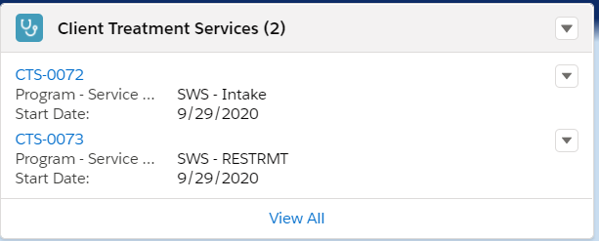 Fig 10.7 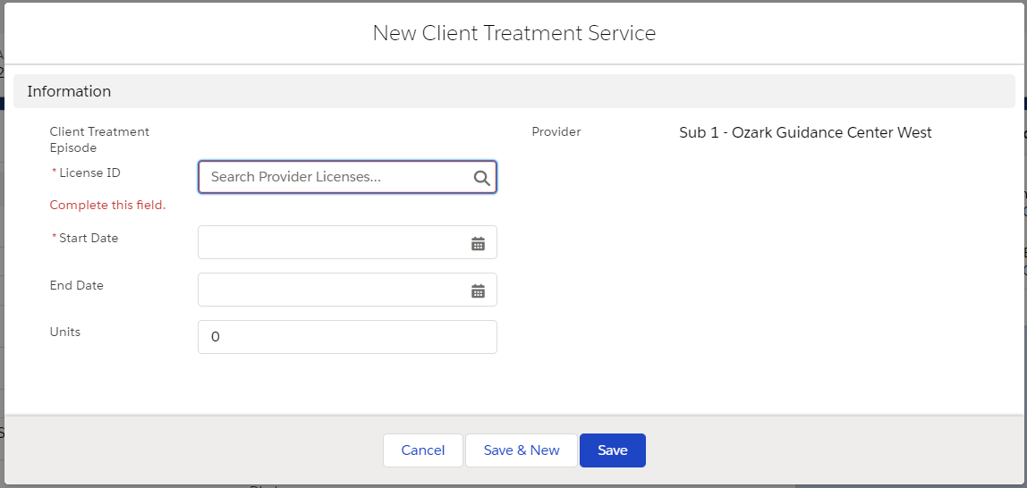 Fig 10.8 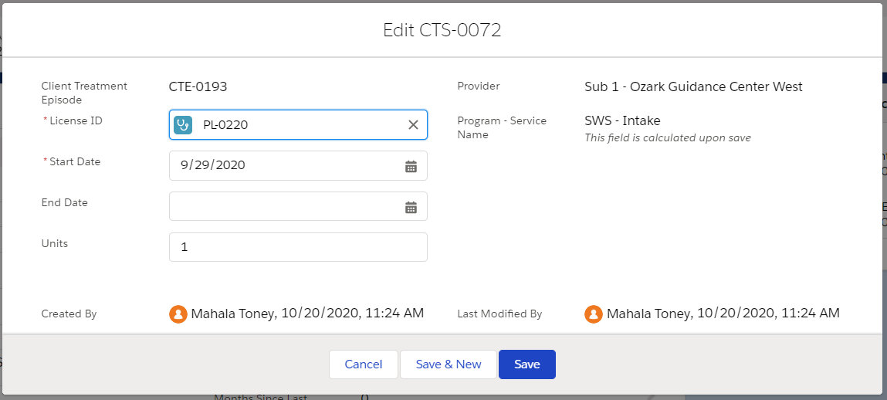 Fig 10.9 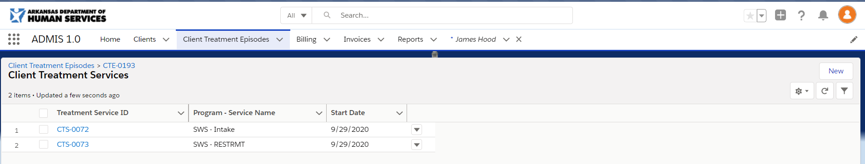 Fig 10.10

Billing
Clicking the Billing menu option(Fig 11.1) on the menu at the top of the screen will display a list of billing records that have been created (Fig 11.2).
Fig 11.1 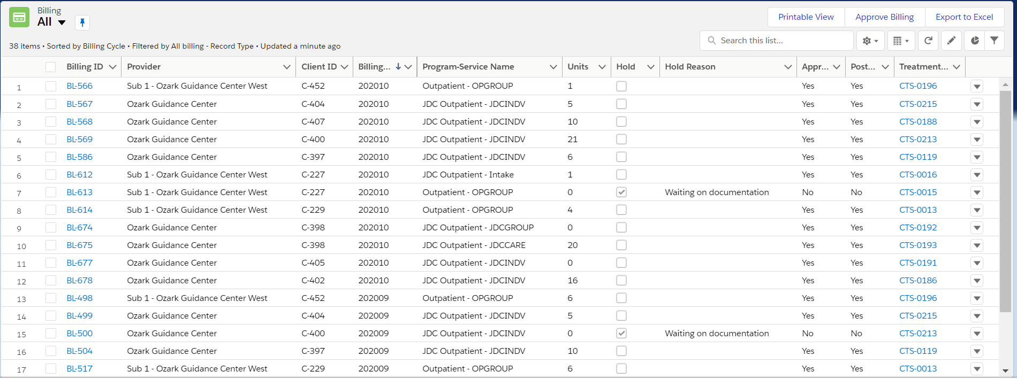 Fig 11.2
To view additional details for rows in the Billing screen, click the Billing ID on the row you wish to view. The Billing Details screen (Fig 11.3) will display. You can Edit the details by clicking the button located at the top right of the screen. The Edit [Billing ID] screen (Fig 11.4) will display and allow you to update Units, Notes, Hold, Hold Reason, and Approved fields.
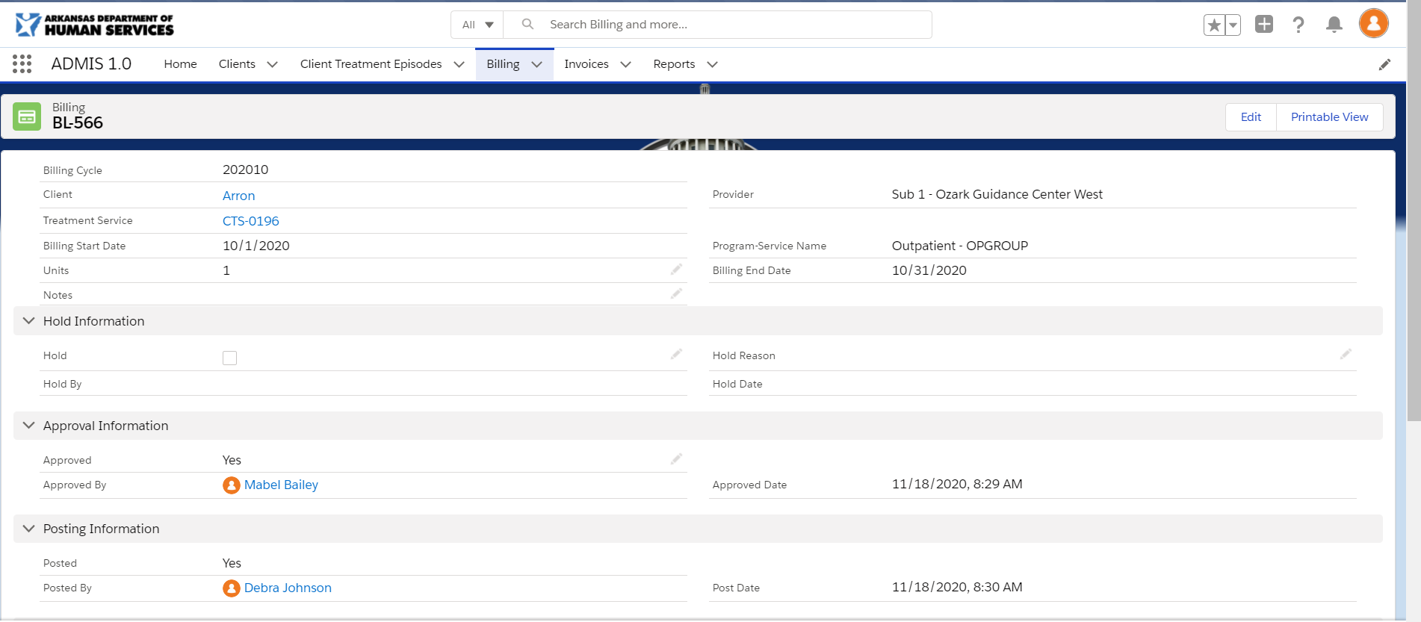Fig 11.3 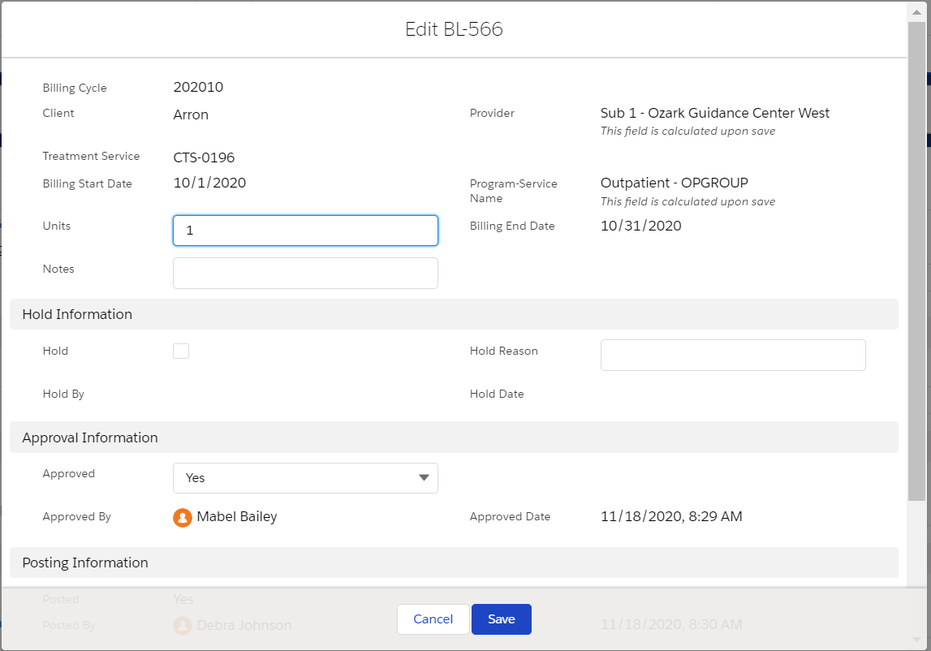Fig 11.4
You have the ability to discard changes by clicking the button. All data entered will not be saved and will navigate you back to the Billing screen. Clicking the button will save the screen changes and return you to the Billing screen.
For quick edits you will have the option by editable fields on pages you view. Clicking this option will display an editable field on the screen (Fig 11.5). Fields that have been updated will be highlighted in yellow for you to review (Fig 11.6). At the bottom of the screen, you have the ability to discard changes by clicking the button. All data entered will not be saved and the screen will be refreshed to display previously saved data. Clicking the button will save the screen changes and refresh the screen to display the newly saved values.

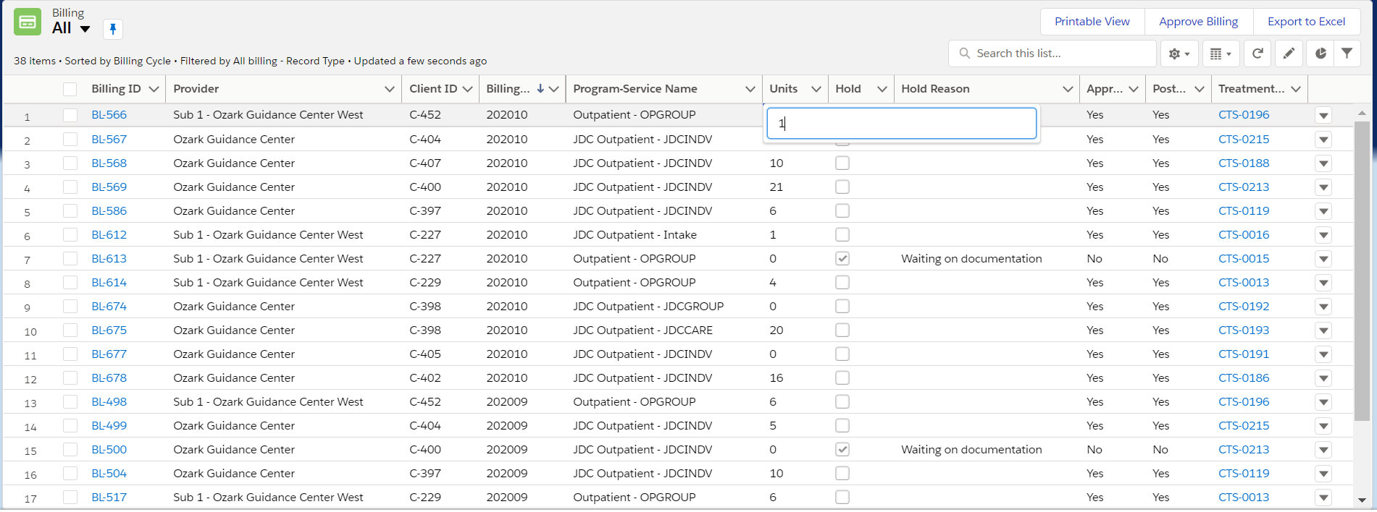 Fig 11.5 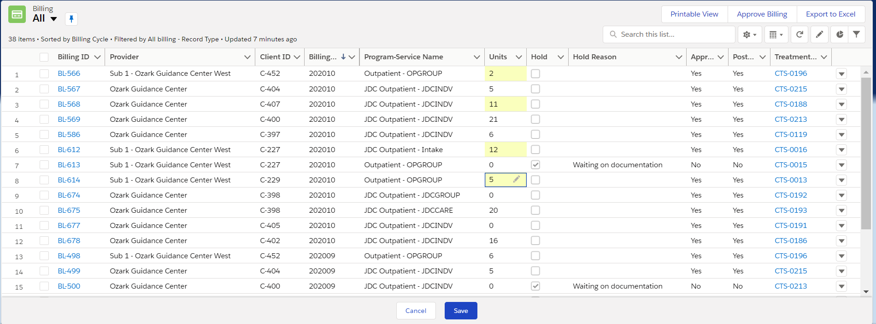 Fig 11.6

Approve Billing Button
Once you have completed saving all changes you wish to make, clicking the 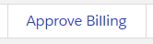 button at the top right of the screen will update the approved column with ‘Yes’ for records that are not on hold. You will be able to approval all records until you have requested billing to be posted or billing is locked on the 16th of each month. Records that were not approved by the 16th of the month, will become available again after billing is ran for the next month.

Posting (DHS ADMIN Task)
Once all records have been approved you will need to contact DHS to have Billing posted. Once Billing is posted, ‘Yes’ will display in the Posted column on the Billing screen.
DHS Admin:
You will post billing by clicking 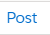 in the Post Activity column on the Billing screen. If records have been posted or it is after the 15th of the month, this option will be locked until the next billing run.

New Button (DHS ADMIN Task)
If a record is posted and needs additional changes, you will need to create an adjustment by using the 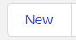 button at the top right of the billing screen. Clicking the new button will display the New Billing: Record Screen (Fig 11.7). You will need to fill out all fields on this page. Once you save the screen, the Billing[Billing ID] (Fig 11.8) screen will load for you to review the record and will display a history of changes at the bottom of the screen (Fig 11.9). When you have completed all changes, you can review the new record displays on the Billing screen for the Provider and request them to complete the approval and Posting process.
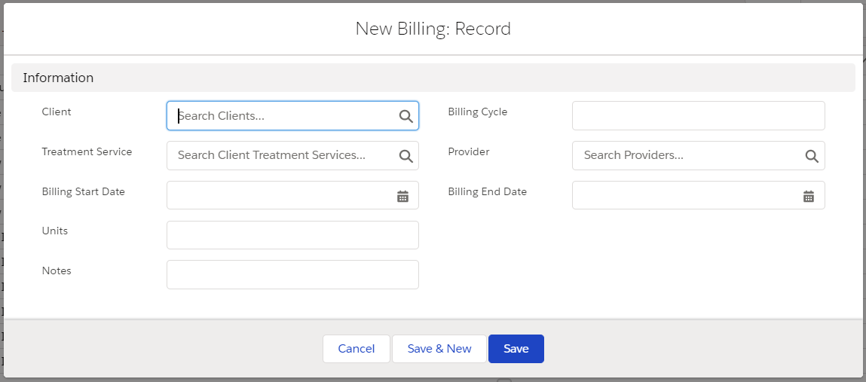 Fig 11.7 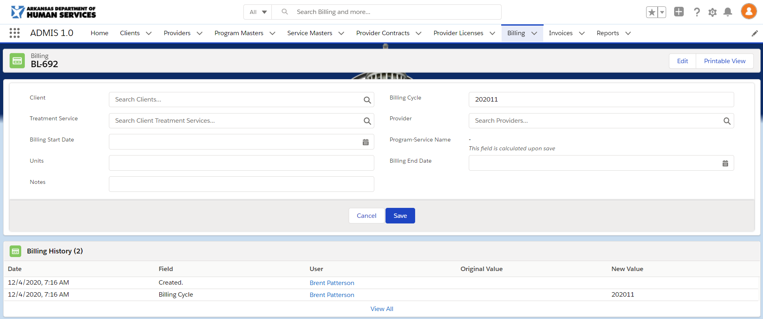 Fig 11.8
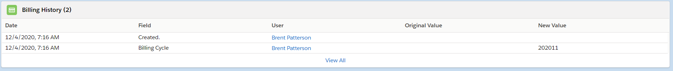 Fig 11.9

Invoice (Master Providers and DHS Users)
Clicking the Invoices menu option (Fig 12.1) on the menu at the top of the screen will display a list of invoices that have been created (Fig 12.2).

Fig 12.1 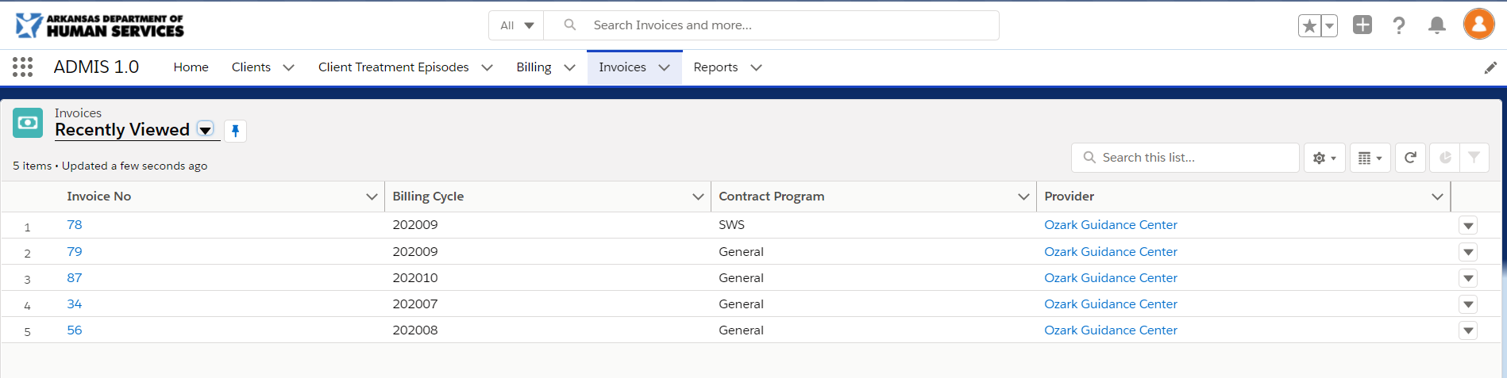 Fig 12.2

Details
To view additional details for rows in the Invoices screen, click the Invoice No on the row you wish to view. The Invoice Summary screen (Fig 12.3) will display.

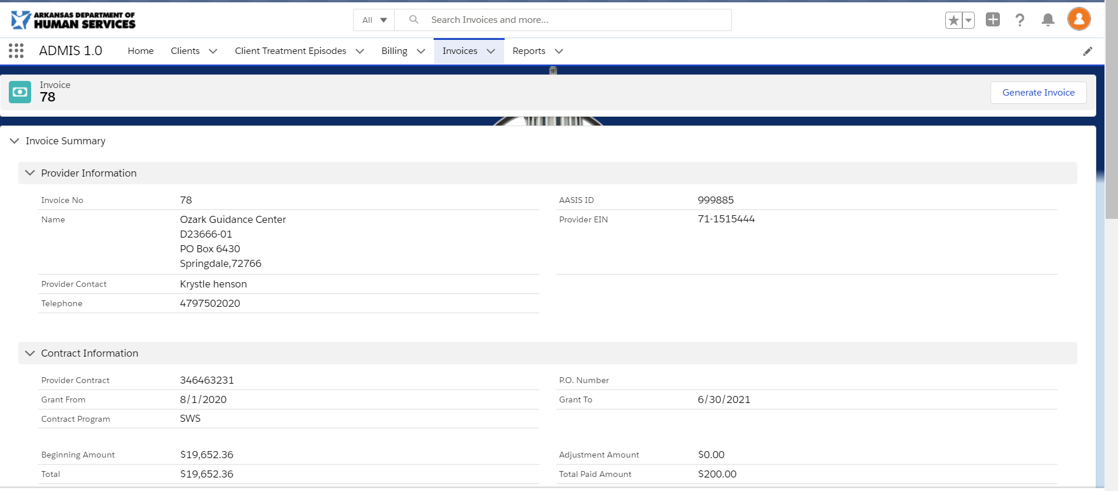 Fig 12.3

Printable Invoice Generation
To generate a printable invoice, you will need to click the 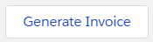 button at the top right of the Invoice Summary screen. Clicking the button will display the Generate Document screen (Fig 12.4). You will select the ‘ADMIS Invoice’ in the Please select a Template field. And then click the button to display the delivery options for the new invoice (Fig 12.5). Clicking the 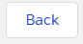 button will display the Choose Template tab. You can cancel the process by clicking the 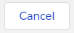 button on any screen. Once the button is clicked, the Invoice Summary screen will refresh, and the new printable invoice pdf will be displayed in a list at the bottom of the screen (Fig 12.6).

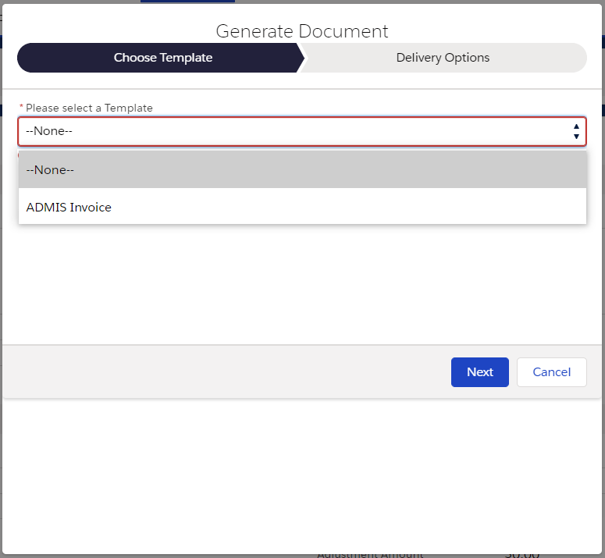 Fig 12.4 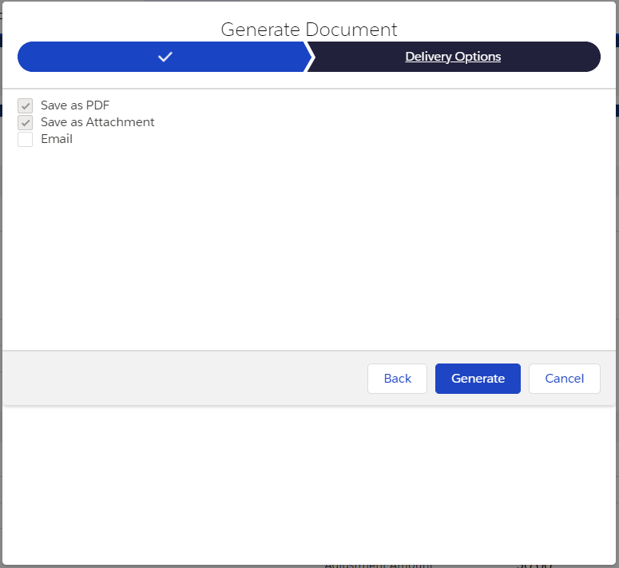 Fig 12.5 Fig 12.6

Clicking the Name of the pdf will display the printable copy the invoice (Fig 12.7). You can download, share or print the invoice by clicking the options at the top of the screen.

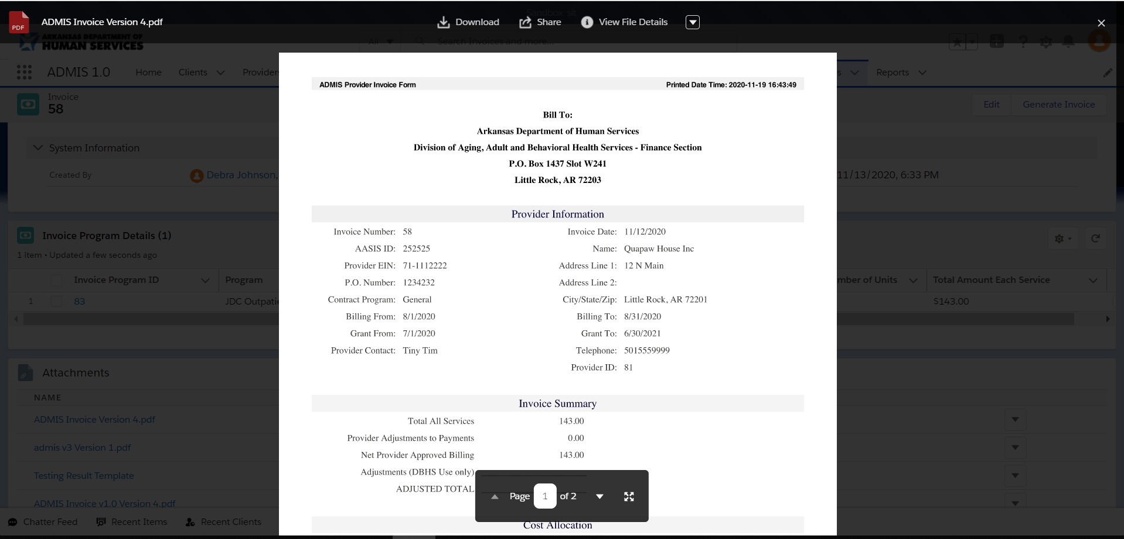 Fig10.7

Reports
Clicking the Reports menu option(Fig 13.1) on the menu at the top of the screen will display a list of Reports that have been recently viewed (Fig 13.2). You can click the All Reports option on the menu on the left of the screen to view all reports (Fig 13.3).

Fig 13.1 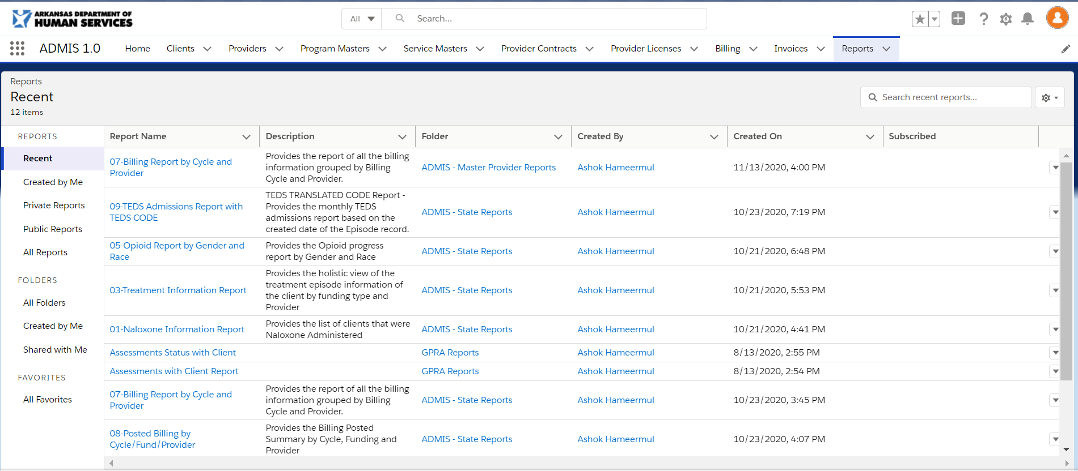 Fig 13.2
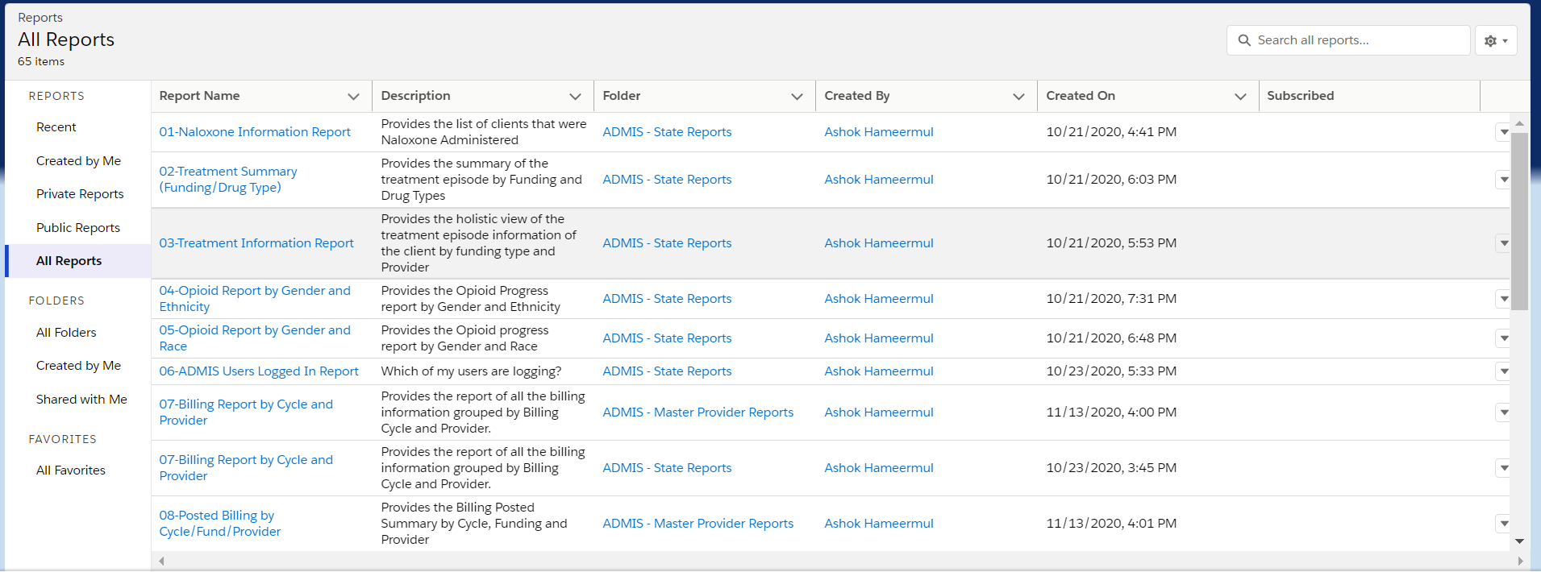 Fig 13.3

  - DHS Users Only
01 - Naloxone Information Report:
The Naloxone Information Report will display the total number of records at the top and a table of clients that administered Naloxone. The table displays the following information:

- Provider: Provider Name 1
- Client ID
- Age
- Gender
- Race
- Ethnicity
- Highest Grade Completed
- Occupation
- County
- Program at Admit: Program Name
- Admit Date
- Discharge Date
- Naloxone Administered

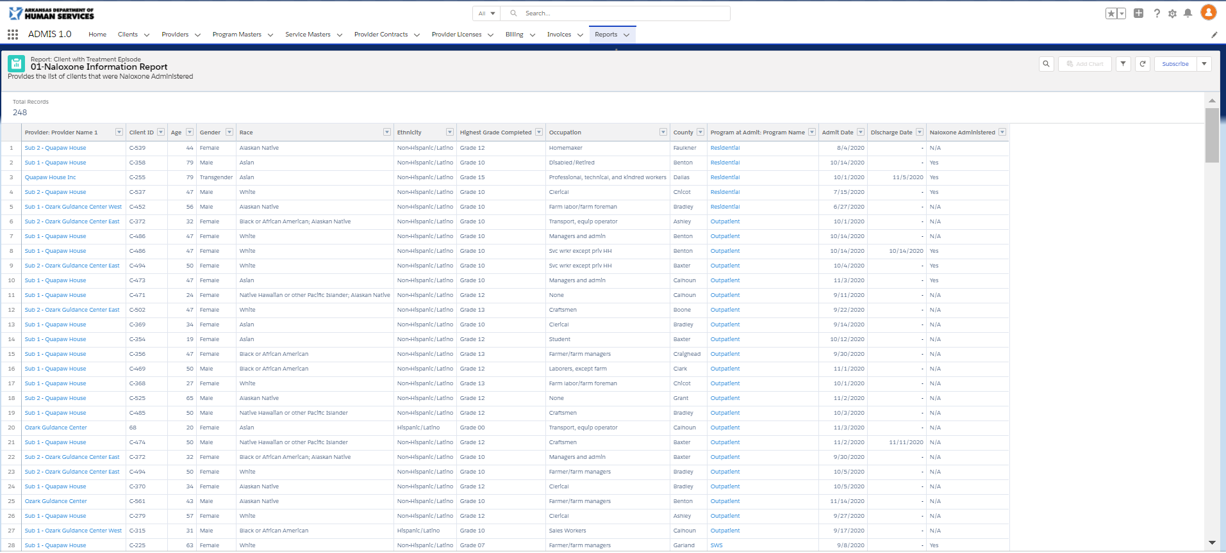 Fig 13.4

02-Treatment Summary (Funding/Drug Type):

The Treatment Summary by Funding & Drug Type will display the total number of records at the top and a table of Drug Types break out by Funding types. The table displays the following information:

- Drug Types – Rows for each of the following - Alcohol, Amphetamines, Barbiturates, Benzodiazapine, Cocaine (excl crack), Crack Cocaine, Hallucinogens, Heroin, Inhalants, Marijuana/Hashish, Methamphetamine, Non-Rx Methadone, Other, Other Opiates and Synthetics, Other Stimulants, PCP
- Funding – Columns for counts of Fundings – DBHS, SOR2, SOR, Other, Total( column at the end)
- Last Row of the table will be a Total Row with totals of all Funding and Total columns

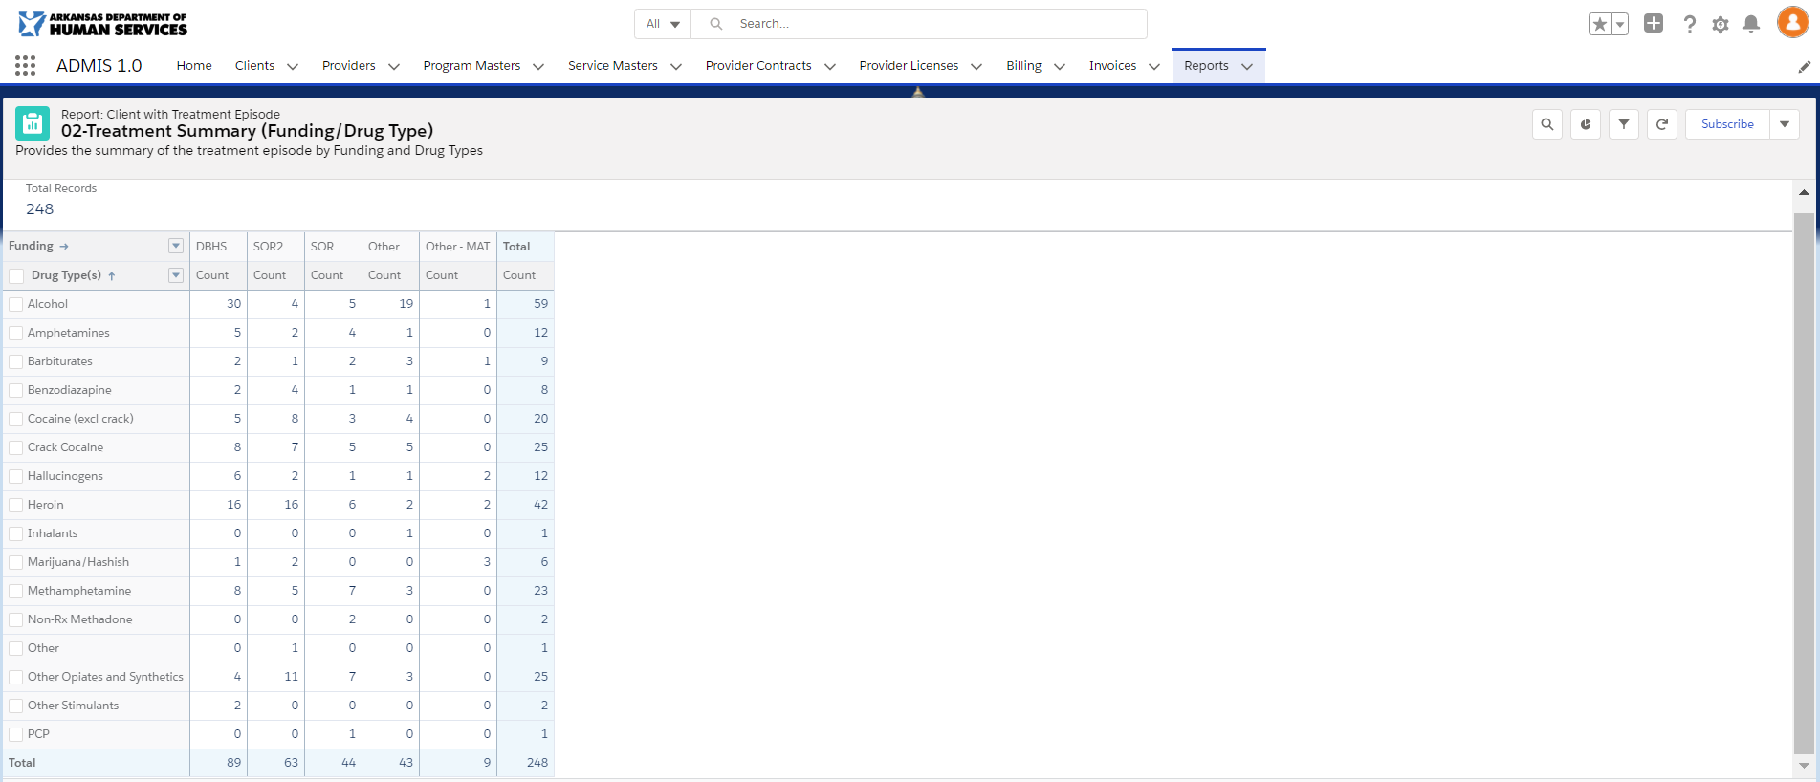 Fig 13.5

Clicking the Total Column values will display a drill down report with the following columns displayed:
- Client ID
- Provider: Provider Name 1
- Admit Date
- Discharge Date

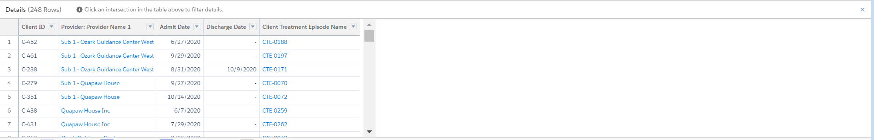 Fig 13.6

03 - Treatment Information Report:

The Treatment Summary Report will display the total number of records at the top and a table break out by Funding types. The table displays the following information:

- Funding - Sorted by Funding, ascending picklist order Ascending
- Provider: Provider Name 1 - Sorted by Provider: Provider Name 1, A-to-Z, Ascending
- Client ID
- Age
- Gender
- Race
- Admit Date
- Created Date
- Program at Admit: Program Name
- County
- Drug Type(s)
- Discharge Date
- Naloxone Administered
- Pregnant
- Woman with Dependent Child
- Armed Forces
- Reserves
- National Guard
- Deployed Combat Zone
- Re-entry from Incarceration
- MAT Types

- Subtotal Rows for Funding, Master Provider, and Sub Provider
- Total Row at the end displays the count of Clients

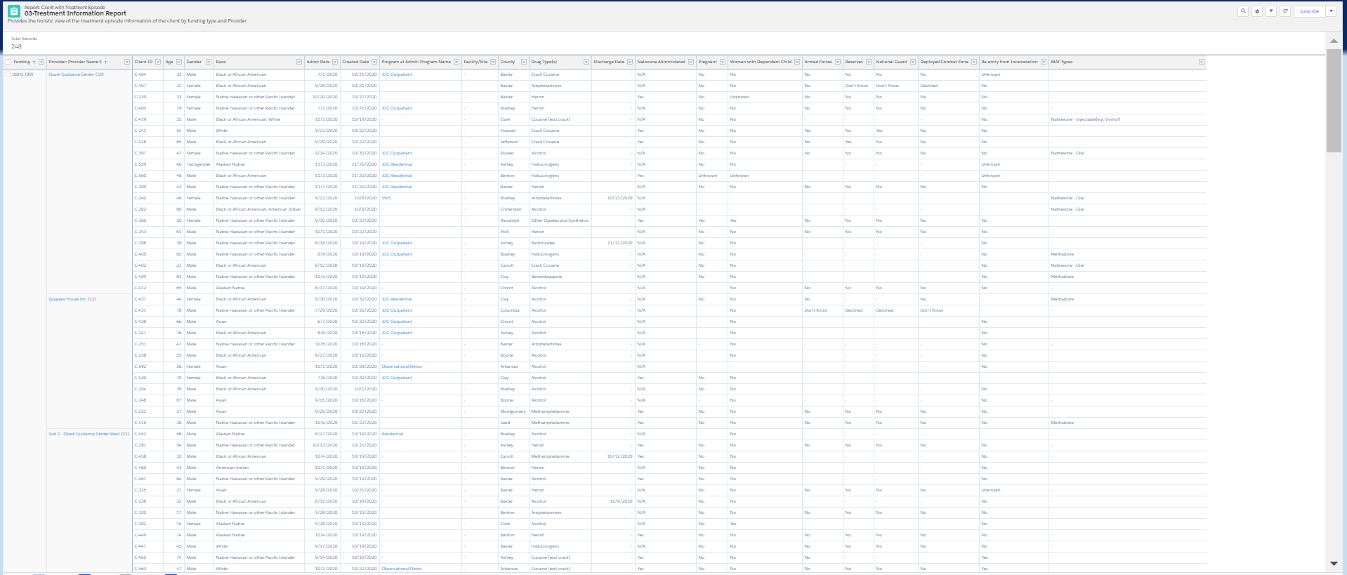 Fig 13.7

04 - Opioid Report by Gender and Ethnicity:

The Opioid Report by Gender and Ethnicity report will display the total number of records at the top and a table of the number of opioid treatments by Ethnicity type counts by Sex for age ranges. The table displays the following information:

- Ethnicity Columns (Hispanic/Latino and Non-Hispanic/Latino) split by Gender (Male and Female) – Counts for gender display
- Rows are created for each Age Category (17 and under, 18-24, 25-44, 45-64, and 65 and above)
- Total Column displays after the last Ethnicity column
- Total Row displays after the last Age Category – Totals all columns

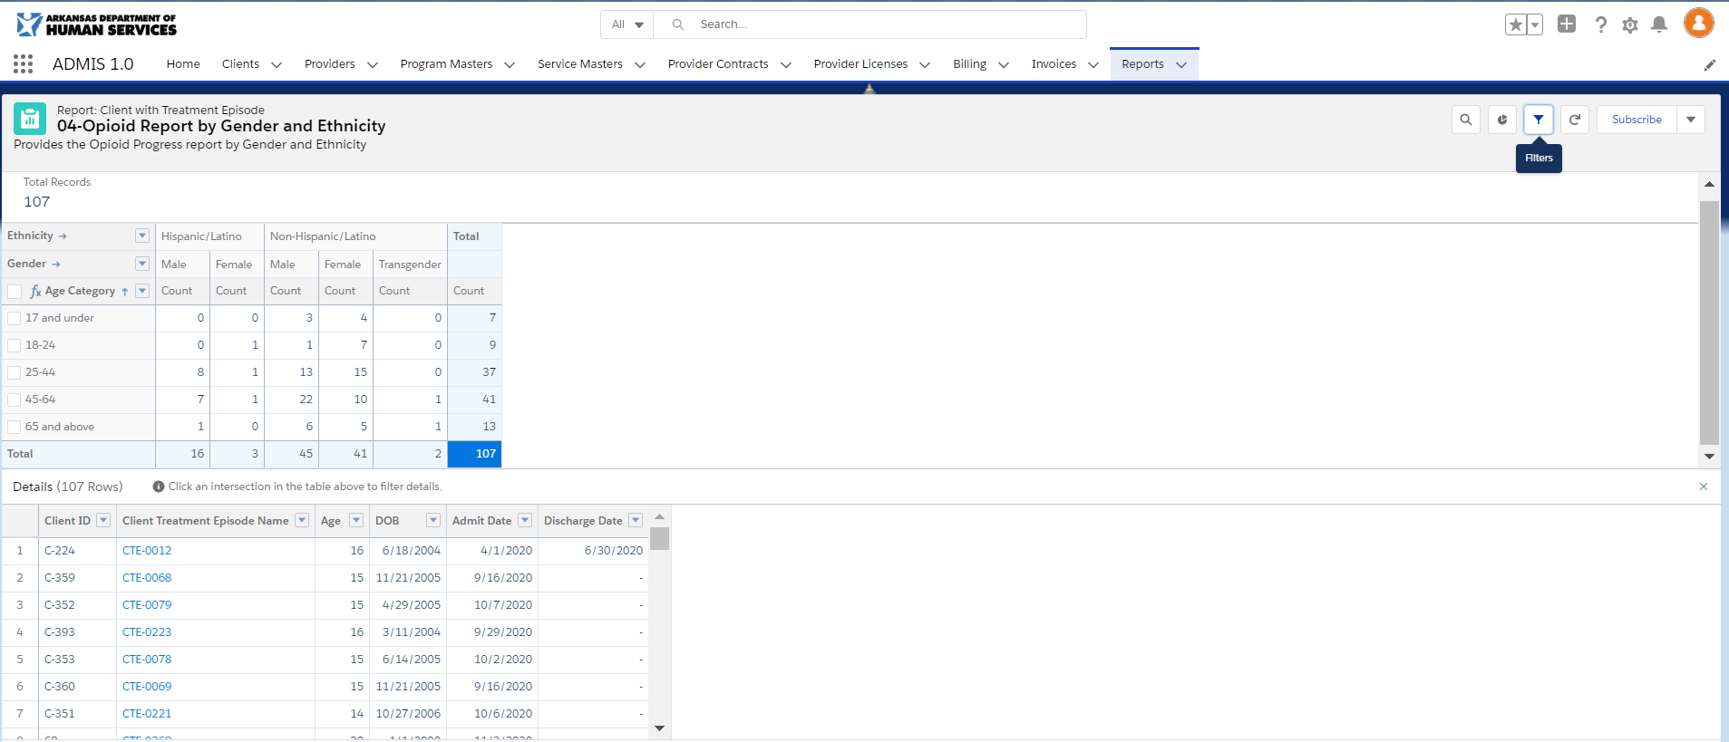 Fig 13.8

05 - Opioid Report by Gender and Race:

The Opioid Report by Gender and Race report will display the total number of records at the top and a table of the number of opioid treatments by Race type counts by Sex for age ranges. The table displays the following information:

- Race Columns (American Indian/Alaskan Native, Asian, Native Hawaiian/Other Pacific Islander, Black or African American, White, More Than One Race Reported, and Unknown ) split by Gender (Male and Female) – Counts for gender display
- Rows are created for each Age Category (17 and under, 18-24, 25-44, 45-64, and 65 and above)
- Total Column displays after the last Race column
- Total Row displays after the last Age Category – Totals all columns

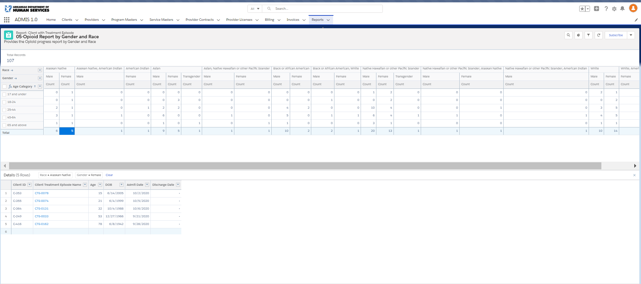 Fig 13.9

06 – ADMIS Users Logged in Report:

The ADMIS Users Logged in Report will display the total number of records at the top and a table break out of the users. The table displays the following information:

- First Name
- Last Name
- Company Name
- Department
- Division
- Title
- Active
- Last Login - Sorted by Last Login, newest-to-oldest, Descending
- Password Expiration Date
- Profile
- Role

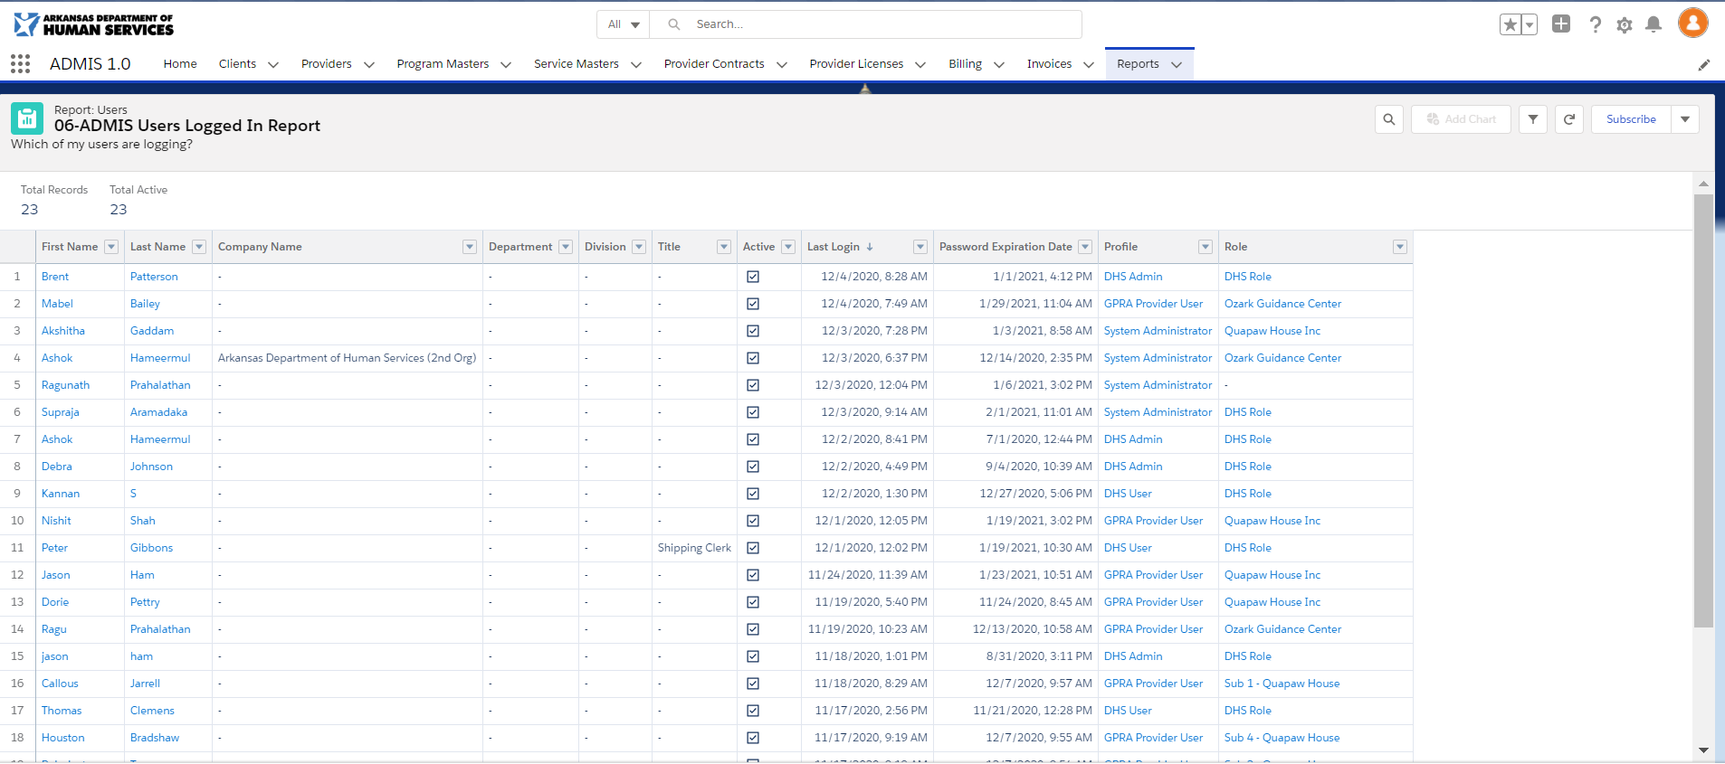 Fig 13.10

09 – TEDS Admissions Report with TEDS CODE:
The TEDS Admissions Report with TEDS CODE report displays the admission data sent for Federal Reporting.

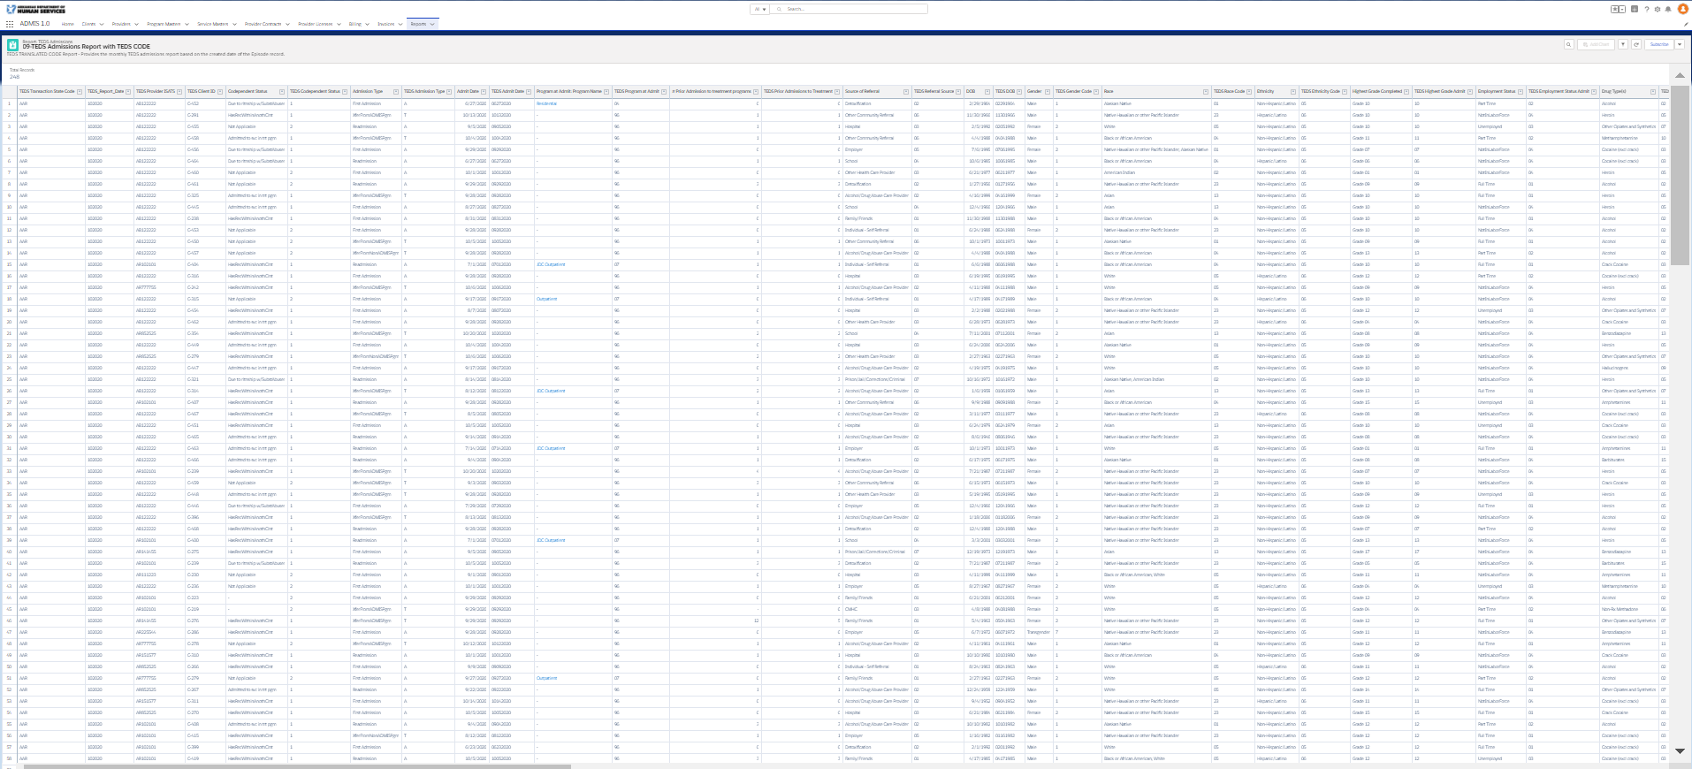 Fig 13.11

10 – TEDS Discharges Report with TEDS CODE:
The TEDS Admissions Report with TEDS CODE report display the discharge data sent for Federal Reporting.

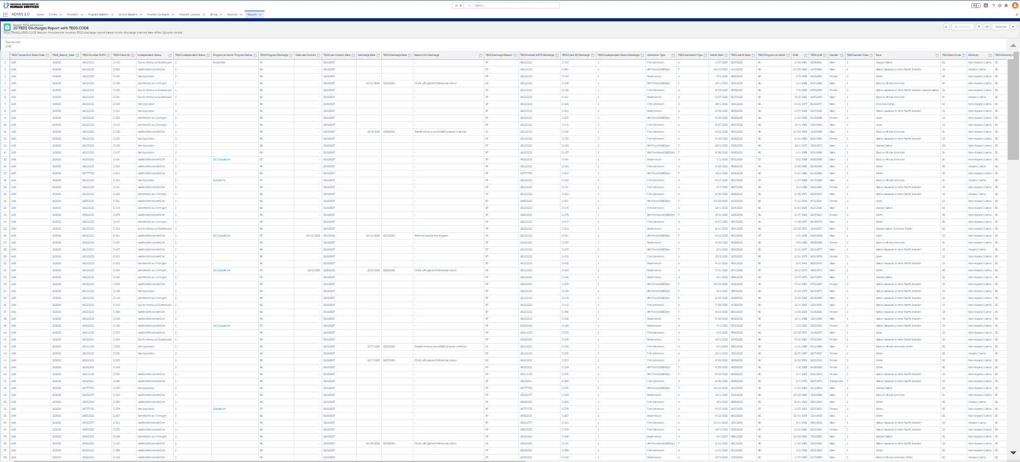Fig 13.12

Master Provider and DHS Users
07 – Billing Report by Cycle and Provider:

The Billing Report by Cycle and Provider report will Total Records and Total Amount at the top of the report and a table of billing cycle records for each provider. The table displays the following information:

- Billing Cycle
- Provider: Provider Name 1
- Billing ID
- Client ID
- Program – Service Name
- Program Funding
- Billing Start Date
- Billing End Date
- Units
- Rate
- Total
- Approved
- Approved By: Full Name
- Approved Date
- Hold
- Hold Reason
- Posted
- Posted By: Full Name
- Post Date

- Subtotal rows will display at the end of records for a provider with the sum of the Total column
- Subtotal Row displays after the last Provider – Totals All Amounts for Total column for all providers

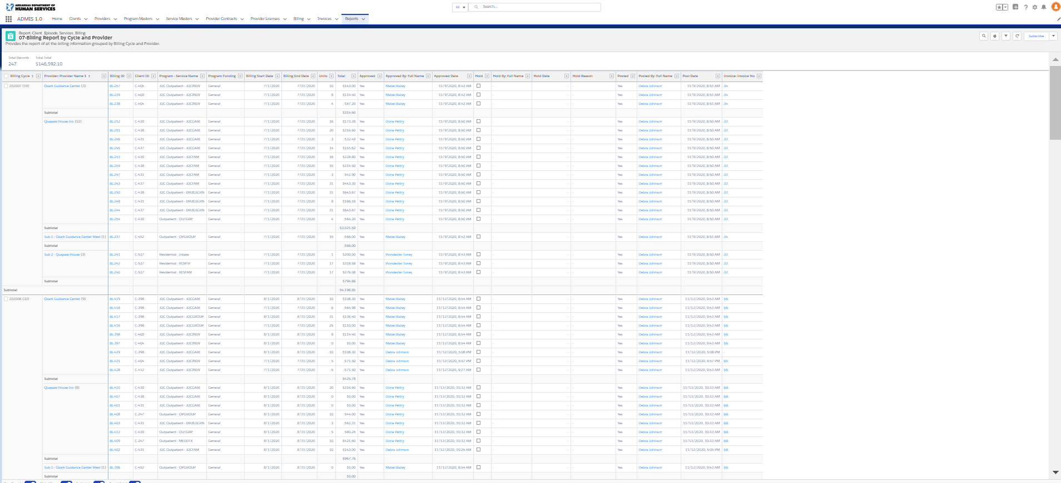 Fig 13.13

08 – Posted Billing by Cycle/Fund/Provider
The Posted Billing by Cycle/Fund/Provider report will display a table of invoice totals for Provider by Funding and a Total drilldown table of Program – Service amounts that are contained in the Funding Invoice Total. The invoice Total table displays the following information:

- Program Funding (General, SWS )
- Rows are created for Billing Cycle, Provider, Invoice amount by Program Funding
- Total Column displays after the last Program Funding
- Total Row displays after the last Provider – Totals All Amounts for Program Funding - Program Group and Total Column

Total Details Report:

The Total Details report will display the following:
- Program - Service Name and Total (Amount billed for the service )
- Total Row displays after the last Program – Service Name – Totals the Total Column

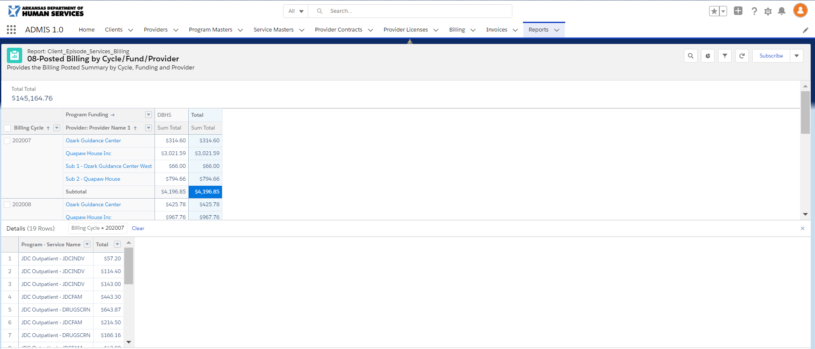 Fig 13.14

