Division of Provider Services & Quality Assurance
P.O. Box 8059, Slot S409, Little Rock, AR 72203-8059

MEMORANDUM

TO: | Nursing Home Administrators, Nursing Facilities, ICFs/MR 16 Beds and Over, HDCs, ICFs/MR Under 16 Beds, Assisted Living Facilities, and other Long-Term Care Facilities
FROM: | Martina Smith, J.D., Division Director
DATE: | July 3, 2023
RE: | Advisory Memo – Enterprise Licensing System (ELS)

The Division of Provider Services and Quality Assurance has been working diligently to develop the Enterprise Licensing System (ELS) for facilities to use to report Incidents and Accidents, pay fees, submit applications, receive correspondence and statements of deficiencies, submit Plans of Corrections, and complete other actions. DPSQA is ready to launch the Incident and Accident portion of the system on August 1, 2023. For those long-term care facilities (LTC) that forward Incidents and Accidents to DPSQA (skilled nursing facilities, nursing facilities, assisted living facilities, and residential care facilities), this system will be a central record for facility reports for incidents and accidents. This process is currently completed by forwarding a 7734, 762, 731, and/or 742 to DPSQA via email or fax. Beginning August 1, 2023, facilities will now complete an action in ELS to provide the applicable Incident and Accident information to DPSQA.

How Do I Register for ELS?
All Providers should be registered through ELS. If you have not registered, go to the Citizen portal, and select Provider Login at: https://arkdhs.force.com/elicensing/s//; and enter some general information about you and/or your facility, if applicable. (See Appendix A). LTC and HCBS providers who have already created a provider account in the new system may access their information by clicking on the link here: https://ardhslicensing.my.site.com/elicensing/s/?language=en_US. DPSQA will cover this for a few minutes of each training session; however, it is advisable that facilities begin navigating in the system before the training session so that you know what questions to ask during the training session.

How Do I Submit Incidents and Accidents in ELS?

Log into your Provider account at https://ardhslicensing.my.site.com/elicensing/s/?language=en_US and click the “Incidents and Accidents” tile. The 7734 for long term care facilities, or the 731 for home and community-based service providers can be completed online by providing all of the case information for the fields indicated. The fields are reflective of the information that would have provided on the paper forms. If a field has a red star, it is a required field, and you will be unable to proceed to the next page until the field is completed.
You may upload documents and photographs when submitting the 7734 or 731. Videos cannot be uploaded, and a physical copy must be submitted by mail to the Incidents and Accidents unit at: Office of Long-Term Care, P.O. Box 8059, Slot 404, Little Rock, AR 72203-8059.
Once you have completed the required fields to sign and submit the information, you will receive an alert to your account and an email to your designated email address advising you that the form has been received and you have five (5) days to submit the 762 or 742 information in the system.

Will We Be Required to Use ELS to Submit Incidents and Accidents?

Yes. All incidents and accidents must be submitted through the ELS beginning August 1, 2023. Paper reports will no longer be accepted for incidents and accidents as of this date.

Will DPSQA offer provider training sessions on this topic?
Yes. DPSQA will host provider training, via Zoom, to assist providers with navigating through ELS and completing Incident and Accidents. Each Zoom link is unique for each day and time of the training, so click on the designated link for each day. You can choose any of the time slots below. You do not have to attend each time slot, as long as you at least attend one session. These trainings will also be recorded and posted on the DHS website for you to view at a later date: https://humanservices.arkansas.gov/divisions-shared-services/provider-services-quality-assurance/information-for-providers/.

ELS Training/Provider Type | Date/Time | Zoom Link
I & A ELS Training  Nursing Homes, ICFs, Assisted Living Facilities I & II, Residential Care Facilities | July 12, 2023  1:00pm – 2:30pm | https://us02web.zoom.us/webinar/register/WN_rRaoiqg4QdSjckYDAOXeag
I & A ELS Training  Nursing Homes, ICFs, Assisted Living Facilities I & II, Residential Care Facilities | July 14, 2023  9:00am – 10:30am | https://us02web.zoom.us/webinar/register/WN_JCz5u0hJTjCQUatAEBJ_Sw
I & A ELS Training  Nursing Homes, ICFs, Assisted Living Facilities I & II, Residential Care Facilities | July 19, 2023  10:00am – 11:30am | https://us02web.zoom.us/webinar/register/WN_NTryP5ozTSKVLg_3RoMdKg
I & A ELS Training  Nursing Homes, ICFs, Assisted Living Facilities I & II, Residential Care Facilities | July 20, 2023  2:00pm – 3:30pm | https://us02web.zoom.us/webinar/register/WN_rcXjJJJxQ0yzhLhSFoXdbw
Follow-up I & A  Q & A Segment | July 25, 2023  9:00am – 10:00am | https://us02web.zoom.us/webinar/register/WN_u8jB0JpVST6u_2NxZtV7eg

Please see below for information on how to register in ELS.
Current Providers:

We have begun using a new online database system called the Enterprise Licensing System (ELS). You can find the main page at https://arkdhs.force.com/elicensing/s// You would need to go to the Provider Login on the top right corner.
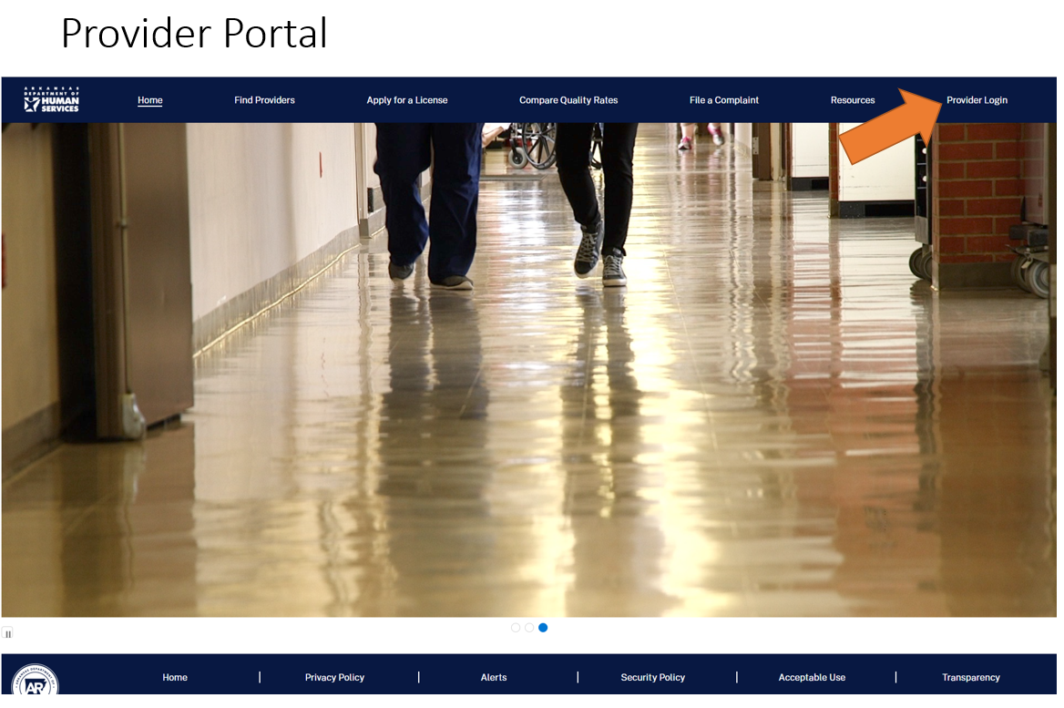

Then select ‘Register Here’.
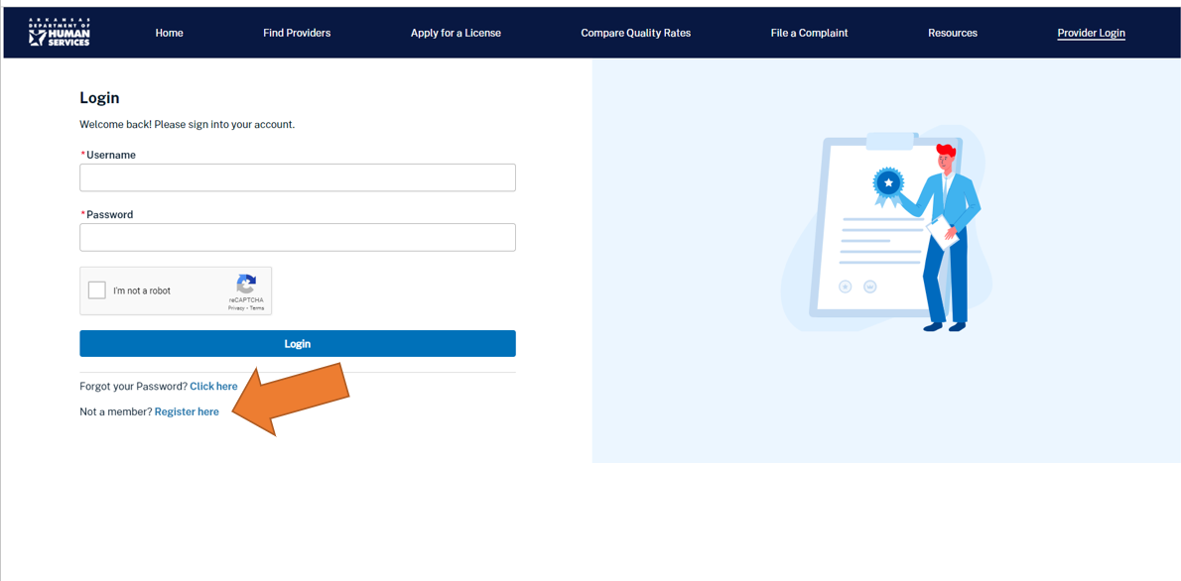
Once you complete your registration for the Enterprise Licensing System (ELS) database, we will need the following additional information. This information will allow us to connect your programs to your specific log in.
- Your User Name
- Legal Name of each program
- License/Certification numbers for each program
- Your Date of birth
- Your title (owner, CEO, etc.)
- Your phone number
- If EIDT: Need Medicaid Number

Please email this information to: DPSQA Provider Applications DPSQA.ProviderApplications@dhs.arkansas.gov

To receive future updates from the Division, please sign up for the Division of Provider Services and Quality Assurance (DPSQA) Provider Subscription Alerts: https://humanservices.arkansas.gov/divisions-shared-services/provider-services-quality-assurance/provider-email-sign-up/.

We Care. We Act. We Change Lives. humanservices.arkansas.gov

