PART A (Must Be Completed By DME Provider Only)
- CLIENT INFORMATION:
Date: | Medicaid ID #: |  | Date of Birth:
Client Name: |  | Sex:  Male: Female: | Current Height: |  | Current Weight:
Address: |  | City: |  | State: |  | Zip:
- ACCESSIBILITY AND TRANSPORTATION:
Ramp to House: | Yes: | No: |  | School Bus: | Yes: | No:
Doorway Accessible: | Yes: | No: |  | Tie Down: | Yes: | No:
Bathroom Accessible: | Yes: | No: |  | Van Lift: | Yes: | No:
Equipment Fits in Trunk: | Yes: | No:

If no ramp to house; describe access to house:

Type of vehicle:

Type of house:
Single-Family: | Apartment: | Multiplex: | Mobile Home: | Other:

If Multi-Story, Will Client Be Required to Get Upstairs: |  | Yes: | No: | N/A:
If Yes, Explain:

Is Client Enrolled in a School: |  | Yes: | No:
If Yes, Name of School:
School Address:

Hours Per Day Client Spends in Wheelchair:

PART A (Must Be Completed By DME Provider Only)
- CURRENT WHEELCHAIR AND SEATING SYSTEMS:
Has a Wheelchair: | Yes: | No: | Serial Number:

Model/Brand Name: |  | Manufacturer:

Power: | Scooter: | Manual: | Standard: | Folding: | Rigid:

Date of Purchase: |  | Previous DME Provider:
- PRESENT SEATING SYSTEMS:
Type of Seat: |  | Type of Back:
Seat Width: |  | Seat Depth:

Can the Current Wheelchair Be Grown/Modified/Repaired to Meet the Client’s Need: | Yes: | No:

If No, Explain:

PART B (Must Be Completed by ATP Only) | PT/OT/SEATING SPECIALIST must ONLY complete PART B when requesting a Scooter, Group One or Group Two Power Wheelchairs with No Power Options
- NEW WHEELCHAIR SPECIFICATIONS:
Power: | If Power Wheelchair, Group #: |  |  |  |  |  |  | Scooter: |  |  |  | Manual:
Brand/Model Name: |  |  |  |  |  | Manufacturer:
Seat Width: |  |  |  | Seat Depth:
Seat To Floor Height: |  |  | Front: |  |  |  |  |  | Rear:
- DRIVE CONTROLS:
Joystick: | Yes: | No: | Standard Mount: | Swing-Away:
Type of Joystick: | Standard: |  | T-Bar: | Ball:
Chin Control: | Sip N’ Puff: |  | Head Array:
Other:
Justification:
- SEATING:
SEAT | BACK | LATERAL SUPPORT
Contour Seat: | Contour: | Curved Pad:
Custom Molded: | Custom Molded: | Fixed: Left/Right
Planar Seat: | Folding: | Flat Pad:
Size: | Planar: | Swing-Away:
Sling Seat: | Sling Back: | Other:
Solid Seat: | Captain’s Seat: | Justification:
Captain’s Seat: | Other:
Other: | Justification:
Justification:

PART B (Must Be Completed By ATP Only)
- BASIC MEASURING AND FITTING:
Independence in a wheelchair and seating device can be either enhanced or inhibited as a result of accurate or inaccurate measurements. Make sure there are complete anatomic and equipment measurements.
ACTUAL USER MEASUREMENTS
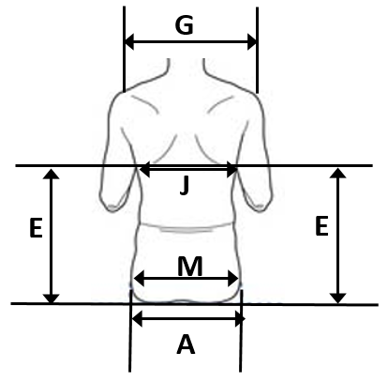
A:
B (R):
B (L):
C (R):
C (L):
D1:
D2:
E (R):
E (L):
F:
G:
H:
I (R):
I (L):
J:
K:
L:
M:
N:

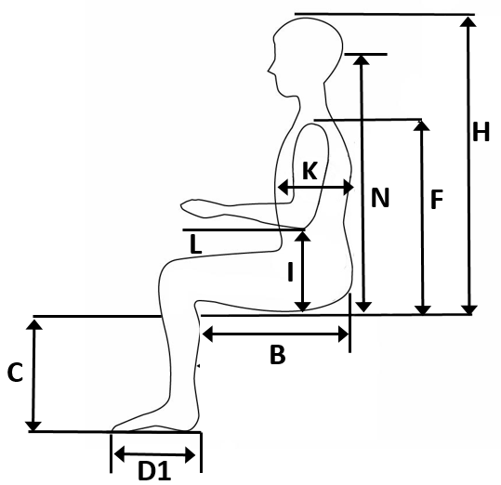

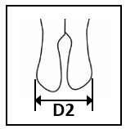
Overall Width of Body (When Scoliosis Present)
Overall Depth of Body (When Kyphosis Present)

PART B (Must Be Completed By ATP ONLY)
- ACCESSORIES:
ARMRESTS | FRONT RIGGING |  |  | REAR WHEELS
Adj. Height: | Angle Adjustable/High Mount: |  |  | Composite/Mag:
Arm Troughs: | Ankle Straps: |  |  | Flat Free Inserts:
Desk Length: | Articulating Leg-Rests:(Circle Number) |  |  | One Arm Drive:
Detachable: | 60 70 75 80 85 90 Degrees |  |  | Right: Left:
Flip Back: | Detachable: |  |  | Hand-Rims (Any Type):
Full Length: | Heel Loops: |  |  | Pneumatic Tires:
Padded Swing-Away: | Leg Straps: |  |  | Projection Hand-Rims:
Swing-Away: | One Piece/Platform: |  |  | Vertical/Oblique:
Other: | Shoe Holders Size: |  |  | Size:
 | Swing-Away: |  |  | Spokes:
Justification: | Toe Straps: |  |  | Other:
 | XLG Footplates:
 | Other: |  |  | Justification:
 | Justification:
Was Client Evaluated in a Power Wheelchair: |  | Yes: | No:
If No, State Reasons Why:
If Yes, Does The Client Have The Fine Motor, Fine Sensory and Cognitive Abilities To Operate The Power Wheelchair Safely With Respect To Others? |  |  |  |  | Yes: | No:
If No, Explain:
Additional Information:

PART B (MUST BE COMPLETED BY ATP ONLY)
- ACCESSORIES: (Continued)
CASTORS: | ACCESSORIES: | SEATBELTS:
Flat-Free Inserts: | Anti-Tip Tubes: | Airplane Styles:
Pneumatic Tires: | Batteries: | Auto Styles:
Solid Tires: | Tray: | Padded:
Justification: | Type: | Velcro:
 | Wheel-Lock Extensions: | Other:
 | Other:
 |  | Justification:
 | Justification:
- POSITIONING COMPONENTS:
Abductors: | Flip Down: |  |  |  | Removable: |  |  | Fixed: |  | Custom: |  | Size: |  | Detachable:
Thigh Support: |  |  | Left: |  |  | Right: |  |  | Bilateral: |  | Fixed: |  |  | Detachable:
Hip Guide: |  |  | Left: |  |  | Right: |  |  | Bilateral: |  | Fixed: |  |  | Detachable:
Head/Neck Support: |  |  |  |  |  |  |  |  | Type:
Vest: |  | Chest Harness: |  |  |  |  | Straps: |  |  | Padded: |  |  | Non-Padded:
Size: |  | Small: |  |  |  | Medium: |  |  |  | Large: |  |  | Extra-Large:
Anterior Trunk Support: |  |  |  |  |  |  | Type: |  |  |  | Size:
Size:
Tilt Or Recline Requirements and Justification:

PART B (MUST BE COMPLETED BY ATP ONLY)
8. PHYSICAL THERAPY:
Physical Therapy: |  |  |  | Yes: |  |  | No:
If Yes, Where and How Often:
Reason For Referral:
Client Lives: |  | Alone: |  |  | With Spouse: |  |  | Parents: |  | Foster Parents:
Residential Facility: |  |  |  |  |  |  |  | Other:
If Residential Facility, Name of Facility:
Does Client Have Any of The Following: (Check All That Apply)
Walker | Cane: |  | Crutches: |  |  | Braces: |  | Orthotics: | Prosthesis |  | Other:
Describe How Any of The Above Are Used:
9. ENVIRONMENTAL EVALUATION:
Is Client Totally Chair Confined: | Yes: | No:
Transfer Capabilities:
Is Client Ambulatory: | Yes: | No:
If Yes, How Far Can Client Walk:
Please Specify Limitation:

PART B (MUST BE COMPLETED BY ATP ONLY)
10. ENVIRONMENTAL EVALUATION: (Continued)
- Is Client Able To Adequately Self-Propel in a Standard/Manual Wheelchair: | Yes: | No:
- Lightweight Wheelchair: | Yes: | No:
- Ultra-Lightweight Wheelchair: | Yes: | No:
- Any Difficulty Wheeling Over Carpet Or Grass: | Yes: | No:
If Yes, Explain:
- Type of Terrain Encountered Daily:
11. MEDICAL NECESSITY CONSIDERATION: (Check all that apply)
- Independent: |  | Pressure Relief:
- Progressive Condition: |  | Endurance:
- Comfort: |  | Growth:
- Supported Position: |  | Other:
12. PRECAUTIONS:
Skin Breakdown: | Yes: |  | No: | High Risk: |  | Moderate Risk: |  | Low Risk:
If Yes, Describe:
Sensation: |  | Absent: |  |  | Impaired: |  | Both:
Location of Sensation:

PART B (MUST BE COMPLETED BY ATP ONLY)

13. Orthopedic Deformities: Tone:
(Check all that apply) (Check all that apply)
14. Spasticity of: (Check all that apply)
Scoliosis: |  |  | Hypertonic: | Yes: |  | No:
Kyphosis: |  |  | Hypotonic: | Yes: |  | No:
Trunk Rotation: |  |  | Mixed: | Yes: |  | No:
Pelvic Rotation: |  |  | Normal: | Yes: |  | No:
Amputee (Specify):
Contractures: |  |  | Weakness of: (Check All That Apply)
Wind Swept: |  |  | All Extremities:
Hip Dislocation: |  |  | Right Lower Extremity:
Spasms: |  |  | Left Lower Extremity:
Other: |  |  | Right Upper Extremity:
Description and Severity of Each: |  |  | Left Upper Extremity:
All Extremities: |  | Detail of Spasticity:
Right Lower Extremity: |  | Detail of Spasticity:
Left Lower Extremity: |  | Detail of Spasticity:
Right Upper Extremity: |  | Detail of Spasticity:
Left Upper Extremity: |  | Detail of Spasticity:
Additional Details:
15. HEAD CONTROL: (Check all that apply) TRUNK CONTROL: (Check all that apply)
None: |  |  | None:
Poor: |  |  | Poor:
Fair: |  |  | Fair:
Good: |  |  | Good:
Provide Detail of Each: |  |  | Provide Detail of Each:
PART B (MUST BE COMPLETED BY ATP ONLY)

16. CONTRACTURES: (Check all that apply) OTHER: (Check all that apply)
Ankles: | Yes: | No: |  | Edemas: | Yes: | No:
Hips: | Yes: | No: |  | Incontinent: | Yes: | No:
Knees: | Yes: | No: |  | Poor Skin Integrity: | Yes: | No:
Feet: | Yes: | No: |  | History of Decubitus: | Yes: | No:
Shoulders: | Yes: | No: |  | Unable To Position: | Yes: | No:
Elbows: | Yes: | No: |  | Seizures: | Yes: | No:
Hands: | Yes: | No: |  | Vision: | Normal: | Impaired:
Wrists: | Yes: | No: |  | Hearing: | Normal: | Impaired:
17. Additional Information:
Will Client Self-Propel Manual Wheelchair Or Will Family Member Or Caregiver Push Client:
Name of ATP (Please Print) |  |  |  |  | Name of PT/OT/Seating Specialist
RESNA Certified: | Yes |  | No
RESNA Certification Number:
 |  |  |  |  | Signature of PT/OT/Seating Specialist
Signature of ATP |  |  |  |  | Date

PART C (MUST BE COMPLETED BY PRESCRIBING PHYSICIAN/ADVANCED PRACTICE REGISTERED NURSE ONLY)
Medications: Diagnosis: Current
1.
2.
3.
4.
5.
- Injury:
Date of Injury: |  |  |  |  |  |  | Level of Injury:
Future Surgery Planned: |  | Yes | No |  | If Yes, Explain:
- Medical Equipment:
Apnea Monitor: |  |  | Oxygen: |  |  | Communication Device:
Ventilator: |  |  | Other:
- Additional Information:
Seizures: | Are They Controlled? |  | If Yes, How Long?

Prescribing Physician/Advanced Practice Registered Nurse Name  (Please Print) |  | Physician/Advanced Practice Registered Nurse’s Provider Number
Prescribing Physician/Advanced Practice Registered Nurse Signature  (No Stamp Please) |  | Date of Evaluation

