DIVISION OF MEDICAL SERVICES

MEDICAL ASSISTANCE PROGRAM

PROVIDER APPLICATION

As a condition for entering into or renewing a provider agreement, all applicants must complete this provider application. A true, accurate and complete disclosure of all requested information is required by the Federal and State Regulations that govern the Medical Assistance Program. Failure of an applicant to submit the requested information or the submission of inaccurate or incomplete information may result in refusal by the Medical Assistance program to enter into, renew or continue a provider agreement with the applicant. Furthermore, the applicant is required by Federal and State Regulations to update the information submitted on the Provider Application.

Whenever changes in this information occur, please submit the change in writing to:

Medicaid Provider Enrollment Unit

Gainwell Technologies

P.O. Box 8105
Little Rock, AR 72203-8105

All dates, except where otherwise specified, should be written in the month/day/year (MMDDYY) format. Please print all information.

This information is divided into sections. The following describes which sections are to be completed by the applicant:
Section I - All Providers
Section II - Facilities Only
Section III - Pharmacists/Registered Respiratory Therapist Only
Section IV - Provider Group Affiliations
Electronic Fund Transfer - All Providers (optional)
Managed Care Agreement - Primary Care Physician
W-9 Tax Form - All Providers
Contract - All Providers
Ownership and Conviction
Disclosure - All Providers
Disclosure of Significant
Business Transactions - All Providers

FOR OFFICE USE ONLY
Provider ID Number: |  | Pending:
Taxonomy Code: |  | Computer:
Specialty Code: |  | OK to Key:
Provider Type: |  | Keyed:
Effective Date: |  | Maintenance Checked:

SECTION I: ALL PROVIDERS

This section MUST be completed by all providers.

(1) Date of Application: Enter the current date in month/day/year format.

____ ____/____ ____/________
MM DD Year

(2) Last Name, First Name, Middle Initial, and Title: Enter the legal name of the applicant. The title spaces are reserved for designations such as MD, DDS, CRNA or OD. If the space is insufficient, please abbreviate.

If entering any other name such as an organization, corporation or facility, enter the full name of the
entity in item 3. NOTE: Item 2 or 3 must be completed, BUT NOT BOTH.

Last Name First Name M.I. Title

(3) Group, Organization or Facility Name: Enter full name of the entity.
Examples: John R. Doe, PA; Adam B. Corn, Inc.; Arkansas Emer. Phys. Group; Pulaski County Hospital; John Thompson, M. D., DBA Thompson Clinic

________________________________________________________________________________
Corporation Name

________________________________________________________________________________
Fictitious Name (Doing Business As)
Must submit documentation that the above fictitious name is registered with the appropriate board within your state (i.e., Secretary of State’s, County Clerk) of the county in which the corporation’s registered office is located.

(4) Application Type: Circle one of the following codes which coincide with fields 2 or 3. Each application type listed below will be required to complete Disclosure Forms (DMS-675 – Ownership and Conviction Disclosure and DMS-689 – Disclosure of Significant Business Transactions.)

*NOTE: IF THE FORMS ARE NOT COMPLETED AND ATTACHED, THE APPLICATION WILL BE DENIED.

0 = Individual Practitioner (i.e., physician; dentist; a licensed, registered or certified practitioner)
1 = Sole Proprietorship (This includes individually owned businesses)
2 = Government Owned
3 = Business Corporation, for profit
4 = Business Corporation, non-profit * copy of Tax Form 501 (c) (3) must accompany this application
5 = Private, for profit
6 = Private, non-profit * copy of Tax Form 501 (c) (3) must accompany this application
7 = Partnership
8 = Trust
9 = Chain
* NOTE: IF THE TAX FORM IS NOT ATTACHED THE APPLICATION WILL BE DENIED.
(5) SSN/FEIN Number: Enter the Social Security Number of the applicant or the Federal Employer Identification Number of the applicant. IF ENROLLING AN INDIVIDUAL APPLICANT THIS FIELD MUST REFLECT A SOCIAL SECURITY NUMBER.

____ _____ _____ - _____ _____ - _____ _____ _____ _____
Social Security Number

NOTE: If an individual has a Federal Employee Identification Number, you will need to complete two (2) applications and two (2) contracts. One (1) as an individual and one (1) as an organization.

____ _____ - _____ _____ _____ _____ _____ _____ _____
Federal Employee Identification Number

(6) National Provider Identification Number (NPI) and Taxonomy Code: Enter the National Provider Identification Number and the taxonomy code of the applicant.

_______________________________________________________
National Provider Identification Number

_______________________________________________________
Taxonomy Code

(7) Place of Service - Street Address

- Enter the applicant's service location address, include suite number if applicable. THIS FIELD
IS MANDATORY.

___________________________________________________________________________

- Enter any additional street address. (SHOULD REFLECT POST OFFICE BOX IF
UNDELIVERABLE TO A STREET ADDRESS)

___________________________________________________________________________

(C) City, State, Zip+4 Code - enter the applicant's city, state and zip+4 code. Use the Post Office's two letter abbreviation for State. Enter the complete nine-digit zip code.

_______________
City State Zip Code+4

(D) Telephone Number - enter the area code and telephone number of the location in which the services are provided.

__________ _________________________
Area Code Telephone Number

- Fax Number – enter the area code and fax number of the location in which the services are
provided.

__________ _________________________
Area Code Fax Number

(8) Billing Street Address

- This is the billing address where your Medicaid checks, Remittance Statements (RA) and information will be sent. Use the same format as the place of service address; P.O. Box may be entered in billing address.

City State Zip Code+4

Area Code Telephone Number

Area Code Fax Number

- Provider Manuals and Updates
Please review Section I sub-section 101.000; 101.200; and 101.300 in your Arkansas Medicaid provider manual regarding provider manuals and updates. Providers will receive emails notifying them of applicable manual updates, official notices, notices of rule making and provider memos that are available on the Arkansas Medicaid website (medicaid.mmis.arkansas.gov). The website is updated weekly.

Email address:

When providing your email address, please do the following:
- Please ensure your email address is legible.
- Use a generic email address that more than one person can access (e.g., xyzclinic@yahoo.com instead of janedoe@yahoo.com). Email addresses often become outdated when an individual leaves a practice or clinic.
- Make sure the email address will accept email from ‘gainwelltechnologies.com’. You may have to instruct your network administrator or email provider to accept emails from ‘gainwelltechnologies.com’. Arkansas Medicaid sends email in bulk and some email services block bulk email unless instructed otherwise.
If Internet access is not yet available in your area, please write “no access” in the email address field above. You will receive a paper copy of applicable manual updates, official notices, notices of rule making and provider memos in the mail.

(9) County: From the following list of codes, indicate the county that coincides with the place of service. If the services are provided in a bordering or out-of-state location, please use the county codes designated at the end of the code list.

County |  | County  Code | County | County  Code | County |  | County  Code
Arkansas | 01 |  | Garland | 26 |  | Newton | 51
Ashley | 02 |  | Grant | 27 |  | Ouachita | 52
Baxter | 03 |  | Greene | 28 |  | Perry | 53
Benton | 04 |  | Hempstead | 29 |  | Phillips | 54
Boone | 05 |  | Hot Spring | 30 |  | Pike | 55
Bradley | 06 |  | Howard | 31 |  | Poinsett | 56
Calhoun | 07 |  | Independence | 32 |  | Polk | 57
Carroll | 08 |  | Izard | 33 |  | Pope | 58
Chicot | 09 |  | Jackson | 34 |  | Prairie | 59
Clark | 10 |  | Jefferson | 35 |  | Pulaski | 60
Clay | 11 |  | Johnson | 36 |  | Randolph | 61
Cleburne | 12 |  | Lafayette | 37 |  | Saline | 62
Cleveland | 13 |  | Lawrence | 38 |  | Scott | 63
Columbia | 14 |  | Lee | 39 |  | Searcy | 64
Conway | 15 |  | Lincoln | 40 |  | Sebastian | 65
Craighead | 16 |  | Little River | 41 |  | Sevier | 66
Crawford | 17 |  | Logan | 42 |  | Sharp | 67
Crittenden | 18 |  | Lonoke | 43 |  | St. Francis | 68
Cross | 19 |  | Madison | 44 |  | Stone | 69
Dallas | 20 |  | Marion | 45 |  | Union | 70
Desha | 21 |  | Miller | 46 |  | Van Buren | 71
Drew | 22 |  | Mississippi | 47 |  | Washington | 72
Faulkner | 23 |  | Monroe | 48 |  | White | 73
Franklin | 24 |  | Montgomery | 49 |  | Woodruff | 74
Fulton | 25 |  | Nevada | 50 |  | Yell | 75
State |  | County  Code | State | County  Code | State |  | County  Code
Louisiana | 91 |  | Oklahoma | 94 |  | Texas | 96
Missouri | 92 |  | Tennessee | 95 |  | All other states | 97
Mississippi | 93

(10) Provider Category (A-C)
Enter the two-digit highlighted code, from the following list, which identifies the services the applicant will be providing.
A) __________________ B) __________________ C) __________________

Code Category Description
N3 Advanced Practice Nurse – Pediatrics
N4 Advanced Practice Nurse – Women’s Health
N6 Advanced Practice Nurse – Family
N7 Advanced Practice Nurse – Adult/Gerontological
N8 Advanced Practice Nurse – Psychiatric Mental Health
N9 Advanced Practice Nurse – Acute Care
N0 Advanced Practice Nurse – Nurse Practitioner - Other
03 Allergy/Immunology
A4 Ambulatory Surgical Center
AA Adolescent Medicine
- Anesthesiology
AV Autism Intensive Intervention Provider
AW Autism Consultant
AX Autism Lead/Line Therapist
AZ Autism Clinical Service Specialist
AH Living Choices Assisted Living Agency
AL Living Choices Assisted Living Facility—Direct Services Provider
AP Living Choices Assisted Living Pharmacist Consultant
64 Audiologist
C1 Cancer Screen (Health Dept. Only)
C2 Cancer Treatment (Health Dept. Only)
06 Cardiovascular Disease
C4 Child Health Management Services
CF Child Health Management Services - Foster Care
- Chiropractor
C8 Communicable Diseases (Health Dept. Only)
04 Community Support Systems Provider Base
C9 Community Support Systems Provider Enhanced
C3 CRNA
HA ACS Waiver Environmental Modifications/Adaptive Equipment
HB ACS Waiver Specialized Medical Supplies
HC ACS Waiver Case Management/Transitional Case Management/Community Transition Services
HE ACS Waiver Supported Employment
H7 ACS Waiver Supportive Living/Respite/Supplemental Support
HG ACS Waiver Crisis Intervention
H9 ACS Waiver Consultation Services
IC IndependentChoices
HF ACS Waiver Organized HealthCare Delivery System
N5 DDS Non-Medicaid
V2 Dental
V1 Dental Clinic (Health Dept. Only)
V0 Dental - Mobile Dental Facility
X5 Dental - Oral Surgeon
V6 Dental - Orthodontia
07 Dermatology
V3 Developmental Day Treatment Center
DR Developmental Rehabilitation Services
V5 Domiciliary Care
CN DYS/TCM Group
CO DYS/TCM Performing
E4 ARChoices in Homecare Waiver - Environmental Modifications
E5 ARChoices in Homecare Waiver - Adult Family Homes
E6 ARChoices in Homecare Waiver - Attendant Care
E7 ARChoices in Homecare Waiver - Home delivered hot meals
EC ARChoices in Homecare Waiver - Home delivered frozen meals
E8 ARChoices in Homecare Waiver - Personal emergency response systems
E9 ARChoices in Homecare Waiver - Adult day care
EA ARChoices in Homecare Waiver - Adult day health care
EB ARChoices in Homecare Waiver - Respite care
E1 Emergency Medicine
(10) Provider Category (Continued)
Code Category Description
E2 Endocrinology
E3 Early and Periodic Screening, Diagnosis and Treatment (EPSDT)
F1 Family Planning
08 Family Practice
F2 Federally Qualified Health Center
10 Gastroenterology
01 General Practice
38 Geriatrics
16 Gynecology - Obstetrics
H1 Hearing Aid Dealer
H2 Hematology
H5 Hemodialysis
H3 Home Health
H6 Hospice
A5 Hospital - AR State Operating Teaching Hospital
W6 Hospital - Inpatient
W7 Hospital - Outpatient
CH Hospital - Critical Access
IH Hospital - Indian Health Services
IS Hospital - Indian Health Services Freestanding
P7 Hospital - Pediatric Inpatient
P8 Hospital - Pediatric Outpatient
R7 Hospital - Rural Inpatient
HN Hyperalimentation Enteral Nutrition - Sole Source
H4 Hyperalimentation Parenteral Nutrition - Sole Source
V8 Immunization (Health Dept. Only)
69 Independent Lab
55 Infectious Diseases
W3 Inpatient Psychiatric - under 21
WA Inpatient Psychiatric - Residential Treatment Unit within Inpatient Psychiatric Hospital
WB Inpatient Psychiatric - Residential Treatment Center
WC Inpatient Psychiatric - Sexual Offenders Program
W4 Intermediate Care Facility
W9 Intermediate Care Facility - Infant Infirmaries
W5 Intermediate Care Facility - Mentally Retarded
11 Internal Medicine
L1 Laryngology
M1 Maternity Clinic (Health Dept. Only)
M4 Medicare/Medicaid Crossover Only
WI Mental Health Practitioner - Licensed Certified Social Worker
W2 Mental Health Practitioner - Licensed Professional Counselor
R5 Mental Health Practitioner - Licensed Marriage and Family Therapist
62 Mental Health Practitioner - Psychologist
XX Mental Health Practitioner – Licensed Psychologist Examiner-Independent
N1 Neonatology
39 Nephrology
13 Neurology
NI Nuclear Medicine
N2 Nurse Midwife
N3 Nurse Practitioner - Pediatric
N4 Nurse Practitioner - OB/GYN
N6 Nurse Practitioner - Family Practice
N7 Nurse Practitioner - Gerontological
RK Offsite Intervention Service - Outpatient Mental and Behavioral Health (ARKids ONLY)
X1 Oncology
- Ophthalmology
X2 Optical Dispensing Contractor
X4 Optometrist
X6 Orthopedic
12 Osteopathy - Manipulative Therapy
X7 Osteopathy - Radiation Therapy
X8 Otology
X9 Otorhinolaryngology
22 Pathology
37 Pediatrics
(10) Provider Category (Continued)
Code Category Description
P1 Personal Care Services
PA Personal Care Services / Area Agency on Aging
PD Personal Care Services / Developmental Disability Services
PE Personal Care Services / Week-end
PG Personal Care Services / Level I Assisted Living Facility
PH Personal Care Services / Level II Assisted Living Facility
R3 Personal Care Services / Residential Care Facility
PS Personal Care Services: Public School or Education Service Cooperative
P2 Pharmacy Independent
PC Pharmacy - Chain
PM Pharmacy - Compounding
PN Pharmacy - Home Infusion
PR Pharmacy - Long Term Care / Closed Door
PV Pharmacy - Administrated Vaccines
P3 Physical Medicine
48 Podiatrist
63 Portable X-ray Equipment
P6 Private Duty Nursing
PF Private Duty Nursing: Public School or Education Service Cooperative
28 Proctology
P4 Prosthetic Devices
V4 Prosthetic - Durable Medical Equipment/Oxygen
Z1 Prosthetic - Orthotic Appliances
26 Psychiatry
P5 Psychiatry - Child
29 Pulmonary Diseases
R9 Radiation Therapy - Complete
RA Radiation Therapy - Technical
30 Radiology - Diagnostic
31 Radiology - Therapeutic
R6 Rehabilitative Services for Persons with Mental Illness
RC Rehabilitative Services for Persons with Physical Disabilities
R1 Rehabilitative Hospital
RJ Rehabilitative Services for Youth and Children DCFS
RL Rehabilitative Services for Youth and Children DYS
CR Respite Care – Children’s Medical Services
R4 Rheumatology
R2 Rural Health Clinic - Provider Based
R8 Rural Health Clinic - Independent Freestanding
S7 School Based Health Clinic - Child Health Services
S8 School Based Health Clinic - Hearing Screener
S9 School Based Health Clinic - Vision Screener
SA School Based Health Clinic - Vision & Hearing Screener
SB School Based Audiology
VV School Based Mental Health Clinic
SO School District Outreach for ARKids
S5 Skilled Nursing Facility
W8 Skilled Nursing Facility - Special Services
S6 SNF Hospital Distinct Part Bed
S1 Surgery - Cardio
S2 Surgery - Colon & Rectal
O2 Surgery - General
14 Surgery - Neurological
20 Surgery - Orthopedic
53 Surgery - Pediatric
54 Surgery - Oncology
24 Surgery - Plastic & Reconstructive
33 Surgery - Thoracic
S4 Surgery - Vascular
C5 Targeted Case Management - Ages 60 and Older
C6 Targeted Case Management - Ages 00 - 20
C7 Targeted Case Management - Ages 21 - 59
CM Targeted Case Management - Developmental Disabilities Certification - Ages 00 - 20
T6 Therapy - Occupational
(10) Provider Category (Continued)
Code Category Description
T1 Therapy - Physical
T2 Therapy - Speech Pathologist
TO Therapy - Occupational Assistant
TP Therapy - Physical Assistant
TS Therapy - Speech Pathologist Assistant
A1 Transportation - Ambulance, Emergency
A2 Transportation - Ambulance, Non-emergency
A6 Transportation - Advanced Life Support with EKG
A7 Transportation - Advanced Life Support without EKG
TA Transportation - Air Ambulance/Helicopter
TB Transportation - Air Ambulance/Fixed Wing
TD Transportation - Broker
TC Transportation - Non-Emergency
TH Tuberculosis (Health Dept. Only)
34 Urology
V7 Ventilator Equipment

(11) Certification Code: This code identifies the type of provider the certification number in field 12 defines. If an entry is made in this field (11), an entry MUST be made in fields 12 and 13 unless the entry is a 5. Please check the appropriate code.

0 = Mental Health [ ]
1 = Home Health [ ]
2 = CRNA [ ]
3 = Nursing Home [ ]
4 = Other [ ]
5 = Non-applicable [ ]

(12) Certification Number: If applicable, enter the certification number assigned to the applicant by the appropriate certification board/agency.

A CURRENT COPY OF THIS CERTIFICATION MUST ACCOMPANY THIS APPLICATION.

_____ _____ _____ _____ _____ _____ _____ _____ _____ _____

(13) End Date: Enter the expiration date of the applicant's current certification number in month/day/year format.

____ ____/____ ____/________
MM DD Year

(14) Fiscal Year: Enter the date of the applicant's fiscal year end. This date is in month/day format.

____ ____/____ ____
MM DD

(15) DEA Number: If applicable, enter the number assigned to the applicant by the Federal Drug Enforcement Agency. Pharmacies must submit this information to be enrolled.

Required for Pharmacies and Dental Surgeons
A CURRENT COPY OF THIS CERTIFICATE MUST ACCOMPANY THIS APPLICATION.

_____ _____ _____ _____ _____ _____ _____ _____ _____
(16) End Date: Enter the expiration date of the current DEA Number in month/day/year format.

____ ____/____ ____/________
MM DD Year

(17) License Number: If applicable, enter the license number assigned to the applicant by the appropriate state licensure board. If the license issued is a temporary license, enter TEMP. If the license number is smaller than the fields allowed, leave the last spaces blank.

A CURRENT COPY OF THIS LICENSE MUST ACCOMPANY THIS APPLICATION.

_____ _____ _____ _____ _____ _____ _____ _____ _____ _____

(18) End Date: Enter the expiration date of the applicant's current license in month/day/year format.

____ ____/____ ____/________
MM DD Year

(19) CLINICAL LABORATORY IMPROVEMENT AMENDMENTS (CLIA): If applicable, enter the CLIA number assigned to the applicant. A copy of the CLIA certificate is required in order to have your laboratory test paid.

_____ _____ _____ _____ _____ _____ _____ _____ _____ _____

FOR OFFICE USE ONLY
Provider ID Number: |  | Pending:
Taxonomy Code: |  | Computer:
Specialty Code: |  | OK to Key:
Provider Type: |  | Keyed:
Effective Date: |  | Maintenance Checked:

SECTION II: FACILITIES ONLY

(20) Special Facility Program: Check the appropriate value to depict if the applicant's facility is indigent care, teaching facility/university or UR plan. Special facility program values include:

*A = Indigent care only [ ]
**B = Teaching facility/university only [ ]
***C = UR plan only [ ]
D = A/B [ ]
E = A/C [ ]
F = B/C [ ]
G = A/B/C [ ]
N = No special program [ ]

* Indigent Care - Indicate whether the facility is qualified for the indigent care allowance.

NOTE: Facilities which serve a disproportionate number of indigent patients (defined as exceeding 20% Medicaid days as compared to a total patient day) may qualify for an indigent care allowance. If the facility meets the above criteria, please send the appropriate excerpt from the most current cost report that reflects total Medicaid days and total patient days.

** Teaching/University Facility - Indicate whether the facility is designated as a teaching/university affiliated institution and participates in three or more residency training programs.

*** Utilization Review Plan - Does the facility have a Utilization Review Plan applicable to all Medicaid patients?

(21) Total Beds: Enter the total number of beds in the facility.

___________________________________
# of Beds

FOR OFFICE USE ONLY
Provider ID Number: |  | Pending:
Taxonomy Code: |  | Computer:
Specialty Code: |  | OK to Key:
Provider Type: |  | Keyed:
Effective Date: |  | Maintenance Checked:

SECTION III: PHARMACIST/REGISTERED RESPIRATORY THERAPIST ONLY

PHARMACIES - PLEASE INDICATE IF THIS APPLICANT IS A CHAIN-OWNED PHARMACY WITH 11 OR MORE RETAIL PHARMACIES NATIONALLY. (FRANCHISES THAT ARE INDIVIDUALLY OWNED ARE NOT CHAIN-OWNED UNLESS ONE INDIVIDUAL OR CORPORATION OWNS 11 OR MORE RETAIL STORES.)
YES NO

(22) Please list each pharmacist/registered respiratory therapist name, Social Security Number, license number and effective date of employment.

Please indicate by the pharmacist’s name whether that pharmacist is certified to administer Vaccines. If you are providing Vaccines, the pharmacy will need to be enrolled in the Medicare program. Please include the pharmacy Medicare Billing Provider ID Number on the Medicare Verification Form and attach proof of Medicare enrollment to the application. Please refer to the Medicare Verification Form for proof of Medicare requirements.

A copy of current registered respiratory therapist is required. Subsequent renewal must be provided when issued.

NOTE: Registered Respiratory Therapists must enter registration number in license number field.

___________________________ _____________________ Administering Vaccines (see above)
Name of Pharmacist/ Social Security Number ______ _______
Registered Respiratory Therapist yes no

___________________________________________ ______________________
License/Registration Number Effective Date of Employment

___________________________ _____________________ Administering Vaccines (see above)
Name of Pharmacist/ Social Security Number ______ _______
Registered Respiratory Therapist yes no

___________________________________________ ______________________
License/Registration Number Effective Date of Employment

___________________________ _____________________ Administering Vaccines (see above)
Name of Pharmacist/ Social Security Number ______ _______
Registered Respiratory Therapist yes no

___________________________________________ ______________________
License/Registration Number Effective Date of Employment

___________________________ _____________________ Administering Vaccines (see above)
Name of Pharmacist/ Social Security Number ______ _______
Registered Respiratory Therapist yes no

___________________________________________ ______________________
License/Registration Number Effective Date of Employment
FOR OFFICE USE ONLY
Provider ID Number: |  | Pending:
Taxonomy Code: |  | Computer:
Specialty Code: |  | OK to Key:
Provider Type: |  | Keyed:
Effective Date: |  | Maintenance Checked:

SECTION IV: PROVIDER GROUP AFFILIATIONS

(23) If the applicant is affiliated with a group practice or an organization that is authorized to submit Medicaid claims on their behalf, the applicant must complete this section and sign the Appointment of Billing Intermediary Statement. Add extra sheets if necessary.

Last Name First Name M.I. Title

Group Organization Name

Group Provider ID Number Effective Date (Applicant Joined Group)

Group Taxonomy Code Expiration Date (Applicant Left Group)

City State Zip Code

The undersigned Provider authorizes the above-listed Group Practice Organization to submit claims to the Arkansas Division of Medical Services (hereinafter the Division) on his/her/its behalf, in accordance with the applicable Division regulations. The Provider also authorizes the Division to issue payment checks on his/her/its behalf to the above listed Group Practice Organization, in accordance with applicable Division requirements.

The Provider accepts full liability to the Division for all acts committed by each Group Practice Organization listed above which relate in any manner to said Group Practice Organization's performance of duties in preparing and submitting claims on the Provider's behalf within the scope of its actual or apparent authority. Should any such acts result in the violation of any of the laws, rules or regulations governing the Medical Assistance Program or the Provider's agreement with the Division, the Provider shall be fully liable to the Division as if such acts were the Provider's own acts.

The Provider agrees to notify the Division at least ten days prior to the effective date of the revocation of this Appointment of Billing Intermediary. In such event, the Provider's liability for the acts of the Group Practice Organization shall continue until the tenth day after the Department's receipt of such notification or the effective date of the revocation, whichever date is later.

An original or approved electronic signature of the individual provider is mandatory. (No stamped or copied signature is allowed; “approved electronic signature” is described at the Arkansas Medicaid website, https://medicaid.mmis.arkansas.gov/.)

Signature Title Date Provider ID Number

Typed or Printed Name Provider Taxonomy Code
Primary Care Physicians must complete the Primary Care Physician Agreement in order to have their managed care fees paid to a new group Provider ID Number.
FOR OFFICE USE ONLY
Provider ID Number: |  | Pending:
Taxonomy Code: |  | Computer:
Specialty Code: |  | OK to Key:
Provider Type: |  | Keyed:
Effective Date: |  | Maintenance Checked:

SECTION IV: PROVIDER GROUP AFFILIATIONS

(24) If the applicant is affiliated with a group practice or an organization that is authorized to submit Medicaid claims on their behalf, the applicant must complete this section and sign the Appointment of Billing Intermediary Statement. Add extra sheets if necessary.

Last Name First Name M.I. Title

Group Organization Name

Group Provider ID Number Effective Date (Applicant Joined Group)

Group Taxonomy Code Expiration Date (Applicant Left Group)

City State Zip Code

The undersigned Provider authorizes the above-listed Group Practice Organization to submit claims to the Arkansas Division of Medical Services (hereinafter the Division) on his/her/its behalf, in accordance with the applicable Division regulations. The Provider also authorizes the Division to issue payment checks on his/her/its behalf to the above listed Group Practice Organization, in accordance with applicable Division requirements.

The Provider accepts full liability to the Division for all acts committed by each Group Practice Organization listed above which relate in any manner to said Group Practice Organization's performance of duties in preparing and submitting claims on the Provider's behalf within the scope of its actual or apparent authority. Should any such acts result in the violation of any of the laws, rules or regulations governing the Medical Assistance Program or the Provider's agreement with the Division, the Provider shall be fully liable to the Division as if such acts were the Provider's own acts.

The Provider agrees to notify the Division at least ten days prior to the effective date of the revocation of this Appointment of Billing Intermediary. In such event, the Provider's liability for the acts of the Group Practice Organization shall continue until the tenth day after the Department's receipt of such notification or the effective date of the revocation, whichever date is later.

An original or approved electronic signature of the individual provider is mandatory. (No stamped or copied signature is allowed; “approved electronic signature” is described at the Arkansas Medicaid website, https://medicaid.mmis.arkansas.gov/.)

Signature Title Date Provider ID Number

Typed or Printed Name Provider Taxonomy Code
Primary Care Physicians must complete the Primary Care Physician Agreement in order to have their managed care fees paid to a new group Provider ID Number.

Authorization for Electronic Funds Transfer
(Automatic Deposit)
Dear Provider:

Provider Enrollment will no longer accept provider enrollment applications without a completed authorization for Electronic Funds Transfer (EFT). Providers must utilize EFT, which allows your Medicaid payments to be directly deposited into your bank account. In addition to providing more secure payment and decreased administrative costs, you will notice a difference in your cash flow with EFT because it makes your money available sooner than the actual clearance date of paper checks. Arkansas Medicaid appreciates your cooperation in allowing us to be more efficient and environmentally friendly.

When enrolling as a Medicaid provider, you must complete the Authorization for Electronic Funds Transfer form and attach a VOIDED CHECK OR A LETTER FROM THE BANK REFLECTING THE BANK’S ABA NUMBER AND YOUR ACCOUNT NUMBER to have your Medicaid payment automatically deposited.

Beginning February 15, 2021, Provider Enrollment will no longer accept faxed copies of this form or attachments. EFT forms and attachments can be uploaded on the provider portal (preferred) or mailed to the address at the bottom of the EFT form. If you need help uploading documents on the portal, view or print the MMIS Job Aid – Uploading Documents.

Requests to update EFT information will be verified by a provider enrollment analyst. Before processing any EFT changes (except new enrollments), the provider will be called and asked to confirm the change was requested.

If you have any further questions concerning this letter, please contact the Provider Assistance Center at
501-376-2211 (local or out-of-state) or 1-800-457-4454 (in-state WATS).

Sincerely,

Arkansas Department of Human Services
Authorization for Electronic Funds Transfer
(Automatic Deposit)
Name of Medicaid Provider
Provider ID # Taxonomy Code
Provider Telephone
Address Number
City, State Zip Code
A copy of a voided check or a letter from the bank is required to verify these numbers. The name on the voided check or letter from bank must match the name of the Medicaid provider stated above. Temporary checks are invalid if they do not have the provider’s name and address printed by the bank.
Type of Authorization New Change Cancel
Checking Savings (if not indicated will be automatically entered as checking)
ABA Transit Bank Account
Number Number
Name of Bank
Bank Address
City, State Zip Code
I hereby authorize the Arkansas Medicaid Program/Title XIX, to initiate credit entries to my bank account as indicated above and the depository named above to credit the same to such account. I understand I am responsible for the validity on this form.
I understand in endorsing or depositing this check that payment will be from Federal and State funds and that any falsification or concealment of a material fact, may be prosecuted under Federal and State laws.

Printed name Job title

Provider’s Original Signature (required)
If mailing, please return this form and attachments to:
Medicaid Provider Enrollment Unit
Gainwell Technologies
P.O. Box 8105
Little Rock, AR 72203-8105

ARKANSAS MEDICAID PRIMARY CARE PHYSICIAN (PCP) MANAGED CARE PROGRAM
PCP PARTICIPATION AGREEMENT

• General Practitioner (including osteopath)
• Internal Medicine • Family Practitioner • Pediatrician
• Obstetrician • Gynecologist • Certified Nurse-Midwife

If your specialty of practice is listed above, you MUST complete the Primary Care Physician Participation Agreement and the EPSDT Agreement to participate in the Arkansas Medicaid Program. Please refer to Section I of your Arkansas Medicaid Provider manual for information concerning the Primary Care Physician Program.

* NOTE * Providers whose specialty is either Internal Medicine or Obstetrician/Gynecology have the option of enrolling in the Child Health Services (EPSDT) program, please review the Primary Care Physicians policy in Section I of your Arkansas Medicaid Provider manual.

This agreement is made and entered into between
(Please print or type provider’s name)
hereafter called provider, and the Arkansas Division of Medical Services, hereafter called Medicaid.

The provider in consideration of the material benefits to be derived, and the rules and regulations of the Medicaid Program agrees as follows:
A. To be a Medicaid enrolled Physician provider and comply with all pertinent Medicaid policies, regulations, and State Plan standards.
B. To be a Medicaid enrolled Early Periodic Screening Diagnosis and Treatment (EPSDT) provider and to comply with all pertinent Medicaid policies, regulations, and State Plan standards. (Internists, Obstetricians/Gynecologists are exempt from this requirement.)
C. To perform various services as a primary care physician under the guidelines of the Primary Care Physician Managed Care Program and to comply with all pertinent Medicaid policies, regulations, and State Plan standards.
D. To authorize their name be listed as a primary care physician and consent to release their name to interested parties.
Managed Care 24-hour number:
Requested Effective Date: (Currently enrolled providers only)

Please indicate the maximum number of Medicaid clients you are willing to accept for primary care services.
(a maximum of 2500):

Please indicate the Provider ID Number (individual or group) for your management care fee payment designation and

inclusion on a Federal 1099 Tax Form:
Provider ID Number

Physicians without hospital admitting privileges, please list the name of the enrolled PCP with admitting privileges who has agreed to be responsible for your client inpatient admissions:
An agreement signed by the PCP and the Admitting
physician is required.

County Codes
**Please indicate all the counties in Arkansas in which you will provide primary care physician services by checking the county codes designated below. You can select a maximum of 20 counties. If more than 20 counties are selected, you must include a statement letter explaining the need for more than 20 counties. DHS will review and approve/deny requests for more than 20 counties.

County Code/Name

County Code/State

County Code/Name

County Code/State

County Code/Name

County Code/State

Please note: Per Section I, page 84, subsection 185.120, item 2 of the Arkansas Medicaid Physicians provider manual, a PCP must be physically located in the State of Arkansas or in a bordering state trade-area city. The trade-area cities are:
- Monroe and Shreveport, Louisiana
- Clarksdale and Greenville, Mississippi
- Poplar Bluff, Missouri
- Poteau and Sallisaw, Oklahoma
- Memphis, Tennessee
- Texarkana, Texas

Primary Care Physician Provider ID Number Primary Care Physician Signature Date

AGREEMENT
TO PARTICIPATE AS A SCREENING PROVIDER IN THE ARKANSAS
CHILD HEALTH SERVICES EARLY AND PERIODIC SCREENING,
DIAGNOSIS AND TREATMENT (EPSDT) PROGRAM

This agreement made and entered into this ____ day of _____________, 20___ and between ________________________, hereinafter called Provider, and Arkansas Division of Medical Services.
The provider, in consideration of the material benefits to be derived, and the covenants and undertakings of Arkansas Division of Medical Services agree as follows:
A. To perform various components of the screening examination in accordance with exemplary age-specified Child Health Services (EPSDT) screening procedures:
B. To bill for screening services only after services have been provided in accordance with the current Arkansas Child Health Services (EPSDT) medical periodicity schedule:
C. To permit provider’s name to be listed as a full screening provider with the Child Health Services (EPSDT) program and consent to inclusion on Child Health Services (EPSDT) provider list made available to county Human Services staff for selection by eligible beneficiaries. School Based Child Health providers are excluded from this requirement as they provide services only to those beneficiaries enrolled in their individual school.
In witness whereof the Parties hereto have set their hands in duplicate the day and date first written above.

________________________________________
Provider Original Signature
________________________________________
Provider Identification Number/Taxonomy Code
________________________________________
Authorized Representative of Arkansas Division of Medical Services

FORM W-9

REQUEST FOR TAXPAYER

IDENTIFICATION NUMBER AND CERTIFICATION

The Department of Finance and Administration and the Department of Human Services have mandated that an IRS form W-9 be completed by all vendors doing business with the Department of Human Services.

NOTE:

TO ENSURE CORRECT PROCESSING OF THE 1099 --- PLEASE REVIEW THE FOLLOWING: WHEN BILLING FOR SERVICES UNDER CLINIC NAME AND IRS NUMBER, THE CLINIC AND EACH INDIVIDUAL PROVIDER (i.e., physician, therapist, dentist, etc.) MUST ENROLL BY COMPLETING A SEPARATE APPLICATION AND CONTRACT. A CLINIC PROVIDER ID NUMBER WILL BE ISSUED AND LINKED WITH EACH INDIVIDUAL’S PROVIDER ID NUMBER WITHIN THAT GROUP. THE CLINIC PROVIDER ID NUMBER MUST BE PLACED IN THE PAY TO FIELD AND THE INDIVIDUAL PROVIDER ID NUMBER MUST BE PLACED IN THE PERFORMING FIELD. THIS WILL ENSURE THAT THE 1099 REFLECTS THE CORRECT TAX NUMBER. PLEASE REFER TO YOUR PROVIDER MANUAL FOR CLAIMS PROCESSING INSTRUCTIONS.

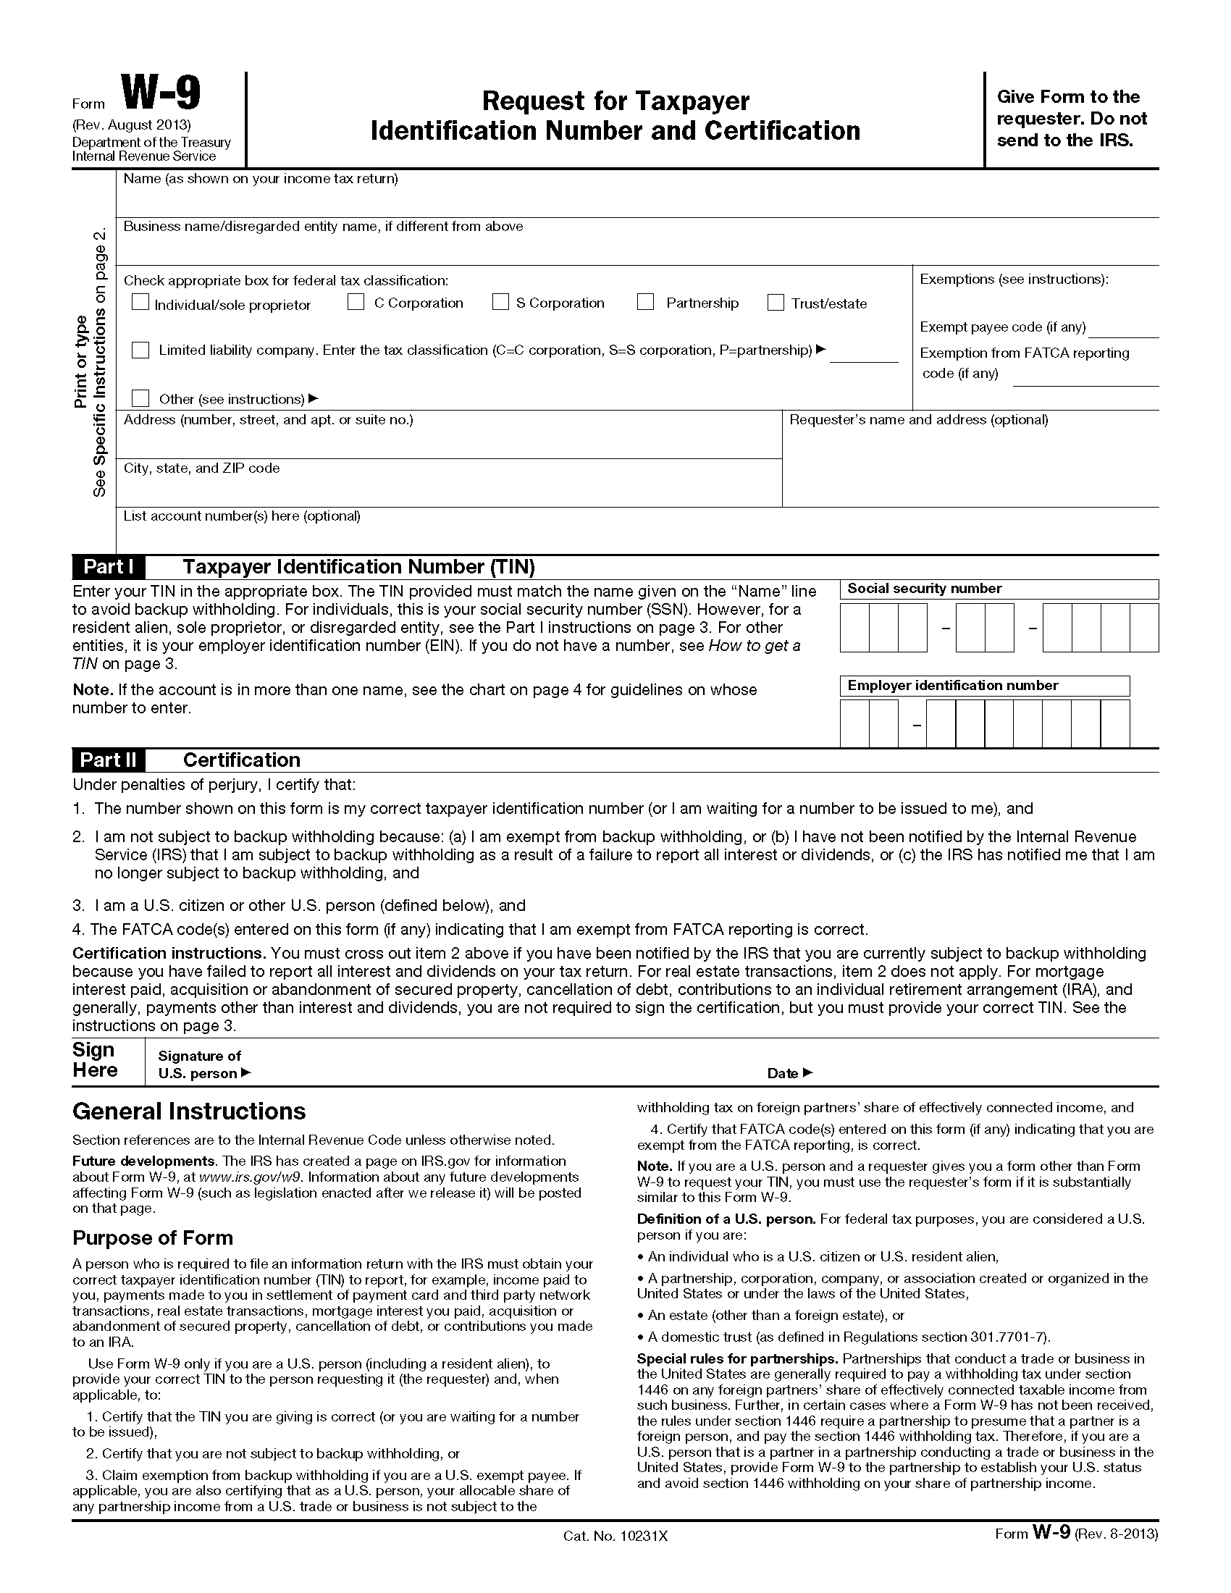
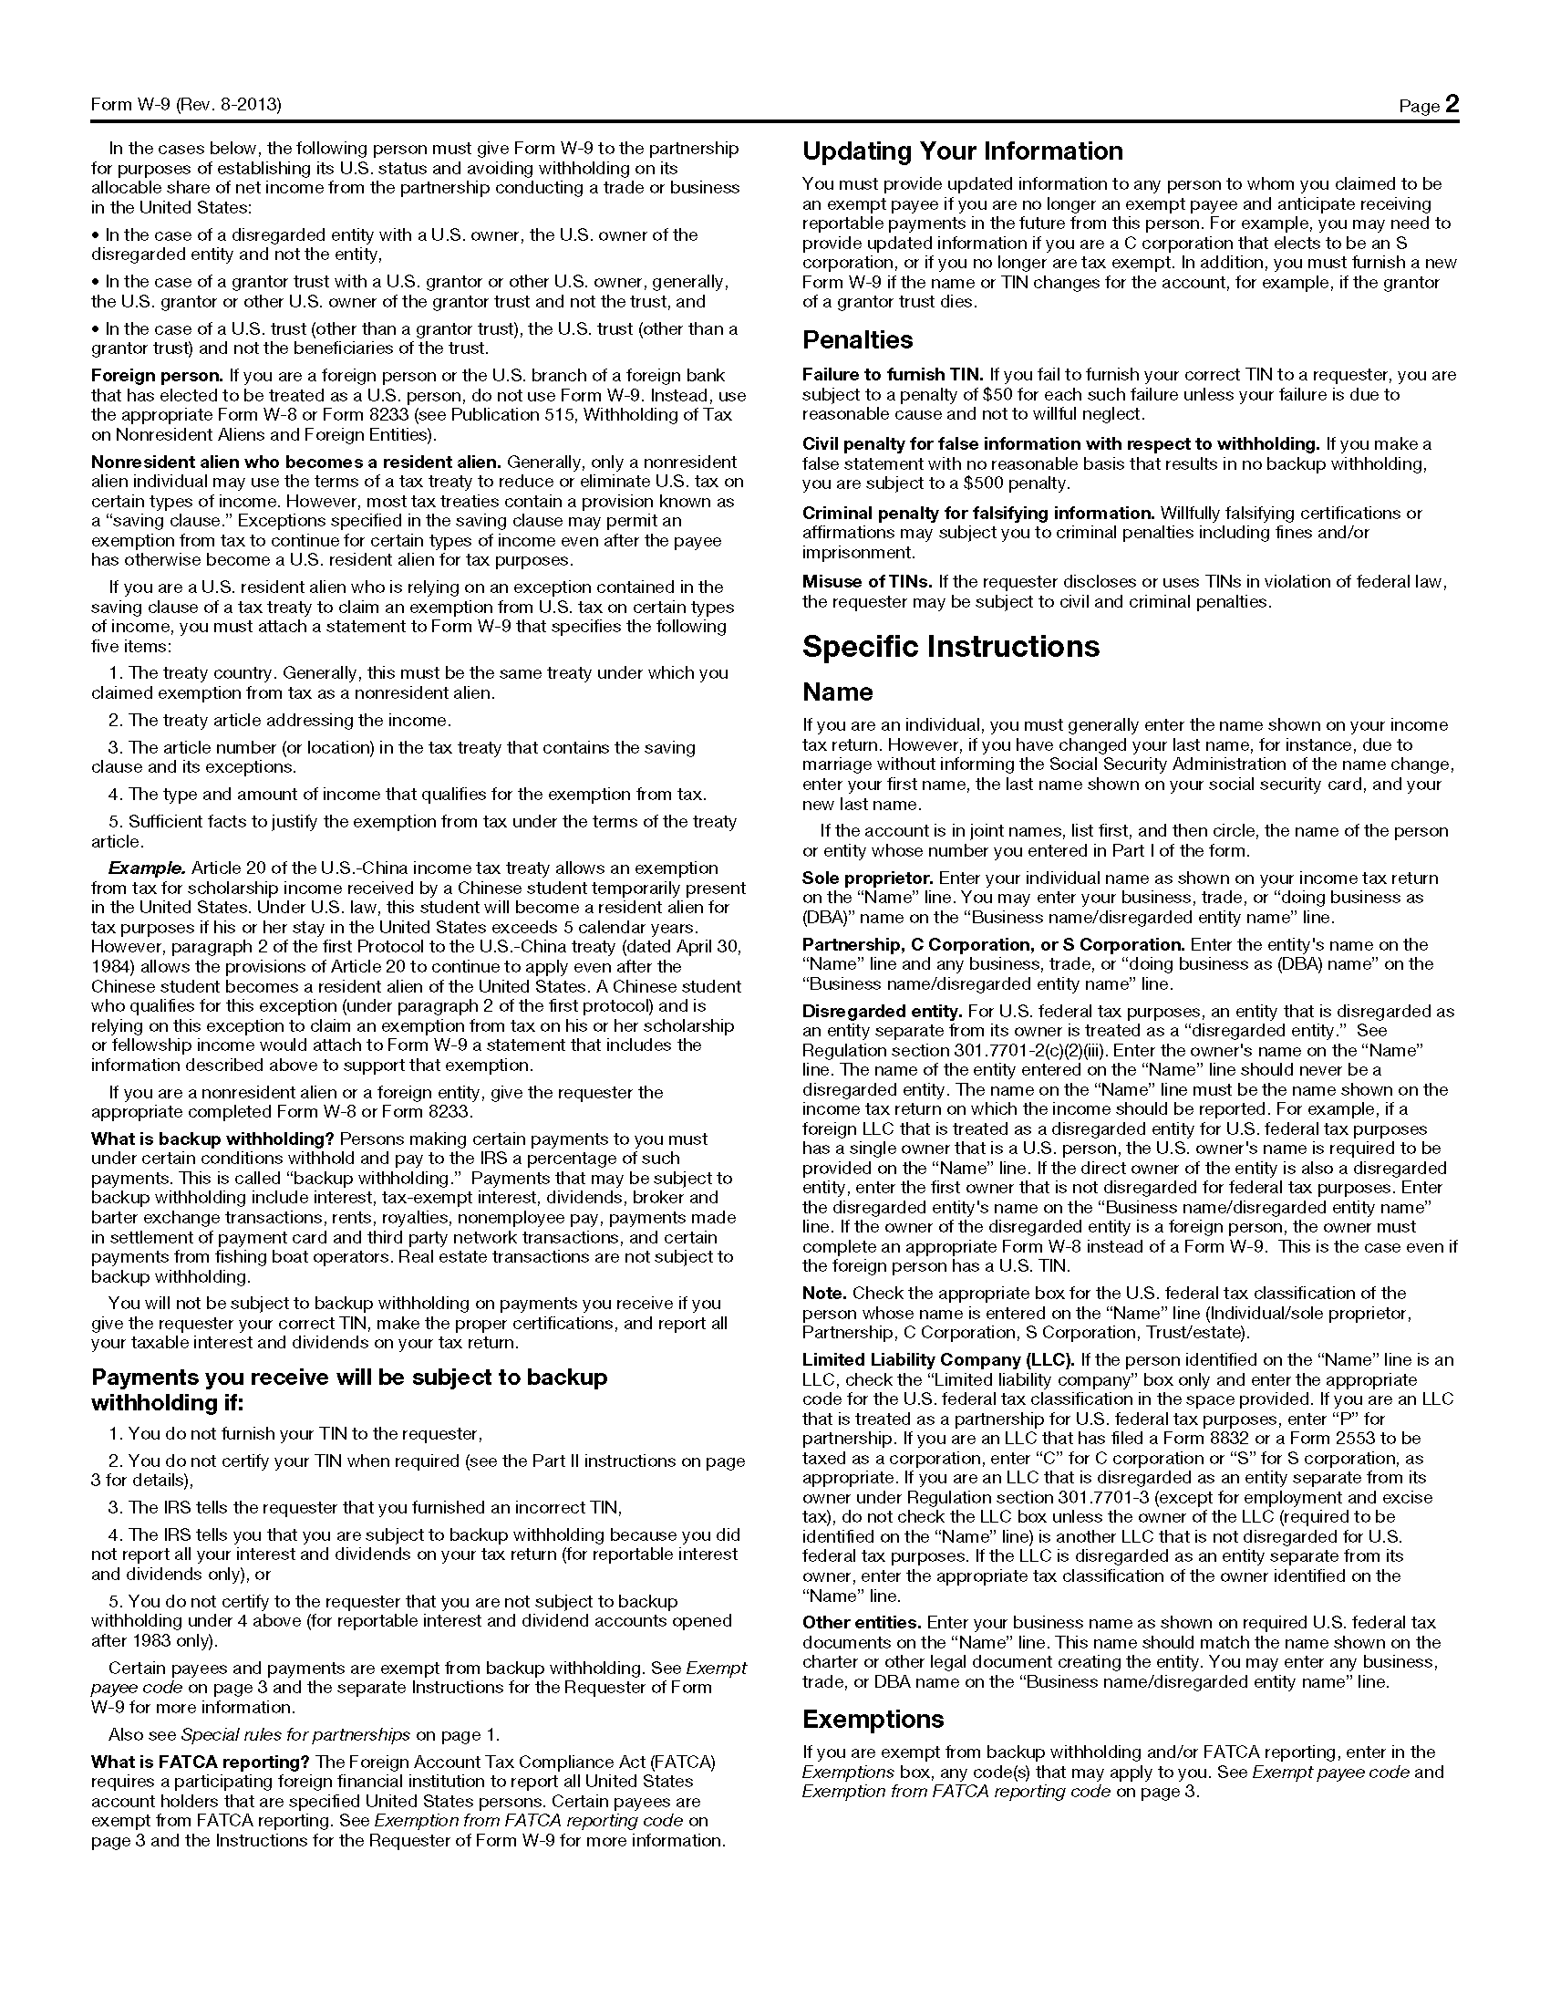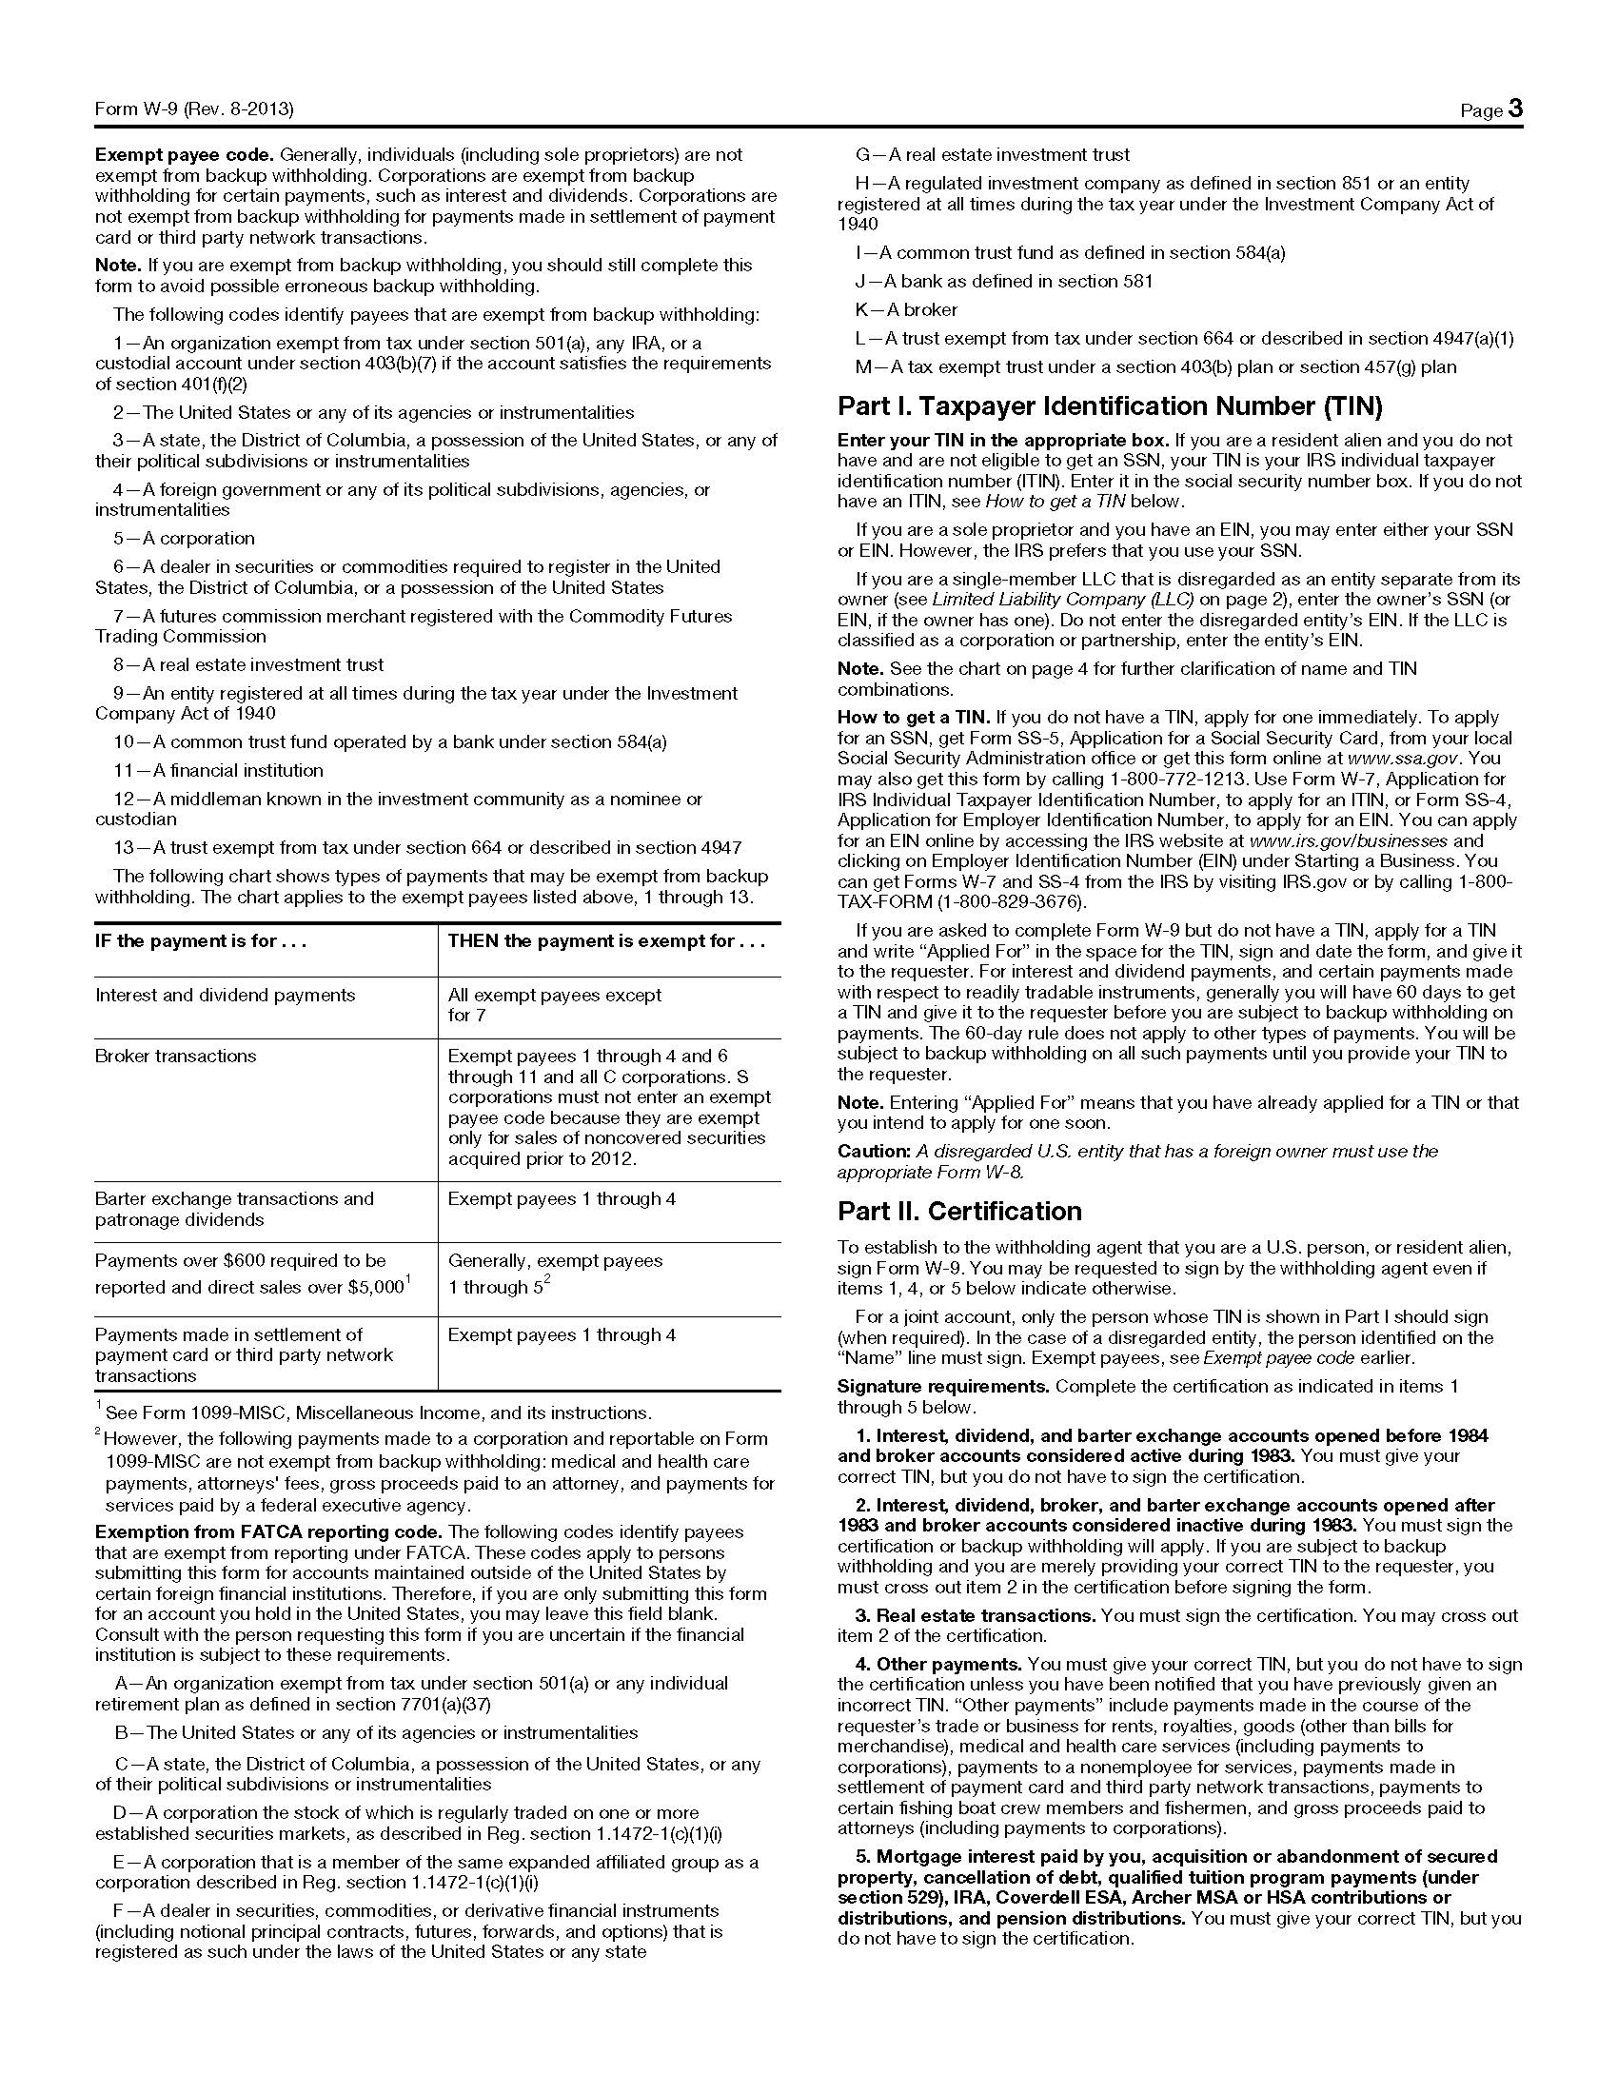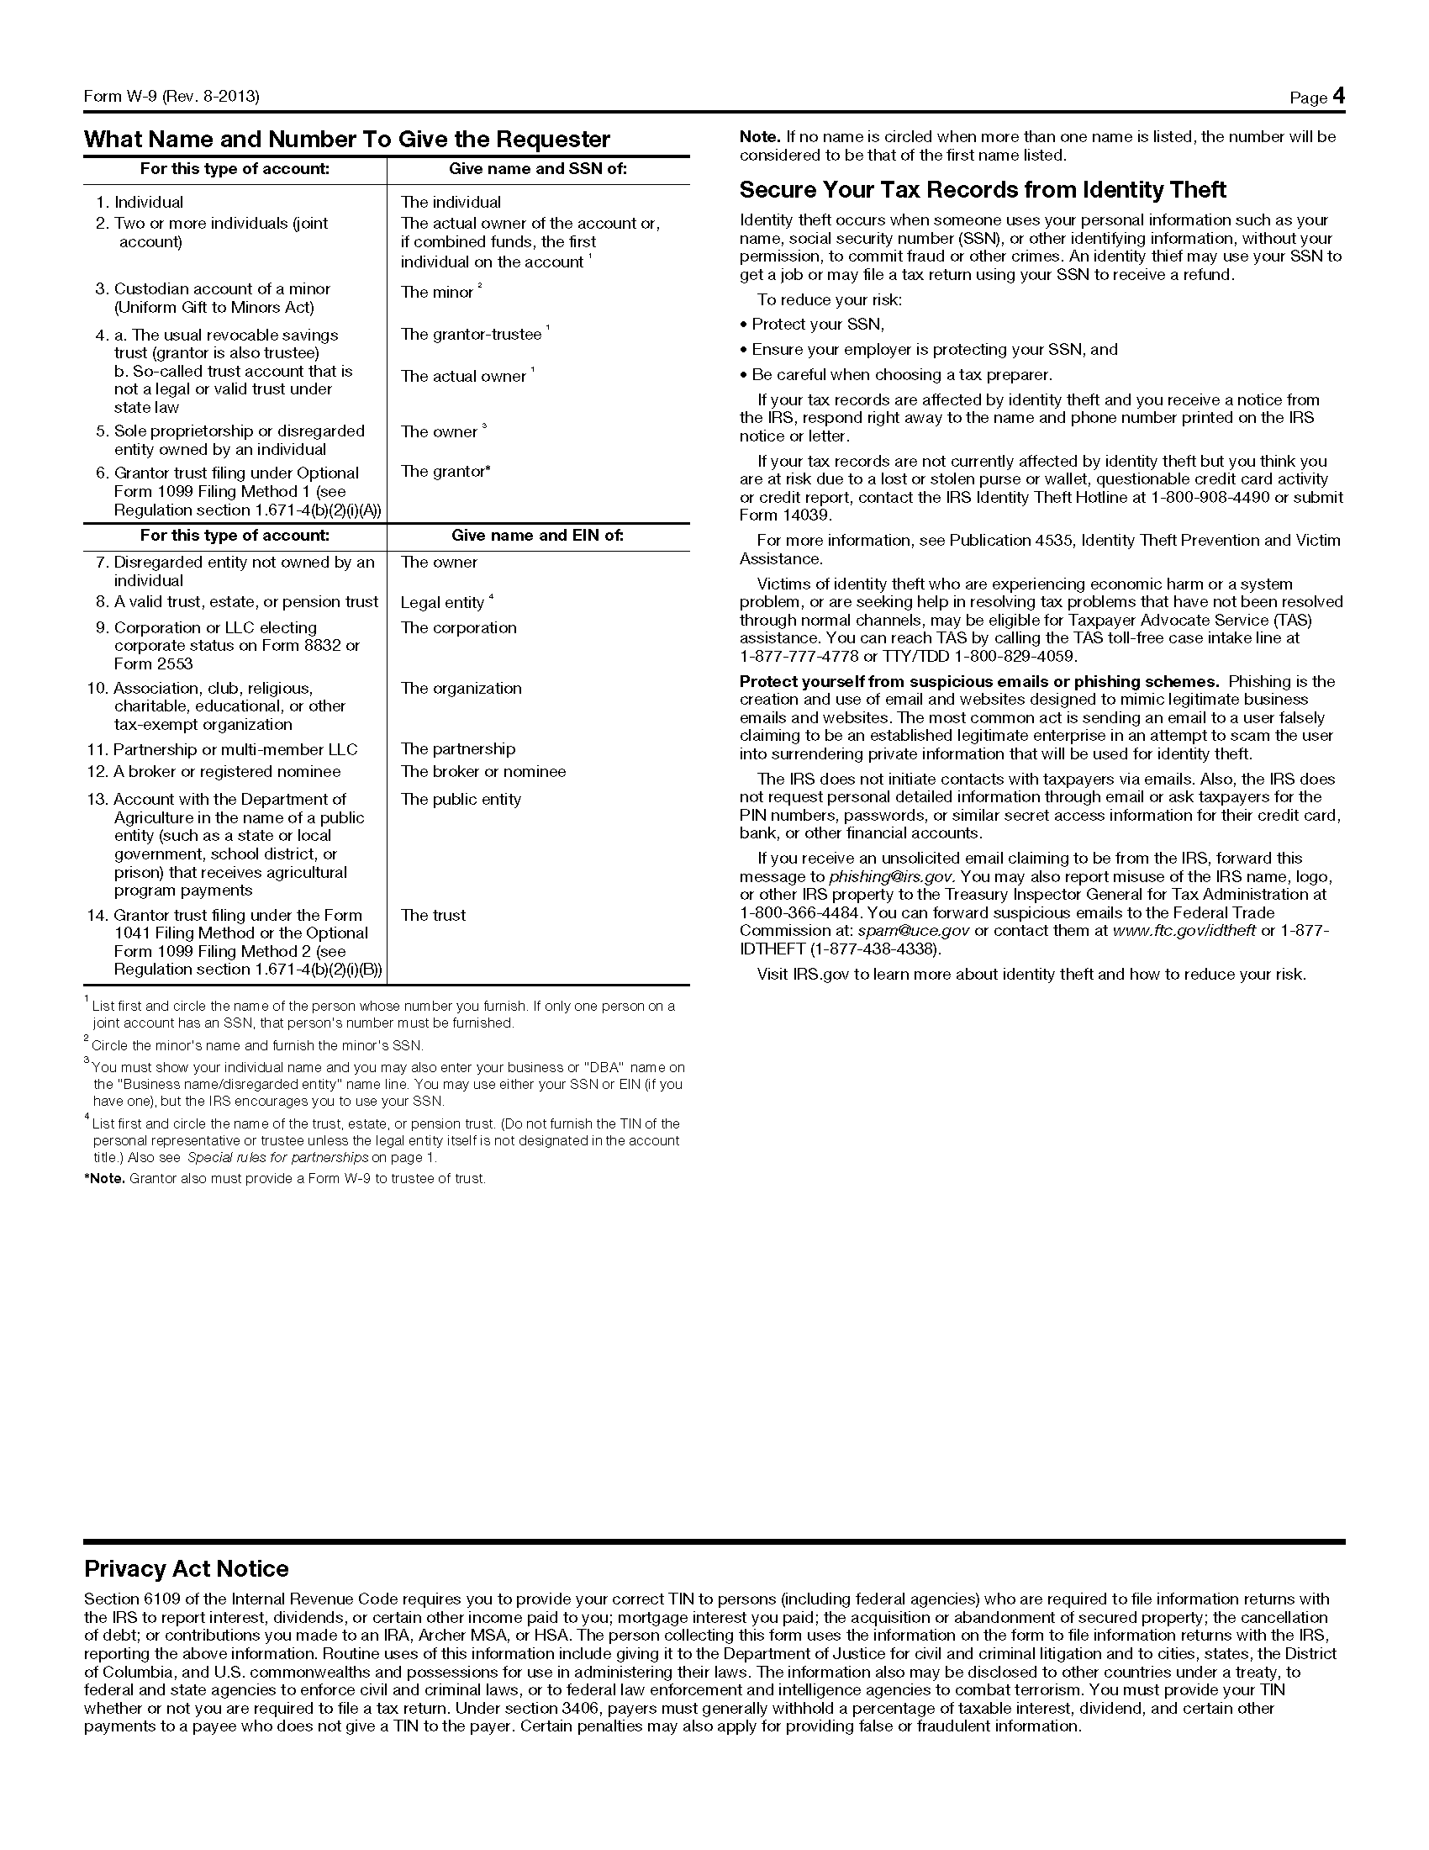

IMPORTANT
Read ALL instructions and definitions contained on this form and use the information as a reference while completing the Ownership and Conviction Disclosure Form.
Completion and submission of this form is a condition of participation in the Medicaid Program and is a condition of approval or renewal of a provider agreement between the disclosing entity and the Division of Medical Services.
Full and accurate disclosure of ownership and financial interests is required. Failure to submit full and accurate requested information may result in a refusal to enter into a provider agreement or contract, or in termination of existing provider agreements.
INSTRUCTIONS FOR COMPLETING DISCLOSURE FORM
Answer all questions as of the current date. If additional space is needed, attach the information at the end of the provider application before returning to the Medicaid Provider Enrollment Unit.

DEFINITIONS
Provider: a named person or entity that furnishes, or arranges for furnishing health related services for which it claims payment under the Medicaid Program
Disclosing entity: a Medicaid provider (other than an individual practitioner or group of practitioners), or a fiscal agent.
Indirect ownership: an ownership interest in an entity that has direct or indirect ownership interest in the disclosing entity. The amount of indirect ownership interest in the disclosing entity that is held by any other entity is determined by multiplying the percentage of ownership interest at each level. (Example: If A owns 10% of the stock in a corporation which owns 80% of the stock of the disclosing entity, A’s interest equates to an 8% indirect ownership interest in the disclosing entity and must be reported. Conversely, if B owns 80% of the stock of a corporation which owns 5% of the stock of the disclosing entity, B’s interest equates to a 4% indirect ownership interest in the disclosing entity and need not be reported).
Ownership or control interest: a person or corporation that: (1) has an ownership interest totaling 5 percent or more in a disclosing entity; (2) has an indirect ownership interest equal to 5 percent or more in a disclosing entity; (3) has a combination of direct and indirect ownership interest equal to 5 percent or more in a disclosing entity; (4) owns an interest of 5 percent or more in any mortgage, deed of trust, note, or other obligation secured by the disclosing entity if that interest equals at least 5 percent of the value of the property or assets of the disclosing entity; (5) is an officer or director of a disclosing entity that is organized as a corporation; or (6) is a partner in a disclosing entity that is organized as a partnership.
Ownership Interest: equity in the capital, stock, or profits of the disclosing entity. To determine the percentage of ownership, mortgage, deed of trust, note, or other obligation, the percentage of interest owned in the obligation is multiplied by the percentage of the disclosing entity’s assets used to secure the obligation. (Example: If A owns 10% of a note secured by 60% of the provider’s assets, A’s interest in the provider’s assets equates to 6% and must be reported. If B owns 40% of a note secured by 10% of the provider’s assets, B’s interest in the provider’s assets equates to 4% and need not be reported).
Managing employee: a general manager, business manager, administrator, director, or other individuals who exercise operational or managerial control over, or who directly or indirectly conducts the day-to-day operations of an institution, organization, or agency
Subcontractor: (1) an individual, agency, or organization to which a disclosing entity has contracted or delegated some of its management functions or responsibilities of furnishing health related services; or (2) an individual, agency, or organization with which a fiscal agent has entered into a contract, agreement, purchase order, or lease to obtain space, supplies, equipment, or services provided under the Medicaid agreement. Additionally, if the accrediting agency prohibits subcontracting, sub-leasing or lending its accreditation to another organization, Arkansas Medicaid will follow the restrictions set forth by the accrediting agency.
Supplier: an individual, agency, or organization from which a provider purchases goods or services used in carrying out its responsibilities under Medicaid (e.g., a commercial laundry, a manufacturer of hospital beds, or a pharmaceutical firm).
Wholly owned supplier: a supplier whose total ownership interest is held by a provider or by a person/ persons or other entity with an ownership or control interest in a provider.
Significant business transaction: any business transaction or series of related transactions that, during any one fiscal year, exceeds either $25,000 or 5 percent of a provider’s total operating expenses.

Print the name, physical address and PO Box address and each location, complete Social Security Number and percentage of interest of each person, Corporation, Limited Liability Company, Partnership, Limited Liability Partnership, or other organization with a direct or indirect ownership or control interest of 5% or more in the named entity or in any subcontractor in which the named entity has direct or indirect ownership of 5% or more. [This applies to all Medicaid providers.]

Individuals – for each individual listed, provide date of birth and COMPLETE Social Security Number

Full Name | Date of Birth | Complete Primary Address and PO Box Address | % of Interest | Complete Social Security Number

Corporations/Limited Liability Companies/Partnerships/Other Legal Entities or
Organizations – for each legal entity or organization listed, provide the Tax ID Number and submit a copy of the legal entity or organization’s IRS form SS4 and the approval letter with this application. Companies must include each business address location with complete addresses.

Name | Complete Primary Address and  PO Box Address with Each Business Location | % of Interest | Tax ID Number

Are any of the above mentioned persons related to each other as a spouse, parent, child, or sibling?
Yes________ No________ If yes, print name and provide relationship.

Name | Relationship

Do any of the persons, legal entities or organizations with an ownership or control interest have any ownership or control interest of 5% or more in any other entity doing business with the Arkansas Medicaid Program?
Yes_______ No_______ If yes, print name, address and Tax ID Number and amount of % of interest they own.

Name | Complete Primary Address and  PO Box Address with Each Business Location | % of Interest | Tax ID Number

List the name, address, date of birth, and complete Social Security Number for any person who is a managing employee of the named entity. For larger corporations having more than 3 managing employees or board members, please use next page (4)*.

Name | Address | Date of Birth | Complete Social Security Number

List any person who has a direct or indirect ownership or control interest in the named entity, or is an agent, or managing employee of the named entity who has been convicted of a criminal offense related to that person’s involvement in any program under Medicaid, Medicare, or Title XX programs in any state:

Name | Offense

List names of persons or entities with direct/indirect ownership or control interest in the named entity, or is an agent or managing employee of the named entity who, as listed in DHS Policy 1088 (Participant Exclusion Rule), has been found guilty, or pled guilty or nolo contendere, to any crime related to: (1) obtaining, attempting to obtain, or performing a public or private contract or subcontract, (2) embezzlement, theft, forgery, bribery, falsification or destruction of records, any form of fraud, receipt of stolen property, or any other offense indicating moral turpitude or a lack of business integrity or honesty, (3) dangerous drugs, controlled substances, or other drug-related offenses when the offense is a felony, (4) federal antitrust statutes, (5) the submission of bids or proposals, (6) any physical or sexual abuse or neglect when the offense is a felony.

Name | Offense

*Use this sheet for multiple business managers/owners or board members.

Name | Address | Date of Birth | Complete Social Security Number
Provider Statement:

“By signing this form, I certify that the information provided on this form is true and correct. I will notify the Division of Medical Services Medicaid Provider Enrollment Unit if any information changes. I will comply with all aspects of this disclosure form. By completing and signing this form, I give consent for the information contained herein to be disclosed to the Department of Health and Human Services or any other appropriate governmental agencies, including the Office of Homeland Security.”

Name:____________________________________ Title:_________________________
(Print or Type) (Print or Type)

Signature:_________________________________ Date:_________________________

IMPORTANT

Read ALL instructions and definitions contained on this form and use the information as a reference while completing the Significant Business Transactions Disclosure Form.

Completion and submission of this form is a condition of participation in the Medicaid Program and is a condition of approval or renewal of a provider agreement between the disclosing entity and the Division of Medical Services.

Full, complete and accurate disclosure of ownership and business transaction information is required. Upon request, the provider must furnish all records described in the provider contract within thirty-five (35) days of the date on a request by the Department, the Medicaid Fraud Control Unit, the Arkansas Office of the Medicaid Inspector General, or the U.S. Secretary of the Department of Health and Human Services or a designated agent or representative of any entity entitled to those records, full and complete information about:

1) The ownership of any subcontractor with whom the provider has had business transactions totaling more than $25,000 during the 12-month period ending on the date of the request; and

2) Any significant business transaction between the provider and any wholly owned supplier, or between the provider and any subcontractor, during the 5-year period ending on the date of the request.

Full, complete and accurate disclosure of ownership and financial interests is required. Failure to submit requested information may result in a refusal to enter into a provider agreement or contract, or in termination of existing provider agreements.

INSTRUCTIONS FOR COMPLETING DISCLOSURE FORM
Answer all questions as of the current date. If additional space is needed, please attach the information at the end of the application for new enrollments, or attach to the form for updated information from existing providers, before returning to the Medicaid Provider Enrollment Unit.

DEFINITIONS

Provider: a named person or entity that furnishes, or arranges for furnishing health related services for which it claims payment under the Medicaid Program.

Disclosing entity: a Medicaid provider (other than an individual practitioner or group of practitioners), or a fiscal agent.

Subcontractor: (1) an individual, agency, or organization to which a disclosing entity has contracted or delegated some of its management functions or responsibilities of furnishing health related services; or (2) an individual, agency, or organization with which a fiscal agent has entered into a contract, agreement, purchase order, or lease to obtain space, supplies, equipment, or services provided under the Medicaid agreement. Additionally, if the accrediting agency prohibits subcontracting, sub-leasing or lending its accreditation to another organization, Arkansas Medicaid will follow the restrictions set forth by the accrediting agency.

Supplier: an individual, agency, or organization from which a provider purchases goods or services used in carrying out its responsibilities under Medicaid (e.g., a commercial laundry, a manufacturer of hospital beds, or a pharmaceutical firm).

Wholly owned supplier: a supplier whose total ownership interest is held by a provider or by a person/persons or other entity with an ownership or control interest in a provider.

Significant business transaction: any business transaction or series of related transactions that, during any one fiscal year, exceeds either $25,000 or 5 percent of a provider’s total operating expenses.

DISCLOSURE OF SIGNIFICANT BUSINESS TRANSACTIONS

Submit full, accurate and complete disclosure concerning the following information:

- Ownership of any subcontractor with whom the named entity has had business transactions totaling more than $25,000 during the last 12 months (12-month period ending as of the date on this application).
________________________________________________________________________
________________________________________________________________________
________________________________________________________________________

- Any significant business transaction between the named entity and any wholly owned supplier in the last 5 years (5-year period ending as of the date of this application).
________________________________________________________________________________________________________________________________________________________________________________________________________________________

- Any significant business transaction between the named entity and any subcontractor in the last 5 years (5-year period ending as of the date of this application).
________________________________________________________________________________________________________________________________________________________________________________________________________________________

Beginning on the effective date of enrollment in the Arkansas Medicaid Program, full, accurate and complete disclosure shall be submitted concerning any significant business transaction that occurs between the named entity and any subcontractor or wholly owned supplier. This information shall be submitted within 35 days of the date the transaction takes place.

Provider Statement:

“By signing this form, I certify that the information provided on this form is true and correct. I will notify the Division of Medical Services Medicaid Provider Enrollment Unit if any information changes. I will comply with all aspects of this disclosure form. By completing and signing this form, I give consent for the information contained herein to be disclosed to the Department of Health and Human Services or any other appropriate governmental agencies, including the Office of Homeland Security.”

Name:____________________________________ Title:_________________________
(Print or Type) (Print or Type)

Signature:_________________________________ Date:_________________________

CONTRACT

TO PARTICIPATE IN THE ARKANSAS MEDICAL ASSISTANCE

PROGRAM ADMINISTERED BY THE DIVISION OF MEDICAL

SERVICES UNDER TITLE XIX (MEDICAID)

INSTRUCTIONS

Please ensure that the provider name on the front page of the contract is identical to that listed in item #2 or item #3 of the application.

If these two names do not match, your enrollment will be denied and the enrollment packet will be returned.

CONTRACT
TO PARTICIPATE IN THE ARKANSAS MEDICAL ASSISTANCE PROGRAM
ADMINISTERED BY THE DIVISION OF MEDICAL SERVICES
TITLE XIX (MEDICAID)

The following agreement is entered into between _______________________________________________, hereinafter called Provider, and the Arkansas Department of Human Services, hereafter called Department:
I. Provider, in consideration of the covenants therein, agrees:
A. To keep records in accordance with generally accepted standards for the type of business and the healthcare services provided, related to services provided to individuals receiving assistance under the State Plan and billing for such services
B. To make available and, upon request, furnish all records described above to the Department, the Medicaid Fraud Control Unit of the Arkansas Office of the Attorney General, the U.S. Secretary of the Department of Health and Human Services or a designated agent or representative of any entity entitled to records. For all Medicaid beneficiaries, these records include, but are not limited to those records which are defined in Section "A" of this contract. For clients who are not Medicaid beneficiaries, the records that must be furnished are financial records of charges billed to non-Medicaid insurance to ensure that charges billed to Medicaid do not exceed charges billed to non-Medicaid insurance.
1) In connection with this contract each party hereto will receive certain confidential information relating to the other party. For purposes of this contract, any information furnished or made available to one party relating to the financial condition, results of operation, business, customers, properties, assets, liabilities or information relating to the financial condition relating to beneficiaries and providers, including but not limited to protected health information as defined by the Privacy Rule promulgated pursuant to the Health Insurance Portability and Accountability Act (HIPAA) of 1996, is collectively referred to as “Confidential Information."
2) The contract shall safeguard the use and disclosure of information concerning applicants for or beneficiaries of Title XIX services in accordance with 42 CFR Part 431, Subpart F, and shall comply with 45 CFR Parts 160 and 164 and shall restrict access to and disclosure of such information in compliance with federal and state laws and regulations.“
C. To make available and, upon request, furnish all records described above within thirty-five (35) days of the date on a request by the Department, the Medicaid Fraud Control Unit, the Arkansas Office of the Medicaid Inspector General, or the U.S. Secretary of the Department of Health and Human Services or a designated agent or representative of any entity entitled to those records, full and complete information about:
1) The ownership of any subcontractor with whom the provider has had business transactions totaling more than $25,000 during the 12-month period ending on the date of the request; and
2) Any significant business transaction between the provider and any wholly owned supplier, or between the provider and any subcontractor, during the 5-year period ending on the date of the request.
D. To accept assignment under Title XVIII (Medicare) in order to receive payment under Title XIX (Medicaid) for any applicable deductible or coinsurance that may be due and payable under Title XIX (Medicaid).
E. To bill Medicaid only after a service has been provided, or as otherwise specified in the appropriate Arkansas Medicaid Provider Manual, Official Notice, or Remittance Advice message.
F. To accept payment from Medicaid as payment in full for a covered service, and to make no additional charges to the beneficiary or accept any additional payment from the beneficiary except cost share (co-pay or deductible amounts) established by the Medicaid Program.
G. To take assignment and file claims with third party sources (medical or liability insurance, etc.), and if third party payment is made to the Provider, to reimburse Medicaid up to the amount Medicaid paid for the services; to make no claims against third party sources for services for which a claim has been submitted to Medicaid; and to notify Medicaid of the identity of each third party source discovered after submission of a claim or claims to Medicaid.
H. To make no charge to a beneficiary for a claim or a portion of a claim when a determination that the service was not medically necessary is made based on the professional opinion of a peer reviewer; except that such charge may be made to the beneficiary when he/she has requested the service and has prior knowledge that he/she will be responsible for the cost of such service; and to reimburse the Division of Medical Services for all monies paid for claims for services that later were determined "not medically necessary."
I. To provide all services without discrimination on the grounds of race, color, national origin, or physical or mental disability within the provisions of Title VI of the Federal Civil Rights Act, Section 504 of the Rehabilitation Act of 1973 and the Americans with Disabilities Act of 1990.
J. To accept all changes legally made in the Program, and recognize and abide by such changes upon being notified by the Medicaid Program in the form of an update to, or an Official Notice/Remittance Advice Message pertaining to, the appropriate Arkansas Medicaid Provider Manual.
K. That the Department has furnished the Provider with a copy of the Arkansas Medicaid Provider Manual containing the rules, regulations and procedures pertaining to his/her profession. The Provider agrees that the terms and conditions contained therein shall be a part of this contract if the same were set out verbatim herein. The Provider states that he/she is currently licensed to practice in Arkansas or within the State where services were rendered and agrees to promptly notify the Department if his/her license is revoked or suspended. The Provider acknowledges by signature on this contract that he/she has received a copy of the appropriate Arkansas Medicaid Provider Manual.
L. To conform to all Medicaid requirements covered in Federal or State laws, regulations or manuals.
M. To certify by original signature within 48 hours of claims being submitted by an electronic media, a claim count and dollar amount billed, that the information on the claims submitted is true, accurate and complete. The Provider agrees to maintain this certification as a matter of record for all claims submitted electronically, by any media.
N. To notify the Department before any change of ownership or operating status. Upon change of ownership or operating status the successor owner or operator shall, as a condition of assumption of this agreement, hold the Department harmless for any rate or payment increases, decreases, or adjustments without respect to whether the increase, decrease, or adjustment relates to services delivered before the change in ownership or operating status.
O. FOR HOSPITALS ONLY
To understand that the Quality Improvement Organization (Arkansas Foundation for Medical Care, Inc.) is responsible for the review of Medicaid admissions to inpatient hospitals, specifically for length of stay purposes, medical necessity and as otherwise specified in the Memorandum of Understanding between the individual hospital and Arkansas Foundation for Medical Care, Inc.
II. The Department, in consideration of the material benefits and the covenants and undertakings of the Provider, agrees as follows:
A. To make payment to the above named Provider for the appropriate Medicaid covered services provided to eligible Medicaid beneficiaries in accordance with the applicable Medicaid reimbursement schedule in effect for the dates of service, and in accordance with the manual of rules, regulations and procedures that is a part of this contract.
B. To notify the above named Provider of applicable changes in Medicaid rules and regulations as they occur.
C. To safeguard the confidentiality of any medical records received by the Department or its fiscal intermediary, as specified in Federal and State regulations.
III. This contract may be terminated or renewed in accordance with the following provisions:
A. This contract may be voluntarily terminated by either party by giving thirty (30) days written notice to the other party without cause and/or convenience of either party;
B. This contract will be automatically renewed for one year on July 1 of each year if neither party gives notice requesting termination;
C. This contract may be terminated immediately by the Department for the following reasons:
1) Returned mail
2) Death of provider
3) Change of ownership
4) Or other reason for which a sanction may be issued as set forth under the applicable Medicaid
Provider Manual.
If the Provider is a legal entity other than a person, the person signing this Provider Contract on behalf of the Provider warrants that he/she has legal authority to bind the Provider. The signature of the Provider or the person with the legal authority to bind the Provider on this contract certifies the Provider understands that payment and satisfaction of these claims will be made from Federal and State funds, and that any false claims, statements, or documents, or concealment of material fact, may be prosecuted under applicable Federal and State laws.
Provider Name: ______________________________________________________________________________
(As inscribed on previous page of contract)
Provider Provider Enrollment

By: ____________________________________ By: ________________________________________
(Signature Required) (Signature)

Name: ____________________________________ Name:______________________________________
(Typed or Printed Name Required) (Typed Name)

Title: ____________________________________ Title:________________________________________
(Required)

Date:_______________________________________ Date:_______________________________________

(Required)
Effective Date of Contract:______________________

DATA SHARING AGREEMENT

Between

The Division of Medical Services
Arkansas Medicaid

and

Insurance or Managed Care Plan Providing Medicare Part C
(“Medicare Advantage”) and/or Part D Services

WITNESSETH:

Based upon the following recitals, the Division of Medical Services and

(hereinafter referred to as

“Medicare Plan”), FEI # , enter into this data sharing agreement.

ARTICLE I. PURPOSE

The Centers for Medicare and Medicaid Services (CMS) has issued correspondence to Medicare Plans on the policies and procedures for initiating corrections to CMS’ low-income subsidy data for plan enrollees for whom the plan has documentation about their Arkansas Medicaid eligibility or residence in an institution under a Medicaid-covered stay. CMS further has provided guidance for Medicare Advantage Special Needs Plans that cover individuals eligible for both Medicare and Medicaid, requiring such plans to verify eligibility through, among other means, a systems query to a State Medicaid eligibility data system. The purpose of this data sharing agreement is to provide the “best available evidence” (BAE) of Medicaid eligibility to the Medicare Plans through access to the Arkansas Medicaid Management Information System (MMIS), while protecting the confidentiality of the data which is transferred.

ARTICLE II. THE PARTIES

2.0 Division of Medical Services

- Division of Medical Services (DMS) states that it is the single state agency that administers the Arkansas Medicaid Program.

- Division of Medical Services has authority to enter into this Agreement.

- Division of Medical Services states that its mailing address for purposes of this Agreement is as follows:

Gainwell Technologies
Provider Enrollment
P. O. Box 8105
Little Rock, AR 72203-8105

2.1 MEDICARE PLAN

- The Medicare Plan provider states that it has authority to enter into this
Agreement pursuant to its contractual arrangement with the CMS for the purpose of determining dual eligibility of persons qualifying for the Medicare Advantage and/or Medicare Part D prescription drug program.

- The Medicare Plan provider states that its mailing address for purposes of this Agreement is as follows:

Company Name:

Attention:

Address:

City, State, Zip:

ARTICLE III. TERMS

3.0 MODIFICATIONS

This Agreement contains all the agreements of the parties and no oral representation by either party is binding. Any modifications to this Agreement must be in writing and signed by both parties prior to the effective date of the modification.

3.1 ASSIGNMENT

Neither party shall assign or transfer any rights or obligations under this Agreement without the prior written consent of the other party.

ARTICLE IV. SCOPE OF WORK – DATA SHARING

4.0 The Division of Medical Services shall allow the Medicare Plan to enroll in the Arkansas Medicaid Program by completing a Provider Enrollment application. This application can be accessed through the Arkansas Medicaid Website at https://medicaid.mmis.arkansas.gov/, or by contacting the Provider Enrollment Unit.

4.1 The Medicare Plan will receive a welcome letter containing a provider number, and an effective date which will allow the Medicare Plan access to verify client eligibility. The Medicare Plan will not submit claims for processing.

4.2 The Medicare Plan will pay the fee of ten cents per electronic eligibility verification transaction.

4.3 The Medicare Plan will receive a paper Remittance Advice weekly of the number of eligibility verifications conducted and the dollar amount owed.

4.4 The Medicare Plan will be invoiced quarterly for the electronic verification transactions submitted. This will balance to the sum of all Remittance Advices received for the quarter.

ARTICLE V. CONFIDENTIALITY, PRIVACY and SECURITY

5.0 The Medicare Plan agrees that Arkansas Medicaid recipient information is confidential and is not to be released to the general public.

5.1 The Medicare Plan agrees not to release the information governed by these Arkansas Medicaid recipient requirements to any other state agency or public citizen without the approval of the Division of Medical Services.

5.2 The use or disclosure of information concerning recipients shall be limited to purposes directly connected with the administration of the state’s Arkansas Medicaid program and eligibility verification relating to Medicare Advantage and/or Medicare Part D plans.

5.3 This restriction shall also apply to the disclosure of information in summary, statistical, or other form which does not identify particular individuals.

5.4 Medicare Plan agrees that Arkansas Medicaid recipient and provider information cannot be re-marketed, summarized, distributed, or sold to any other organization without the express written approval of the Division of Medical Services.

5.2 Medicare Plan agrees to comply with the Federal Privacy Regulations and the Federal Security Regulations as contained in 45 C.F.R. Parts 160 through 164 that are applicable to such party as mandated by the Health Insurance Portability and Accountability Act of 1996 (HIPAA) and 42 U.S.C. §§ 1320d -1320d-8.

5.3 Medicare Plan must report any known breach of confidentiality, privacy, or security, as defined under HIPAA, to the Division of Medical Services Privacy and Confidentiality Officer within 48 hours of knowledge of an unauthorized act. Failure to perform may constitute immediate termination of contract.

ARTICLE VI. LAWS APPLICABLE

6.0 The parties agree to abide by all federal and state statutes applicable to this Agreement.

6.1 The explicit inclusion of some statutory and regulatory duties in this Agreement shall not exclude other statutory or regulatory duties.

6.2 All questions pertaining to validity, interpretation and administration of this Agreement shall be determined in accordance with the laws of the State of Arkansas, regardless of where any service is performed.

6.3 If any portion of this Agreement is found to be in violation of federal or state statutes, that portion shall be stricken from this Agreement and the remainder of the Agreement shall remain in full force and effect.

ARTICLE VII. TERMINATION

7.0 This Agreement may be terminated by either party for cause with a thirty (30) day written notice to the other party. Either party may terminate without cause with a sixty (60) day written notice to the other party. All notices of termination must be in writing.

7.1 In the event funding of the Arkansas Medicaid program from the state, federal or other sources is withdrawn, reduced, or limited in any way after the effective date of this Agreement and prior to the anticipated Agreement expiration date, this Agreement may be terminated immediately by the Division of Medical Services.

7.2 Violation of the confidentiality provisions of this Agreement, as outlined in Article V, shall be grounds for immediate termination.

EXECUTED BY:

Name and Title (printed) of Medicare Plan Authorized Designee

Signature Date

